PHYS-468 Exercise 03 – Continued structural organization, Digitalization
Due date: The exercise is due one week after the lecture on Tuesday before 13:00hrs.
Hand in: Submit the assignment to Moodle as a PDF file with the file name PHYS-468-Exercise-<number>-<name>.pdf, where <number> is a two-digit number (starting with “01”), and <name> is your name.
Name: Last name, First name
Sciper: ######

- List the different types of detergents. What are their differences? The CMC is a measure for the strength of a detergent. Explain. What factors influence the CMC? You want to isolate a membrane protein and analyse it. What kind of detergent would you choose?
https://www.sigmaaldrich.com/CH/de/technical-documents/technical-article/protein-biology/protein-lysis-and-extraction/detergent-properties
- As a small deviation: Proteins are built from amino acids (aa) of which 20 different ones exist in nature, each with individual properties. The protein sequence dictates the latter three-dimensional arrangement of the fully folded protein. This is based on the physico-chemical interactions between the aa and their surroundings. Below, you find all 20 aa, with their name, three -and single letter code as well as their chemical structure. Try to group them into different classes:
  - Hydrophobic
  - Hydrophilic
  - Aromatic
  - Basic
  - Acidic
  - Polar
For all hydrophobic aa, highlight the corresponding regions on the structure.
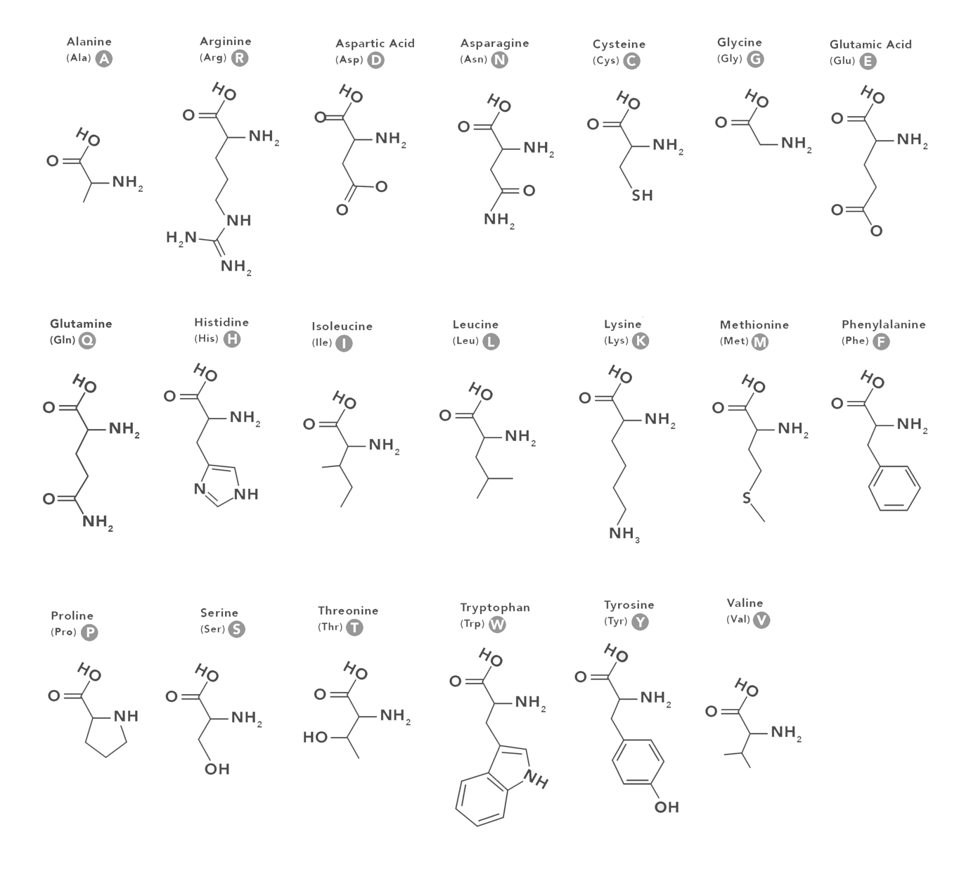

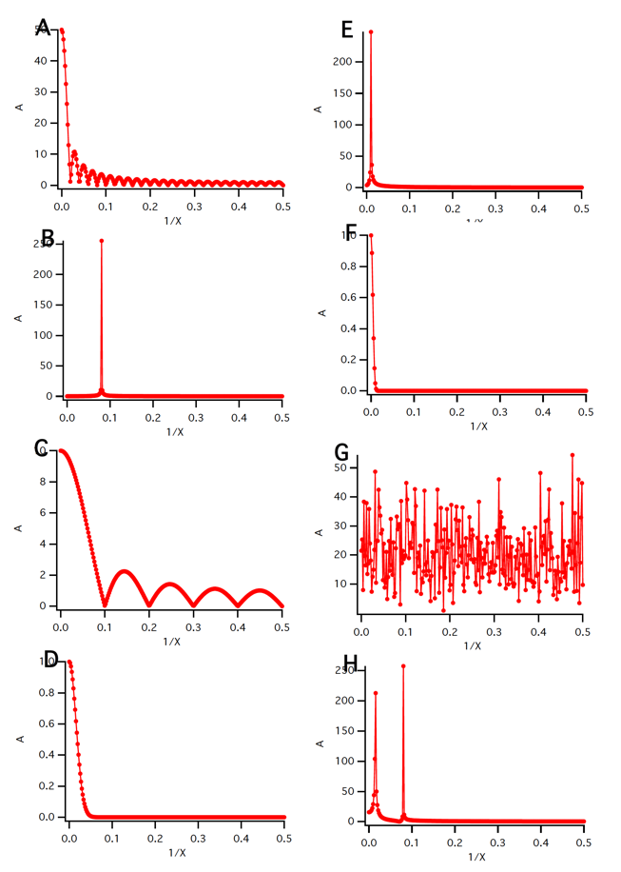
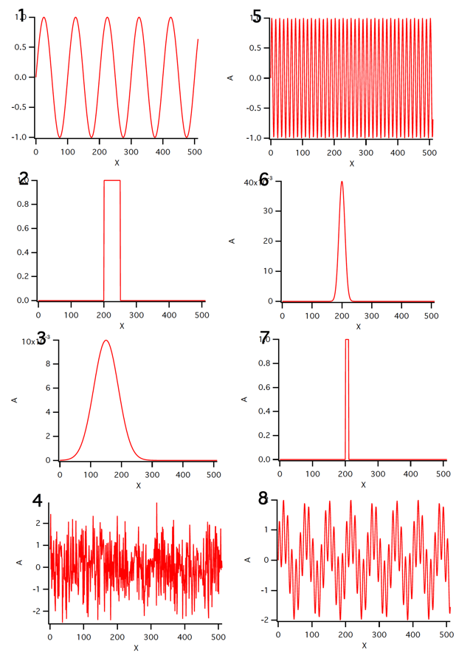
- Correlate the functions from real-space (1-8) with the corresponding Fourier space (A-H).

- Explain in plain language, what the correlation between two functions is, and what the convolution between two functions is.

- You recorded an image with a light microscope at a magnification of 5000x. The pixel-size of your camera in the microscope is 40um.
  - What is the maximally possible theoretical resolution (at the specimen level) that you can expect (Nyquist frequency)?
  - Is this realistic? If not, why?

