PHYS-468 Exercise 13 – NMR & AFM
Due date: The exercise is due one week after the lecture on Tuesday before 13:00hrs.
Hand in: Submit the assignment to Moodle as a PDF file with the file name PHYS-468-Exercise-<number>-<name>.pdf, where <number> is a two-digit number (starting with “01”), and <name> is your name.

Name: Last name, First name
Sciper: ######

- Make a drawing of the essential technical hardware components of an NMR spectrometer. Label the components.
- A 1D hydrogen NMR experiment with iodoethane (CH3-CH2-I) gives the following spectrum:
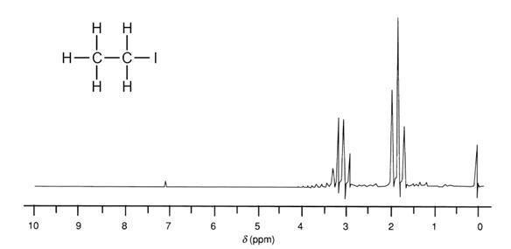
Explain the peaks at 0 ppm, 1.9 ppm, and 3.1 ppm. Which hydrogen atoms give rise to which lines in the spectrum?

- Explain the key differences between scanning tunnelling microscopy and atomic force microscopy.
- Make a drawing of the essential elements of an AFM. Label the components.
- What is a major drawback of the AFM techniques in terms of information we can get? (think about the experiment with the bacteria cell wall)
- Why is it important to see damage, or faulty surfaces, after an AFM image acquisition? Shouldn’t we aim for a damage-free image?
- AFM measurements allow the visualization of individual protein surfaces. What information can we learn if we generate short movies of similarly ranked surfaces?
- Explain the basic principle of the following AFM imaging methods and think of a possible experiment using the method:
  - Contact mode
  - Dynamic mode
  - High-speed
  - Force spectroscopy
  - Affinity imaging

