PHYS-468 Exercise 10 – Radiation Biophysics, OCT
Due date: The exercise is due one week after the lecture on Tuesday before 13:00hrs.
Hand in: Submit the assignment to Moodle as a PDF file with the file name PHYS-468-Exercise-<number>-<name>.pdf, where <number> is a two-digit number (starting with “01”), and <name> is your name.

Name: Last name, First name
Sciper: ######

Radiation
- What are the different types of ionizing radiation? Explain the differences.

- How many protons and neutrons are in each of the atoms below? Search for the different isotopes and list the protons and neutrons for the corresponding elements
  - Boron
  - Aluminium
  - Iron
  - Radon

- There are various ways to quantify radiation. Why is it necessary to have so many? What would be the implications if we would only measure in Becquerels?

- Define nuclear fission. Under which conditions does this generate energy, and how much?

- Radiation exposure causes damage to biological tissue. Explain how this damage occurs.

- We often think of radiation as dangerous, but how can we use it to gain benefits from it? Elaborate on different techniques and methods.

OCT
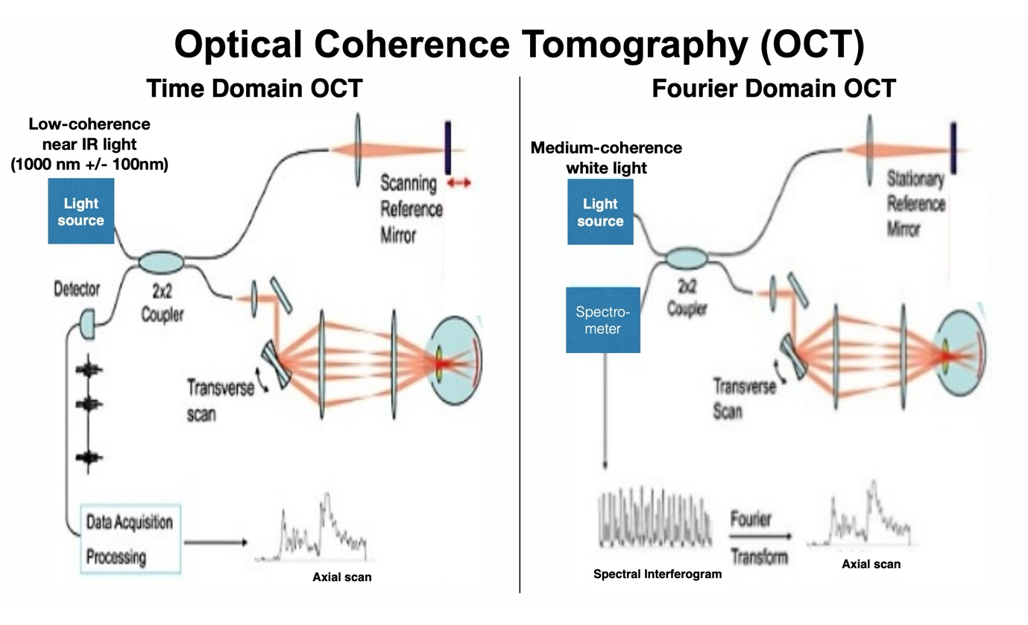
- Explain in your own words the working principle of OCT in the Time Domain and in the Fourier Domain. How can the two different instruments detect the 3D density of the tissue in X, Y and Z ?

