Quality Control of a radiopharmaceutical

Please answer to the following questions:

- How is named the document where the relevant information about a radiopharmaceutical product and its quality control is described? Which information can you obtain from this document?

Summary of product characteristics (SPC)

- Where can you find this document in Switzerland?

- Possibility 1: The SPC is delivered with the product

- Possibility 2: At the following address: www.swissmedicinfo.ch

- Is there any information about the quality control you may perform in this document?

- No b) Yes, generally it is described at the end of the SPC

- Which is the most commonly used analytical technique you may use for the quality control of a radiopharmaceutical kit used for diagnostic applications?

Thin layer (TLC) and paper chromatography

- Please look up the information about the radiopharmaceutical Nanocoll on the Swissmedic webpage. Following the document for the radiopharmaceutical Nanocoll, which percentage of impurities are allowed in the final preparation for patient administration?

For the radiopharmaceutical Nanocoll, the impurities may not be over 5% in the preparation

- In the chromatogram of a Nanocoll preparation shown below, draw a line at the Rf (0.8) with taking into account the following information:

- The drop was deposed at 40 mm of the beginning (0) of the chromatogram (origin at 40 mm)

- The front line of the solvent stopped to 119 mm from the start (0)

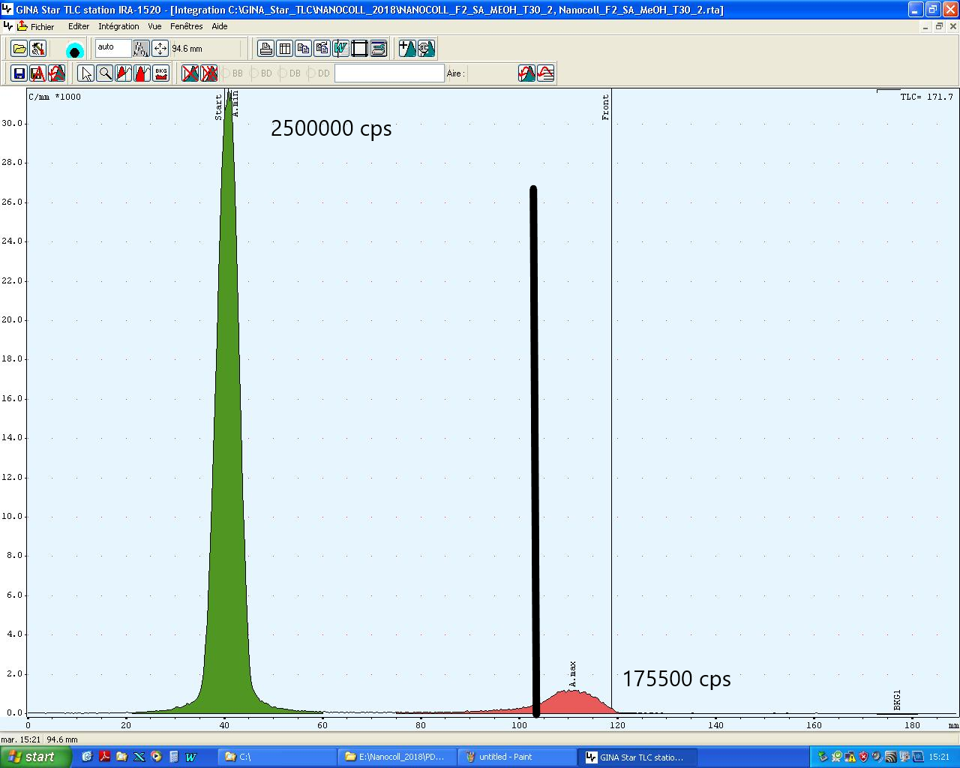

See the picture above. Your origin is at 40 mm. The solvent travelled 119-40 mm from the origin = 79 mm.

The Rf is calculated with the following formula:

Rf = Distance travelled by Spot / Distance traveled by solvent

To indicate an Rf of 0.8, you calculate the distance travelled by the spot:

Rf * Distance travelled by the solvent = Distance travelled by the spot

- 0.8 * 79 = 63.2

From the origin (at 40 mm), you add 63 mm, and this is your Rf 0.8, indicated by the black bar.

- The percentage of the part of the strip below an R_{f} (0.8) is 93%. Do you inject the prepared radipharmaceutical to the patient? What are possible risks by injection this radiopharmaceutical to the patient?

No, the impurity levels are above the 5%. If you inject the product, you risk that the patient will need to do a second exam because the images are of poor quality.

- What effects can occur if you inject a radiopharmaceutical product with a quality below the indicated acceptable impurity levels?

- Poor image quality
- Uncontrolled distribution of the radiopharmaceutical product in the patient's body
- Pharmaceutical side effects due to different chemical forms
- Unnecessary dose to the patient if the exam has to be repeated.

