Solutions: GBCD of Y-doped alumina

GBPD independent of misorientation:
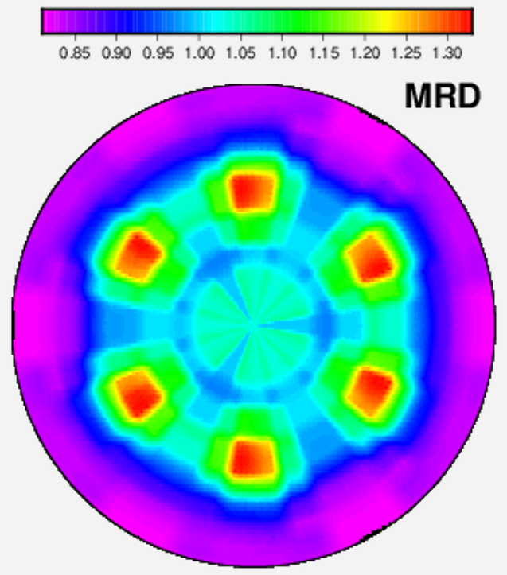

GBCD 60°/[0001]
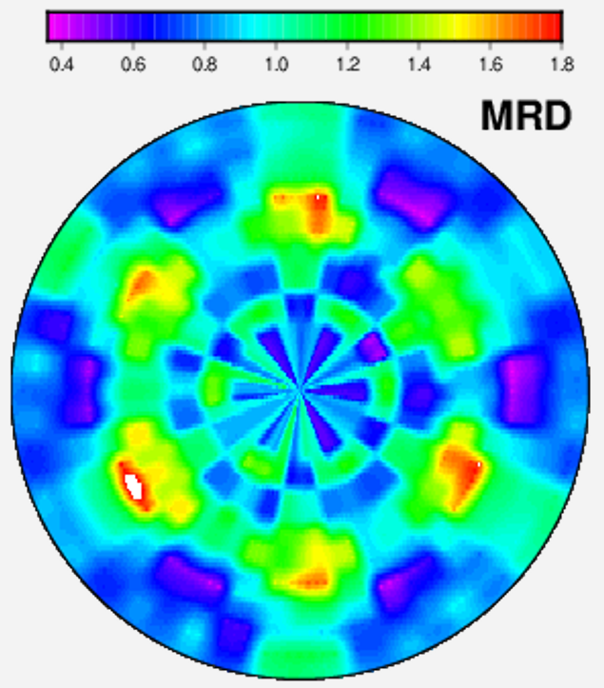

GBCD 144.2°/[1-210]
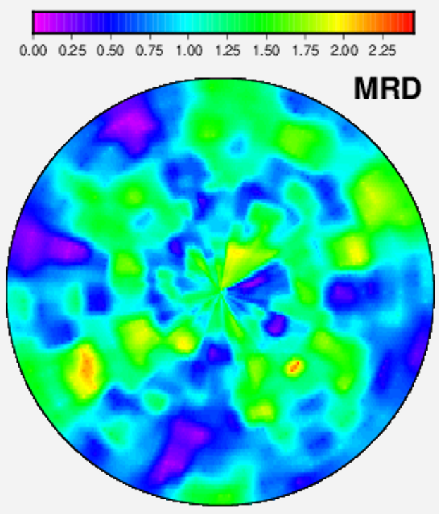
GBCD 38.2°/[0001]
