Project Title
Author A¹; Author B²; Author C²; Author D¹
1) EPFL-Section, 2) EPFL-Section

Abstract: Use approximately 150 words to summarize the study, structured introduction, methods, results, discussion, and conclusion.

Keywords: 2-5 keywords separated by commas.

1. Introduction
This section describes the general background of the problem. It reports how it is currently treated by others The last paragraph should explain the research question of the project. The introduction should not exceed one page.

2. Methods
This section describes the methods only, without results. It should be about 2 pages.
One or two figures can be added. The method should be clearly related to the goal of the work.
This section should end with a brief description of (the nature of) the presented results. You might use the following subsections.

2.1. System
Describe the system, the geometry.

2.2. Physical laws
Presents the physical laws, PDE, constitutive laws, initial and boundary conditions, coupling.

2.3. Numerical model
Describe the mesh, element types, solver, coupling, other specific features related to the numerical aspect. Software (with version) used.

3. Results
This section describes the results only, without any comments, or new methods. It should be 1-2 pages. Results can be presented in tables or graphics. Do not present too many graphics. Focus on the essentials.

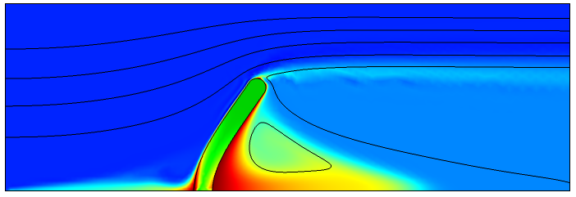
Figure 1. The caption should clearly explain the figure without redundancy with the main text.

 | M1 | M2
P1 | A | B
P2 | C | D
Table 1. The caption should clearly explain the table without redundancy with the main text.

4. Discussion
This is the most important section. It should be 1-2 pages. You comment on your results and evaluate their quality (e.g. comparison to others). You have to discuss the Verification and Validation aspects. You comment on the strengths and limitations of your model.

5. Conclusion
In this final brief section, you recall your goal (question), and to which extent to reach (answer) it. Finally, you can conclude on the clinical relevance, applications, or perspectives.

References
1. No more than 5 references
2. Author, Journal, Volume, Pages, Year
3. In the text, references should appear this way [1].

Acknowledgements
If any.

Author contributions
As for a research paper, list each author’s contribution (using initials) to the project with a short sentence. The typical tasks are the following:
- Choice of the research question
- Design of the methods
- Presentation and analysis of the results
- Discussion of the methods, results, question
- Oral presentation
- Written report
The sentence could be: X and Y set the research question: X and Z developed the model. Y analyzed the results and prepared the graph. X,Y,Z discussed the methods and results. X,Y, Z prepared the oral presentation and wrote the report.

Archive description
Briefly describe the Comsol file(s) of the project that are uploaded on moodle.

Appendix
Add her any supplementary material that is relevant but does not form part of the main article. It may include additional data such as computer code, large tables, or additional figures.

Report format
The styles and formatting of this page can be adapted, but the (main) structure should be maintained. If you prefer, you can use LaTeX (www.overleaf.com). The report should be 4-7 pages. You can add 2-4 figures and 1-2 tables. Use simple past or present, and avoid mixing tenses. Upload the pdf version on moodle.

