Huge Increase in Coral Produces Third Year of Record Highs on the Great Barrier Reef
By Chris Morrison
Daily Sceptic Journal
Articles from 23 August 2024, 15 March 2024, and 10 August 2023

Coral numbers on the Great Barrier Reef (GBR) have “exploded” in recent years despite highly publicised episodes of bleaching, according to a recently published report from the distinguished scientist Dr. Peter Ridd. Almost constant scares are raised by activist scientists and journalists about bleaching events including a nonsense story recently published by the Daily Mail and Reuters that suggested the GBR was in danger of disappearing. Ridd notes that the impact of bleaching is “routinely exaggerated by the media and some science organisations”. He goes on to state that all 3,000 individual reefs in the world’s largest reef system have excellent coral. “Not a single reef or even a single species of reef life has been lost since British settlement,” he adds.
Coral at the Great Barrier Reef (GBR) faces another year of exile from the climate scare headlines with news that the record levels reported in 2021-22 have been sustained in the latest annual period to May 2023. A small drop in the three main areas of the reef was well within margin of error territory, with the Australian Institute of Marine Science (AIMS) reporting that regional average hard coral cover in 2022-2023 was similar to last year at 35.7%. Most reefs underwent little change during the year.
Coral at the reef has been bouncing back sharply for a number of years, with a record 36-year high reported in 2022. But the news of this spectacular recovery has been largely ignored in most media since it had previously been a go-to poster scare story for collectivist Net Zero promoters. But connecting the fate of tropical corals to global warming was always a difficult ask since they grow in waters between 24-32°C. Short boosts in local temperatures can cause temporary bleaching, but it is scientifically impossible to pin it on human-caused climate change, although pseudoscientific ‘attribution’ computer models try very hard.
In the latest year, there was a short local temperature rise, but little bleaching was reported during the 2023 summer. No cyclones hit the reef and crown-of thorns starfish attacks were limited. Nevertheless, natural stresses will always affect the eco-system and AIMS states that these paused the growth of hard coral on some of the reefs.
Like most state-funded scientific bodies, AIMS is fully signed up to climate extremism and delivering politically correct messages to promote the Net Zero solution. Despite reporting what is now a substantial multi-year recovery, it notes that the future is predicted to bring more frequent, intense and enduring marine heatwaves, alongside the persistent threat of crown-of thorns starfish outbreaks and tropical cyclones. More frequent mass coral bleaching is a sign that the GBR is experiencing the consequences of climate change, it claims. However, in a different part of its latest report, AIMS accepts that the recent substantial recovery occurred despite two mass coral bleaching events in 2020 and 2022. There is an acceptance that this underlines that “widespread coral bleaching does not necessarily lead to extensive coral mortality”.
But pockets of extremist catastrophism remain in the mainstream media, notably in the Guardian, fighting to keep the coral destruction story going. A year ago, the newspaper reported that the GBR still had “some capacity” for recovery, but the window was closing fast as the climate continued to warm. Of course the Guardian has form as long as your arm on this score. Back in 1999, George Monbiot told its readers that the “imminent total destruction of the world’s coral reefs is not a scare story but a fact”.
In last year’s Guardian report, Dr. Mike Emslie, who leads the AIMS monitoring service, said he felt a “couple of bullets” had been recently dodged. While the recovery is great, “the predictions are the disturbances will get worse”, he suggested. “The naysayers can put their heads in the sand all they like, but the frequency of disturbances is going gangbusters,” he claimed. Dr. David Wachenfeld from the Great Barrier Reef Marine Park Authority claimed “global heating” of 1.5°C is considered a “guardrail for reefs”, after which the bleaching comes along too quickly for strong recovery.
Coral reefs have been around in one form or another for hundreds of millions of years. Current global temperatures are towards the lower end of the paleoclimatic record. One might wonder how corals manage to survive temperatures up to 10°C higher in the past?
Back in the real world, we can see how the recent solid recovery was sustained across the three main areas of the GBR.
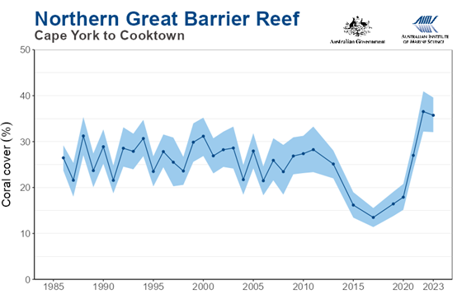
Figure 1
The recovery in the northern GBR actually started around 2017. Last year the coral declined slightly from 36.5% to 35.7%, and was easily within the margin of error calculated by the AIMS. Typhoon Tiffany passed through at the end of the previous reporting season, and could have been responsible for some loss.
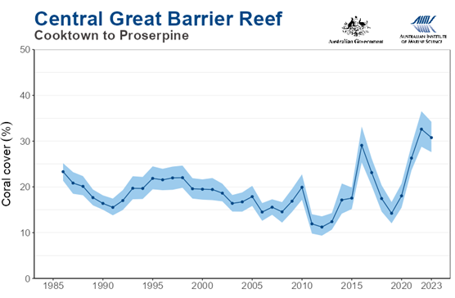
Figure 2
In the centre of the reef, the strong recovery of hard coral cover to 32.6% last year eased slightly, but again, as the AIMS noted, it was within the margin of error.
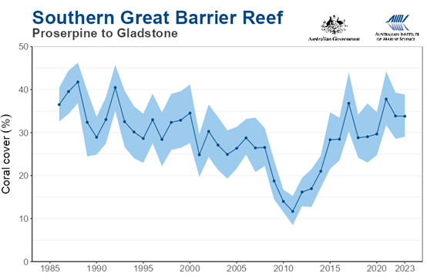
Figure 3
The southern end of the GBR has generally had higher coral cover than elsewhere, but has shown greater variability over the observed record. Last year’s cover was 33.8%, compared with 33.9% the year before. Some coral was reported to have been lost due to starfish predations.
The GBR is the largest reef system on Earth and runs for over 1,400 miles down the eastern side of Australia. It is also the most surveyed reef in the world and the results of scientific endeavour are widely distributed. While this work is often politicised, it is clear that recent evidence shows that temporary spikes in temperature, which occur naturally in the oceans, can cause bleaching. However, this bleaching process can rapidly go into reverse when local conditions stabilise. These findings have been confirmed elsewhere, notably in the remote Palmyra Atoll, 1,200 kms south of Hawaii. A 10-year survey recently observed sudden changes in temperature up to 3°C on two occasions, leading to substantial damage to the coral. A 2015-16 spike led to 90% of the coral bleaching, but the researchers found that within a year only 10% of the coral had died. Within two years, the corals had returned to pre-bleached levels.
The researchers concluded that the coral structures “show evidence of long-term stability” – but don’t hold that front page.
Coral loss on the GBR and elsewhere is one of the great poster scares used by climate alarmists to promote the collectivist Net Zero agenda. Every bleaching event, when corals expel algae in response to natural and localised spikes in water temperatures, is used to forecast catastrophe. Peter Ridd has been studying coral at the GBR for 40 years and is almost a lone voice in calling out what is a major scientific scandal. “The public is being deceived about the reef. How this occurred is a serious issue for the reef-science community which has embraced emotion, ideology and raw self-interest to maintain funding.”
Ridd goes on to note that Australia spends $500 million each year to “save the reef”, but this money could be much better spent on genuine environmental problems such as control of invasive weeds and feral animals, or restoring indigenous fire practices into forests and range land. The GBR is observed to be “one of the most pristine ecosystems in Australia”. It has no feral animals or invasive plants, “unlike virtually any other Australian ecosystem”.
Mainstream attempts to catastrophise natural events at the GBR have suffered a few setbacks of late with record levels of coral being declared in the last two years. Coral alarmism was understandably dropped from the headlines for a short while but the hysterics have been out in force recently with another outbreak of bleaching reported. The graph below compiled by Ridd shows the recent sensational coral growth at the GBR with a note of recent bleaching events that are, needless to say, often portrayed in Armageddon terms.
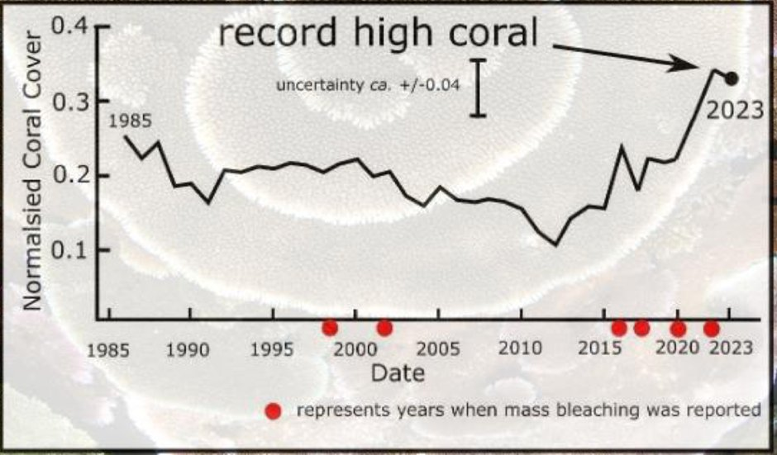
Figure 4
Despite the GBR experiencing four supposedly devastating bleaching events between 2016 and 2022, there has never been more coral in the modern record than in 2022-23, Ridd points out. Quite how the Daily Mail and Reuters can publish their drivel about the GBR being on the “cusp of the worst bleaching event in history” is a mystery, unless, perhaps, they define history as starting sometime around lunchtime last Tuesday.
Ridd goes back a little further in his GBR researches, stating that there has been no decline in the rate of growth of coral going back to 1570. Alas, there is no publicly available information taken from coral growth rings since 2005, “despite this being the period of most interest”, and he suggests this is scandalous. Interestingly, there had been no slowing of growth between 1860 and 1960 when agricultural production and pesticide use started. It is a common eco scare to suggest the GBR is being badly affected by the run off from fertiliser and pesticides, but Ridd finds that agricultural pesticides are generally in such low concentrations “that they cannot be measured even with the most sensitive of instruments”. Much of the GBR is a long way from land and there is massive flushing of water from the Pacific Ocean. Sediment and run-off from farms are said to have “negligible impact” on the GBR.
Ridd also considers claims that coastal ecosystems such as mangroves, seagrass meadows and freshwater wetlands are seriously degraded, degradation said to negatively impact the GBR. “There is limited evidence that that these linkages are significant,” states Ridd. “In addition we should note that of these ecosystems, mangroves are in excellent condition, and seagrass meadows are still widespread and generally healthy despite fluctuating greatly due to cyclones and floods,” he adds.
Dr. Peter Ridd is a man on a mission to bring sanity to the science and debate over corals, and the GBR in particular. He was fired from his professorial post at Queensland-based James Cook University in 2018 for “uncollegiate” behaviour. As the Guardian has observed, Ridd was sacked “for breaches of the university’s code of conduct relating to public commentary about the GBR”. In other words, he was punished for rocking the boat on the ‘settled’ narrative surrounding the doomed ‘send more money immediately’ reef. He is only too keen to test his work in public, and he throws down the gauntlet to the controlling scientific elite. Rather than ignoring the data and hoping nobody will notice, “I challenge them to a public science duel – any time any place,” he says.
In February 2022 the green billionaire-funded Carbon Brief reported that a rise of 0.3ºC in the current global temperature would kill off 99.8% of coral with the rest going as a result of another 0.5ºC of warming. The increasingly unpopular prints are full of similar tosh, despite the fact that sub-tropical corals grow happily between 24ºC-32ºC. Limiting global warming to 1.5ºC rather than 2ºC would likely be the difference between the complete decline of the Great Barrier Reef (GBR), reports the Guardian, quoting a United Nations report. What decline we might ask following three stonking years of embarrassing record growth? Such great click-bait stories are endemic throughout the mainstream media – it’s just a shame about the facts. A newly-published science paper reveals massive increases in coral on the GBR from about 8,000 to 6,000 years ago at a time when sea surface temperatures were 4ºC higher.
The coral story, of course, is an excellent example of the numerous fear-mongering swindles being perpetrated to push the insanities of Net Zero. Three years of record growth on the GBR – the highest in nearly 40 years of constant observation on the world’s largest Reef system – have simply been ignored by the mainstream media. Even worse, there were attempts to deflect the excellent news this year by running a nonsense story from Nature that claimed “climate change” posed an “existential threat” to the GBR. Temperatures at the Reef were said to be at their highest level for 400 years. All of this stuff is published when it is known that gentle and tiny rises in overall sea surface temperature are more likely to benefit coral than cause it long-term harm.

