SCIPER:

Exam questions – Fundamentals in Ecology

Indicative time: 60 minutes
(PLEASE WRITE CLEARLY AND IN A STRUCTURED MANNER)

Student last name: First name:

Examiner: Tom Battin Grade: / 40 points

Short Answer Questions (1 point per question / 10 questions in total)

1) ) In a body of water, the depth at which the availability of light is such that the rate of photosynthesis equals the rate of respiration is called the ________ depth.
Answer: compensation

2) The breakdown of chemical bonds that were formed during the construction of plant and animal tissues is called ________.
Answer: decomposition

3) The release of organically bound nutrients into an inorganic form is called ________.
Answer: mineralization

4) Carbon dioxide and ________ are the major gases in the atmosphere that absorb energy from the sun.
Answer: water vapor

5) The ________ niche is the portion of a fundamental niche in which species can exploit as a result of interactions with other species.
Answer: realized

6) The tiny, photosynthetic, primary producers of open water such as desmids, diatoms, and filamentous algae are referred to as ________.
Answer: phytoplankton

7) Bacteria and fungi secrete ________ into plant and animal tissues to break down the complex organic compounds.
Answer: enzymes

8) ________ is the process by which plants absorb a portion of their nutrients from senescing tissues to be stored and used for the production of new tissues.
Answer: Retranslocation

9) Within any ecosystem, the two major food chains are the ________ food chain and the grazing food chain.
Answer: detrital

10) In aquatic ecosystems, the undissolved remains of dead organisms and other organic material that drifts toward the bottom is called ________ organic matter.
Answer: particulate

Essay Questions (maximum 200 words) (10 points each / 3 questions in total)

- Question: After filling out the five white boxes in the figure below, describe what is depicted in the figure, including explaining the differences between the two curves.

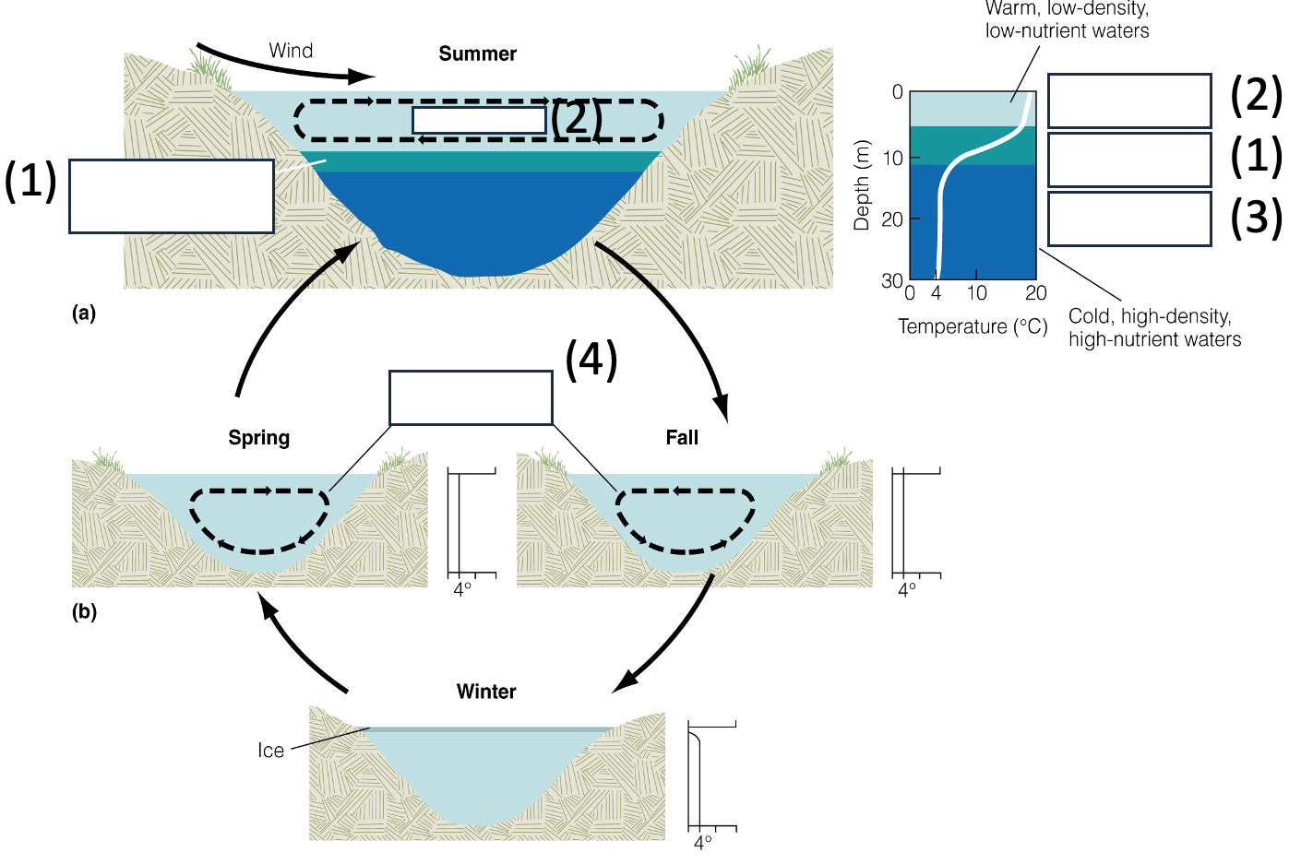

Answer: 1: thermocline; 2: epilimnion; 3: hypolimnion; 4: turnover; 5: shade-intolerant (0.5 points per response; total: 2 points)

The figure shows the seasonal cycle of thermal stratification and turnover in a lake. During summer, the lake stratifies into an epilimnion with elevated water temperature, a thermocline with a sharp gradient of decreasing water temperature and a hypolimnion with uniformly low water temperature (around 4°C) (3 points). During fall, when the solar energy inputs diminish and winds are coming up, the thermal stratification erodes and the lake water is mixing (2.5 points). After winter, as ice melts, the lake undergoes further mixing that transits to stratification as solar energy inputs increase towards summer (2.5 points).

2). Question: After filling out the three white boxes in the figure below, describe the dynamics of the processes that drive the nitrogen content in leaf litter during decomposition.
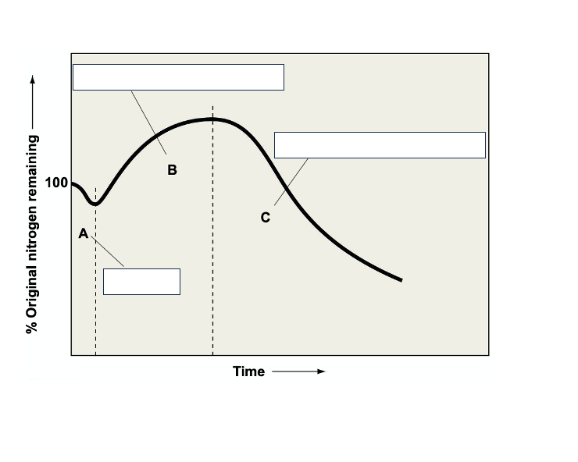
Answer: A: N leaching; B: N immobilization > N mineralisation; C: Immobilisation < mineralisation (3 points)
Leaching: nitrogen in the litter declines as water-soluble compounds are leached out; leaching is generally very short and depends on soil moisture in terrestrial environments. (2.5 points)
Immobilization greater than mineralization: Nitrogen content increases as microbial decomposers immobilize nitrogen from outside the litter; it can exceed 100 percent. As plant material is consumed, nitrogen is immobilized to meet the demands of the decomposers. The C/N ratio declines, hence there is more N than C. (2 points)
Mineralization greater than immobilization. As decomposition proceeds, carbon quality declines because of increasing proportion of lignin. Net release of nitrogen to the soil or water to keep the balance of C to N. (2 points)

- Question: We have perturbed the natural carbon cycle. What is the average anthropogenic CO₂ emission flux (in C) per year? What is the fate of this anthropogenic CO2, and name one of its major impacts that is of planetary relevance.

Answer:
Emission flux: 9.4 Gt C /y. (2 points)
Assimilation by terrestrial vegetation: 3.2 Gt C /y. (2 points)
Sequestration by oceans: 2.4 Gt C /y. (2 points)
Accumulation in atmosphere: 4.7 Gt C /y. (2 points)
Global warming/climate change (2 points)

