Protocol to measure EPR spectra of TEMPO as a function of the addition of ascorbic acid.

Physical principle: EPR measures the resonance signal given by the electronic spin of unpaired electrons. In this experiment, the organic radical TEMPO gives an EPR signal, which can be quantified as function of the amount of added ascorbic acid (which is thought to reduce the radical).

Experimental design: carry out a series of EPR measurements on samples with progressively more ascorbic acid.

The experiment will use a Bruker EMX nano EPR spectrometer. Samples are held in quartz EPR tubes, of 3 mm outside diameter, with a sample volume of 30 μl.

Basic information:
M(TEMPO)= 156.25 g/mol, M(ascorbic acid)= 176.124 g/mol, ρ(D₂O)= 1.11 g/cm³

Step 1:
Preparation of a ~2.5mM solution of TEMPO in H₂O:
Weigh about 40 mg of TEMPO, dissolve in about 1 mL of deionised H₂O then dilute to 10 mL in a volumetric flask. Then take 1 mL, dilute to 10 mL again. The exact concentration of the resulting solution is

$c_{T}=\frac{m_{T}}{M_{T}V}×\frac{1}{10}=0.064{ m}_{T}$(mM)

Preparation of a ~25mM solution of ascorbic acid:
Weigh about 44 mg of ascorbic acid, dissolve in about 1 mL of H₂O then dilute to 10 mL in a volumetric flask.

$c_{A}=\frac{m_{A}}{M_{A}V}=0.57{ m}_{T}$(mM)

Step 2:
EPR Measurement
Add about 40 μL of TEMPO solution to the EPR tube to add 1 μmol TEMPO to the sample. Measure the EPR field sweep spectrum of this sample. Adjust the sweep rate, the magnetic field position and the microwave power, under supervision from the TA.

Step 3: EPR Titration
Add approximately 0.4 μL ascorbic acid solution using a micropipette, and record an EPR spectrum. Continue to add aliquots of ascorbic acid in 9 steps and record EPR spectrum at each step until 2.2 equivalents of ascorbic acid have been added (corresponding to a 2.2 x excess).

Number of Experiment | V_{A} | Total V_{A} | Total n_{A} (1μmol)
1 |  |  | 0.1
2 |  |  | 0.2
3 |  |  | 0.3
4 |  |  | 0.5
5 |  |  | 0.7
6 |  |  | 1.0
7 |  |  | 1.4
8 |  |  | 1.8
9 |  |  | 2.2

Step 4. Recover the data in a format that can be used for further processing and analysis.

Step 5. Tidy up, clean any glassware used. Dispose of any waste materials. Leave the spectrometer in standby.

Identification of Hazards: Ascorbic acid presents no significant hazard. TEMPO is corrosive: wear protective gloves (see screenshot of MSDS). Cutting risk when handling quartz EPR tube.
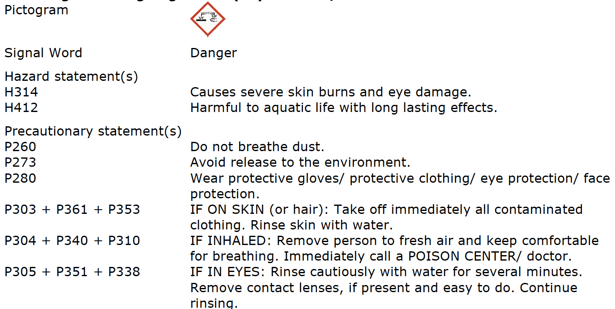

Relevant references:
“Electron Paramagnetic Resonance: A Practitioner's Toolkit,” M. Brustolon, E. Giamello, Eds, John Wiley & Sons, 2008.

