Protein Design Project
  - WEEK 3
This exercise session aims to immerse you in the exploration of dynamics and conformational selectivity in protein design. But what is conformational selectivity in protein design? Simply put, it’s performing protein design by taking into consideration that the interaction between a ligand and its partner involves movement, and therefore “exploration” of different conformations of the ensemble. Keep in mind that proteins (and ligands) are not statues, but rather active biological entities that constantly “move”!

For this, we will slightly shift gears and focus on a different receptor, namely the chemokine receptor CXCR4. We will refer to a recently published paper: https://doi.org/10.1038/s41467-023-38491-9. We will delve into the dynamic interaction between CXCR4 and a flexible peptide derived from the chemokine CXCL12. Upon sensing its native ligand CXCL12, CXCR4 regulates important physiological functions, including cell chemotaxis.

However, the structural details of the interaction between CXCR4 and CXCL12 remain largely unknown. Molecular recognition between flexible peptide and signaling receptors likely involves significant structural rearrangements of both molecules through conformational selection and induced fit effects. Consequently, modelling the structure of the receptor-peptide complex requires exploring a vast conformational binding space. Therefore, the goal of this exercise session is to model the binding between different poses of a flexible peptide and the structure of the receptor, with the long-term goal of using these models as starting points for protein design, similar to what has been done in the previous exercise sessions.

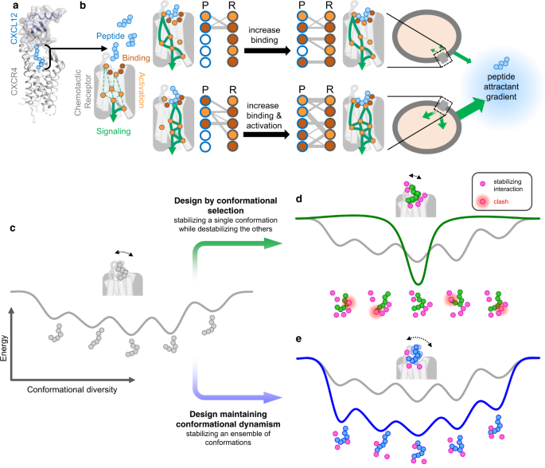

Project guidelines
Suppose you've utilized a Deep Learning-based computational approach, which considers the vast conformational binding space, to generate 5 PDB files depicting potential models of the receptor-peptide interaction. Today's objective is to conduct a structural analysis of these PDB files, focusing on the interface between the receptor and the various binding poses of the flexible peptide within the receptor's pocket. This analysis aims to determine which models are suitable for protein design purposes, and which ones should be discarded due to unfavorable interactions or steric clashes.

Task 1: Utilizing PyMOL, open all 5 PDB files named "Model_n.pdb" simultaneously and align them. Focus on the positioning of the peptide within the receptor's binding pocket, and try to discern the primary differences among the models with regards to the binding poses of the peptide.

Task 2: Examine the interface between the receptor and the peptide for each individual model. Assess how well the peptide fits into the binding pocket, and explore the nature of stabilizing and destabilizing amino acid interactions occurring within a 5 Å distance between the residues of the receptor and the peptide (if needed, refer back to the PyMOL introduction for guidance on how to perform these analyses). Pay close attention to potential steric clashes between the receptor and the peptide, as these could dramatically increase the interface energy and significantly compromise the reliability of the model for protein design purposes.

Task 3: Utilizing the provided energy landscape representing the interface energy between CXCR4 and the peptide across various binding poses for the analyzed models, fill in the blanks by matching each model with the corresponding energy scores.
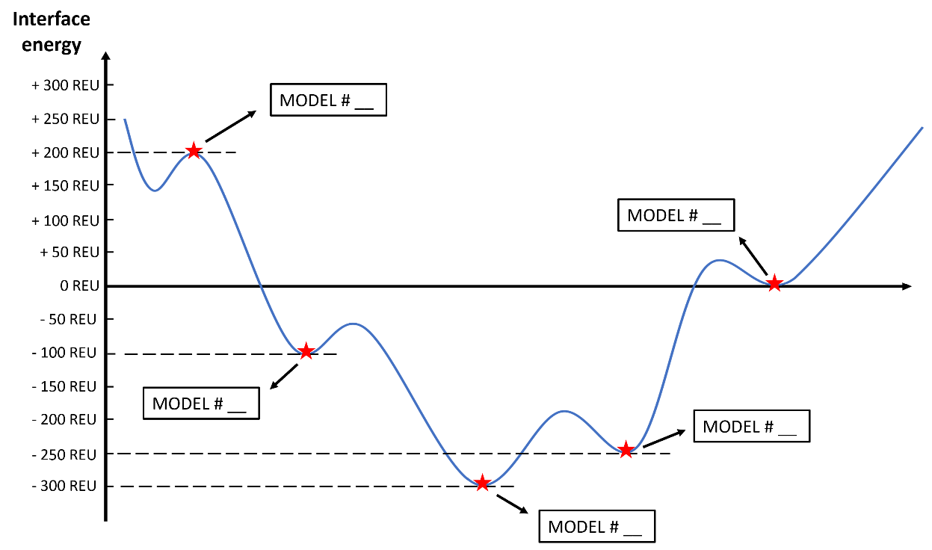
Discuss your choices and clearly state why you think that certain models of CXCR4-peptide pairs exhibit positive or negative interface energy scores. Explain how the peptide fits in the binding pocket, the nature of interactions observed, and how steric clashes support your conclusions.

