Designing proteins with therapeutic applications

1) Background

In the previous exercise sessions you were introduced to G-protein coupled receptors (GPCRs), and you have assessed how they can bind their ligands. You have seen that GPCRs can control crucial cellular functions such as chemotaxis, enabling cells to travel along a chemical gradient. Besides GPCRs, other cell-surface receptors such as ion- or voltage-gated channels or single-pass transmembrane proteins (Figure 1A) enable cells to sense and respond to various molecules in their environment. While these receptors fulfill important biological roles, they can also be hijacked by “non-native” molecules, causing disease. For example, toxin components of snake venom can bind to and block ion channels, resulting in neurotoxic effects (Fig. 1B). Alternatively, various viruses can target cell surface receptors as a means of infecting cells (Fig. 1C). Furthermore, cancer cells can hijack native receptor-ligand signaling pathways (such as PD-1:PD-L1) to avoid being killed by T-cells (Fig. 1D).

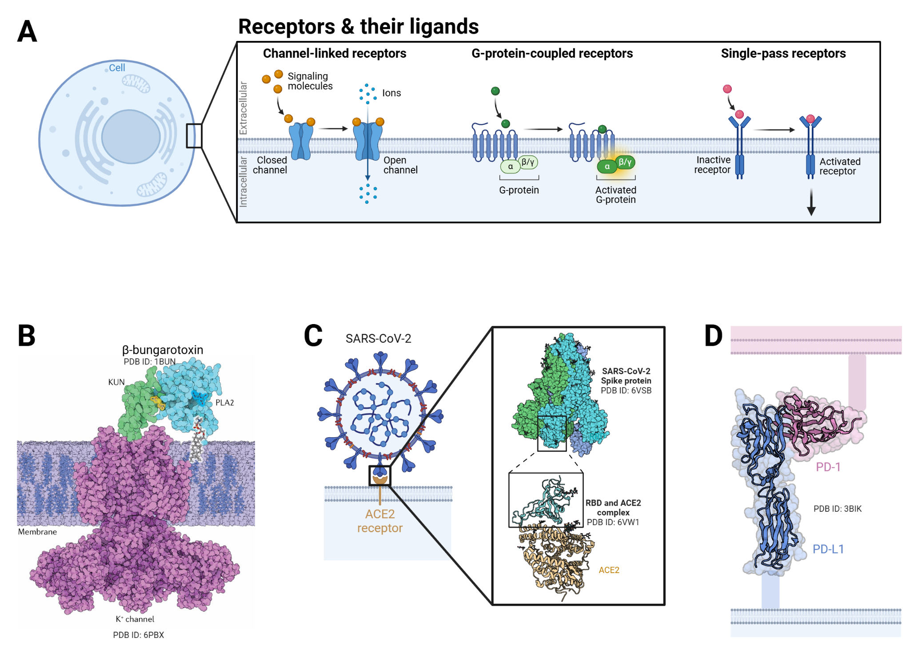
Figure 1. Cell surface receptors enable cells to respond to various ligands in their environment. A) Different receptor families such as ion- or voltage-gated channels, G-protein coupled receptors (GPCRs) or single-pass transmembrane receptors mediate cellular signaling in response to ligand binding. While these receptors play crucial roles in healthy cells, they can also be hijacked by non-native “ligands”. For example B) Snake toxins can bind to and block signaling of ion channels or other targets. C) Viruses such as SARS-CoV-2 bind to cell surface receptors such as ACE2, enabling them to infect cells. D) Cancer cells exploit the PD-1:PD-L1 signaling axis to avoid killing by T-cells. The figure from panel B was modified from Oliveira et. al. 2022 figure 2 https://doi.org/10.1038/s41570-022-00393-7.
Importantly, all these undesirable effects are mediated by protein-protein interactions (PPIs).
Therefore, disrupting these undesired PPIs would have important therapeutic applications. Related to this, the recent advances in de novo protein design have paved the way for designing new PPIs. By designing “mini-binders” it has become possible to target specific sites on a protein (Fig. 2A), thereby preventing (or enabling) binding to other proteins (i.e. through steric exclusion if mini-binder and ligand target the same site).
Alternatively, it is also possible to graft a functional motif (i.e. important for interacting with a specific protein or molecule) onto a de novo designed scaffold in what’s referred to as motif scaffolding (Fig. 2B).

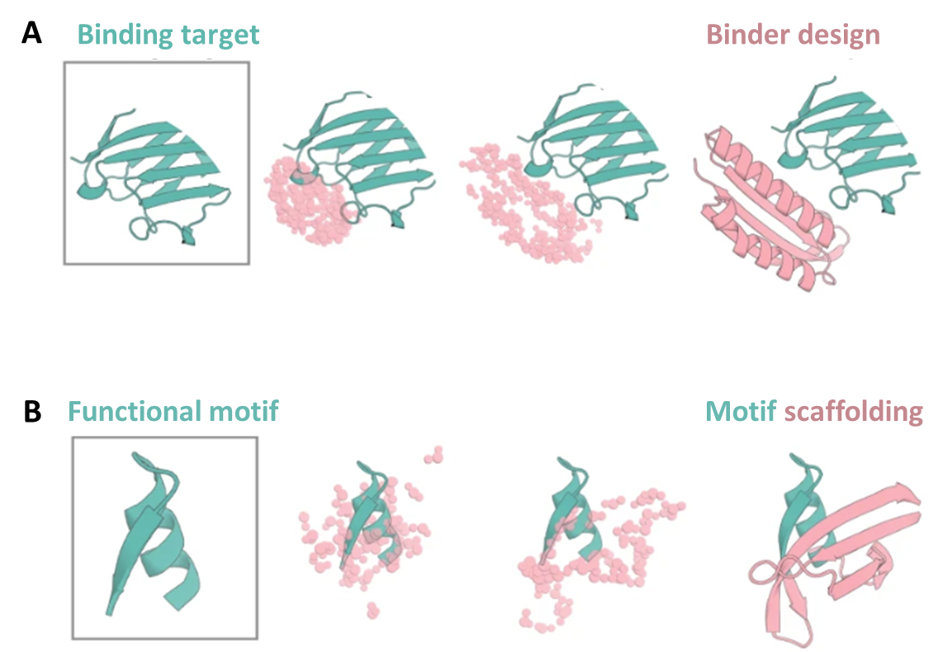
Figure 2. Using RFdiffusion for protein design. A) RFdiffusion can be used to design a binder targeting a target of interest or B) graft a functional motif into a new backbone. This figure was modified from Watson et al. 2023 https://doi.org/10.1038/s41586-023-06415-8 .

2) Project guidelines

In this project, you will gain hands-on experience with state-of-the-art Deep Learning tools such as RFdiffusion, proteinMPNN & AlphaFold and apply them to design novel proteins with potential therapeutic applications. Your task will be to select a target for which you will apply the pipeline mentioned above. To get you started, below are some broad categories for potentially interesting targets.

2.1) Potential targets
These are suggested challenges, but participants are encouraged to explore their own ideas!

- De novo design an inhibitor for lethal snake venom toxins
The goal is to design a protein inhibitor capable of binding and neutralizing lethal snake venom toxins as a treatment for venomous snake bites. Approach: utilize structural data to design a complementary binding interface that prevents the toxin from interacting with its human target.
Example: https://www.nature.com/articles/s41586-024-08393-x

- De novo design an inhibitor for human viruses
The goal is to create a small de novo protein that binds to a viral protein, disrupting its interaction with the human receptor and preventing viral entry. Approach: Design a high-affinity interface that either mimics the human target or destabilizes the viral protein conformation needed for virus entry.
Example: https://www.science.org/doi/10.1126/science.abd9909

- De novo design a peptide agonist or antagonist for a membrane receptor
The goal is to engineer a small peptide that locks a membrane receptor in either its active or inactive conformation. Approach: Design a peptide with high-affinity interactions favoring one receptor conformation over the other.
Example: https://doi.org/10.3389/fbioe.2021.694100

- De novo design a scaffold capable of binding to multiple targets
The goal is to use the Motif Scaffolding application of RFdiffusion to de novo design a scaffold capable of binding two distinct targets. Approach: Identify a biologically relevant application where a single scaffold connecting two functional domains could be therapeutically useful.
Example: https://www.biorxiv.org/content/10.1101/2024.05.07.592871v1.full

2.2) Running the de novo protein design pipeline

- Choose your target of interest
- Find a suitable structure of your target, for example from RCSB.
- Carefully study the structure and identify i.e. the receptor-ligand binding interface.
- Use your structure as an input for the RFdiffusion - proteinMPNN - AlphaFold Pipeline to create your designs
  - Assess the quality of your designs
    - Is AlphaFold confident in the predicted structures?
    - Does the design bind where you expected it? What is the quality of the binder-target interface?
    - …
  - You may need multiple iterations of refinement before obtaining designs that fulfill the desired criteria.
  - Some recommended analytical tools for validation:
    - Getcontacts: Identify and analyze interactions at the binding interface (https://getcontacts.github.io/)
    - ROSIE: Rosetta Online Server that offers several Rosetta applications through a simple web interface, such as energy score calculation, relax and docking (https://rosie.rosettacommons.org/)
    - PDBePISA: Evaluate protein-protein interactions and complex stability (https://www.ebi.ac.uk/pdbe/pisa/)

3) The Deliverables
📄 Report (3-4 pages, excluding figures)
🎤 Presentation (10 min)
This section enlists some important guidelines to be followed for the de novo design project which all the students are supposed to complete by the end of three weeks starting from 20.03.2025. The project will be mainly graded on two given criteria.
- Group presentations (scheduled: 09:00 on 10th April 2025) 10% of total grade
- Individual Reports (Submission by: 23:59 on 1st May 2025) 20% of total grade

Given below are the general guidelines and instructions that need to be referred to while preparing the presentations and reports,

3.1) Guidelines for Group Presentations:
- Maximum duration: 10 minutes per group
- Maximum number of slides: 10
- The presentation can be made around the following sections:
  - Title of the project, names of group members
  - Clear rationale and biological relevance of the chosen target
  - Overview of the pipeline used
  - Results
  - Strengths and weaknesses of your current pipeline
  - Conclusions and future perspectives

Note: Each member of the group would be awarded the same grade based on how well the presentation fits and justifies the above criteria.
3.2) Guidelines for Individual Report:
- Maximum Page count: 3-4 pages, excluding figures & references.
- Times New Roman, font size: 12, line spacing: 1.5
- The individual reports can be written around the following sections:
  - Introduction:
    - Briefly summarize the aim of the project
    - Brief explanation of the biological relevance of the problem being addressed
    - Justification of the choice of targets and design methods
  - Methods: Explanation of the design pipeline and scoring methods used to generate designs and analyze their quality.
  - Results:
    - Diagrams and figures properly annotated and captioned
    - Justifications of designs generated, accepted and rejected based on your criteria.
  - Discussion:
    - Conclusions (whether the aim was achieved)
    - The strengths and weaknesses of the current pipeline
    - Future perspectives (improvement of current pipeline)
    - Potential applications

Please note:
Each report must be personal and original. While collaboration is encouraged, every participant is expected to provide unique insights and independent analyses. Reports from the same team should not be largely identical; make sure your discussion, interpretations, and conclusions reflect your own perspective and reasoning.

