Exercises Biol-480 “Neuroscience I” week 3 (23.09.24)

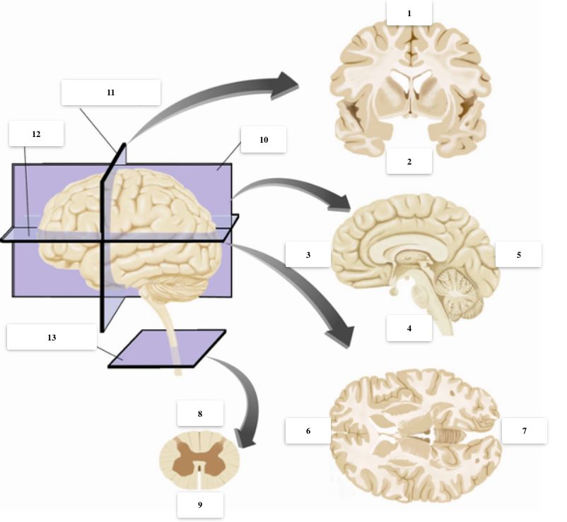

1) Name the different labels above, including cutting planes, axis and relative positions in the brain sections.
1. Dorsal 6. Anterior 11. Coronal/Frontal plane
2. Ventral 7. Posterior 12. Horizontal plane
3. Anterior 8. Dorsal/Posterior 13. Cross-section
4. Ventral/Caudal 9. Ventral/Anterior
5. Posterior 10. Mid-Sagital plane

2) Identify at least 3 CNS structures in the sections above, and name the primary and secondary brain vesicles from which they derive.
Cerebral cortex: prosencephalon (forebrain) and telencephalic vesicle
Thalamus: prosencephalon (forebrain) and diencephalic vesicle
Cerebellum: Rhombencephalon (hindbrain) and metencephalic vesicle

3) From which germ layer does the CNS derive? Name at least 4 morphogenes and indicate the positional information they provide to the neural tube

The CNS derives from the ectoderm. Four morphogenes are:
BMPs – dorsal information
Shh – ventral information
Cerberus – anterior (rostral) information
Wnt, FGFs or retinoic acid – posterior (caudal) information

4) Order chronologically these developmental processes:

Formation of the diencephalic vesicle – induction of neural plate – gastrulation – activity-dependent apoptosis of motoneurons – formation of lower cortical layers – formation of forebrain (or prosencephalic) vesicle – peak of oligodendrogliogenesis – formation of the notochord

Gastrulation – Formation of the notochord – Induction of neural plate – formation of forebrain (or prosencephalic) vesicle – formation of diencephalic vesicle – formation of lower cortical layers – activity-dependent apoptosis of motoneurons – peak of oligodendrogliogenesis

5) How many layers does the neocortex have? What is the pattern of layering in the mammalian cortex? What molecule is the responsible for this?

Neocortex has 6 layers. Cortical layers form in an inside-out manner, with lower layers being formed first and upper layer being formed afterwards. Neuroblasts migrate radially towards the basal side of the telencephalon, using the processes of radial glia cells, and attracted by the gradient of reelin secreted by Cajal-Retzius cells

6) Neurexin is one of the susceptibility genes for autism spectrum disorder (ASD). Could you design an experiment to test a causal role of neurexin mutations in the development of this disease?

Sequencing of human patients to identity mutations in the neurexin gene, followed by expression of the mutated form in the mouse embryo via in utero electroporation and evaluation of behavioural phenotype (social interaction test), glutamatergic signaling, etc.

