Exercises Biol-480 “Neuroepigenetics I” 25/11/2024

Exercise 1: True or False?
Decide whether the following statements are true or false. If false, explain why.
- Epigenetic mechanisms influence the genetic code and not gene expression.
- Histone acetylation facilitates gene transcription.
- Epigenetic changes are permanent and cannot be reversed.
Exercise 2: Epigenetic mechanisms in memory
In your own words, explain:
- How does acetylation affect chromatin structure and gene expression?
- What role do Histone Acetyl Transferases (HATs) and Histone Deacetylases (HDACs) play in this process?
Exercise 3: Epigenetic regulation of the glucocorticoid receptor by childhood abuse
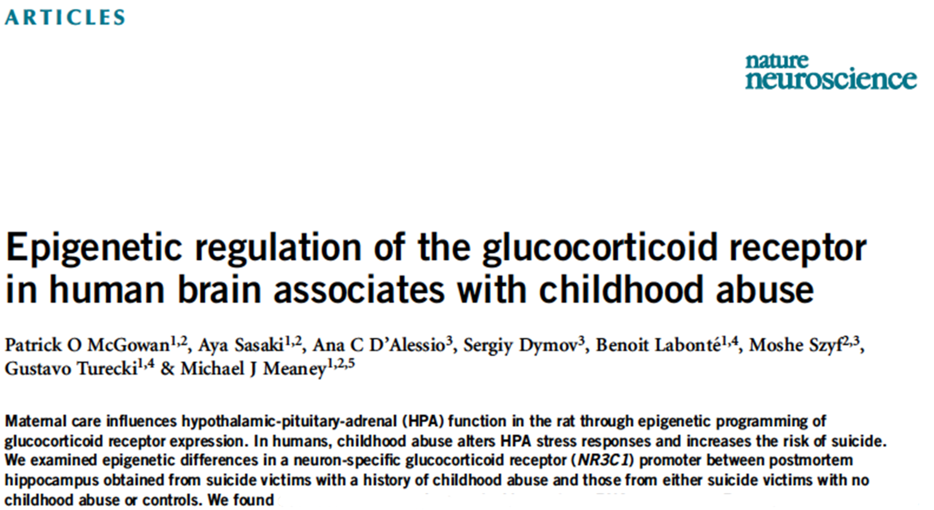
Consider the following article published in Nature Neuroscience in 2009:

- What epigenetic difference do you expect in the promoter region of the glucocorticoid receptor between suicide victims with a history of childhood abuse and suicide victims with no history of childhood abuse? Name at least one, and its effect on gene transcription. (2 points)
- What difference do you expect in terms of glucocorticoid receptor gene transcription between these two groups? In other words, is the glucocorticoid receptor gene expression increased or decreased? (1 point)
- How can you measure the expression of the glucocorticoid receptor gene in human postmortem samples? Name at least one technique. (1 point)
- How does an increased/decreased level of glucocorticoid receptor influence the level of circulating glucocorticoids and thus the person’s stress response? (2 points).

