Exercises Biol-480 “Neuroscience I” week 3 (23.09.24)

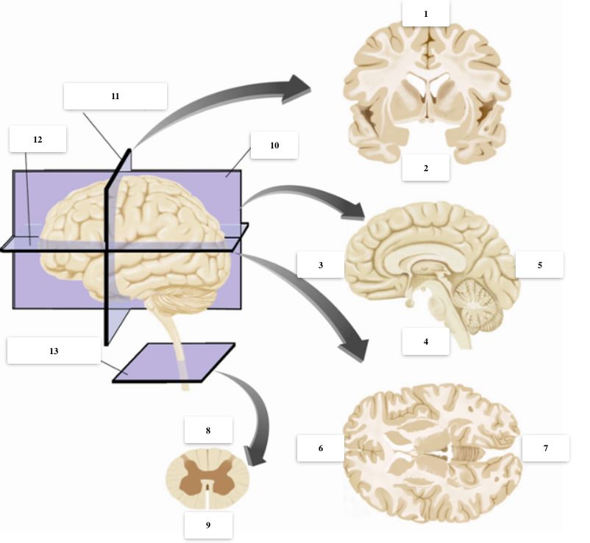

1) Name the different labels above, including cutting planes, axis and relative positions in the brain sections.

2) Identify at least 3 CNS structures in the sections above, and name the primary and secondary brain vesicles from which they derive.

3) From which germ layer does the CNS derive? Name at least 4 morphogenes and indicate the positional information they provide to the neural tube

4) Order chronologically these developmental processes:

Formation of the diencephalic vesicle – induction of neural plate – gastrulation – activity-dependent apoptosis of motoneurons – formation of lower cortical layers – formation of forebrain (or prosencephalic) vesicle – peak of oligodendrogliogenesis – formation of the notochord

5) How many layers does the neocortex have? What is the pattern of layering in the mammalian cortex? What molecule is the responsible for this?

6) Neurexin is one of the susceptibility genes for autism spectrum disorder (ASD). Could you design and experiment to test a causal role of neurexin mutations in the development of this disease?

