EXERCISE 1 "GLOBAL NITROGEN CYCLE AND METABOLIC SYMBIOSIS"

Imagine a microbe that can perform a two-electron transfer reaction between the redox couples NO₂–/NH₃ (E₀' +0.34 V) and ½O₂/H₂O (E₀' +0.82 V).

1. Which molecule is the electron donor? Explain.

2. Which molecule is the electron acceptor? Explain.

3. Write out the Nernst equation relating Gibbs free energy to the difference in reduction potential of an electron donor and an electron acceptor (redox pair) in a redox reaction. Define each term. Make sure you include the correct units, not just the numbers, in your calculations. Not including units was a source of many mistakes on the previous exams.

4. Calculate the amount of free energy liberated in the two-electron-transfer reaction between these redox couples. Show your work.

5. Do you think this organism performs nitrification or denitrification? Do you think this organism lives in aerobic or anaerobic environments? Explain.

EXERCISE 2 "GLOBAL NITROGEN CYCLE AND METABOLIC SYMBIOSIS"

Imagine a microbe that can perform a two-electron transfer reaction between the redox couples NO₂–/NO (E₀' +1.20 V) and N₂O/N₂ (E₀' +1.77 V).

1. Which molecule is the electron donor? Explain.

2. Which molecule is the electron acceptor? Explain.

3. Calculate the amount of free energy liberated in the two-electron-transfer reaction between these redox couples. Show your work.

4. Do you think this organism performs nitrification or denitrification? Do you think this organism lives in aerobic or anaerobic environments? Explain.

5. On a different subject: what chemical transformation do “annamox” bacteria carry out? Why is this transformation important ecologically?

EXERCISE 3 "GLOBAL NITROGEN CYCLE AND METABOLIC SYMBIOSIS"

As depicted in the diagram, some species of cyanobacteria grow in linear chains consisting of two distinct cell types: vegetative cells (in green) and heterocyst cells (in brown).
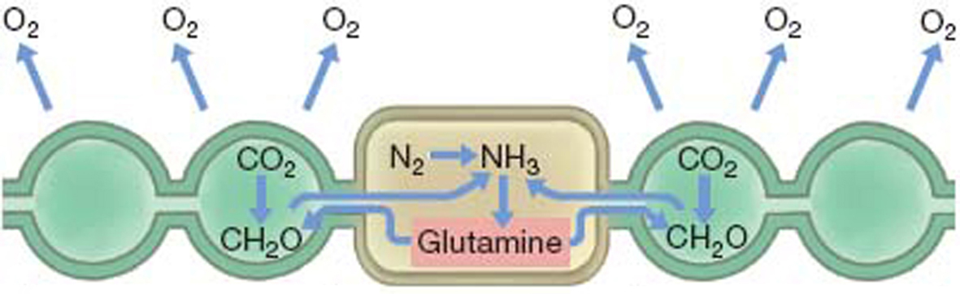

1. What is the metabolic function of vegetative cells?

2. What is the metabolic function of heterocyst cells?

3. What are the signals that cause vegetative cells to differentiate into heterocyst cells?

4. What changes must a vegetative cell undergo in order to become a heterocyst?

5. Why are both types of cells necessary for survival of the organism?

EXERCISE 4 "GLOBAL NITROGEN CYCLE AND METABOLIC SYMBIOSIS"

Some species of cyanobacteria grow in linear chains consisting of two distinct cell types: vegetative cells and heterocyst cells. The diagram illustrates how a chain of vegetative cells (Step 1) can differentiate into a mixed chain of vegetative cells (in green) with heterocyst cells (in brown) interspersed at regular intervals. Explain what is happening at each step of the differentiation process (steps 1-6).
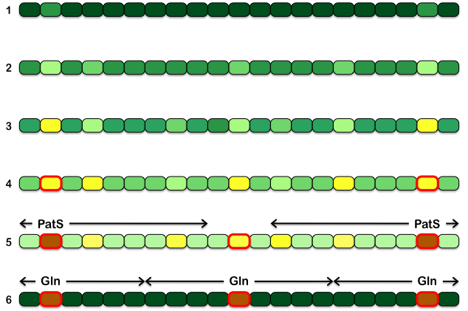

1. Step 2:

2. Step 3:

3. Step 4:

4. Step 5:

5. Step 6:

EXERCISE 5 "GLOBAL NITROGEN CYCLE AND METABOLIC SYMBIOSIS"

Imagine a species of cyanobacteria with an average spacing of 7 vegetative cells (V, in green) between heterocyst cells (H, in brown), which means that the average frequency of heterocyst cells is 1 in 8 (1 heterocyst per 7 vegetative cells). Imagine that one cell in the chain has already become a heterocyst cell, as depicted in the diagram (for simplicity, we ignore vegetative cells on the other side of the heterocyst cell).

1. In a chain of wild-type bacteria, which cell is most likely to become the next heterocyst (H): cell V4 or cell V8 or are they equally likely? Explain.

2. In a chain of patS mutant (loss-of-function) bacteria, which cell is most likely to become the next heterocyst: cell V4 or cell V8 or are they equally likely? Explain.

3. If differentiation of vegetative cells into heterocyst cells is a completely random process, what is the probability that cell V5 will become a heterocyst cell?

4. If differentiation of vegetative cells into heterocyst cells is a completely random process, what is the probability that cell V5 will become the next heterocyst cell?

5. If you engineer a strain of cyanobacteria to overproduce PatS, would the average number of vegetative cells between heterocyst cells increase or decrease? Explain.

EXERCISE 6 "GLOBAL NITROGEN CYCLE AND METABOLIC SYMBIOSIS"

Coral polyps harbor two distinct types of symbionts: cyanobacteria (which are prokaryotic) in the polyp epiderm and zooxanthellae (which are eukaryotic) in the polyp gastroderm.
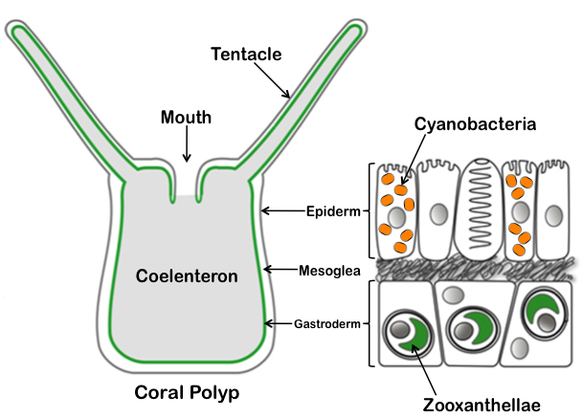

1. Would you classify these symbionts as parasites, commensals, or mutualists? Explain.

2. Would you classify these symbionts as epibiotic or endobiotic? Explain.

3. What is the specific metabolic role of each symbiont? Explain.

4. Which symbiont is active during the day? Explain why.

5. Which symbiont is active during the night? Explain why.

