EXERCISE 1 "BIOMECHANICS OF THE BACTERIAL CYTOSKELETON" :

Bacterial actin-like proteins (like MreB) self-assemble into dynamic filaments that can grow at both ends, shrink at both ends, or treadmill.

1. At low concentrations of ATP-MreB:
MreB filaments grow at the plus end and grow at the minus end.
MreB filaments shrink at the plus end and grow at the minus end.
MreB filaments grow at the plus end and shrink at the minus end.
MreB filaments shrink at the plus end and shrink at the minus end.
Explain your answer:

2. At high concentrations of ATP-MreB:
MreB filaments grow at the plus end and grow at the minus end.
MreB filaments shrink at the plus end and grow at the minus end.
MreB filaments grow at the plus end and shrink at the minus end.
MreB filaments shrink at the plus end and shrink at the minus end.
Explain your answer:

3. At intermediate concentrations of ATP-MreB:
MreB filaments grow at the plus end and grow at the minus end.
MreB filaments shrink at the plus end and grow at the minus end.
MreB filaments grow at the plus end and shrink at the minus end.
MreB filaments shrink at the plus end and shrink at the minus end.
Explain your answer:

4. Bacterial actin-like proteins (like MreB) have intrinsic ATPase activity. Imagine an MreB “hypomorph” mutation that decreases its ATPase activity. At intermediate concentrations:
A hypomorph MreB would form shorter filaments than wild-type MreB.
A hypomorph MreB would form longer filaments than wild-type MreB.
A hypomorph MreB would form filaments equally long as wild-type MreB.
Explain your answer:

5. Bacterial actin-like proteins (like MreB) have intrinsic ATPase activity. Imagine an MreB “hypermorph” mutation that increases its ATPase activity. At intermediate concentrations:
A hypermorph MreB would form shorter filaments than wild-type MreB.
A hypermorph MreB would form longer filaments than wild-type MreB.
A hypermorph MreB would form filaments equally long as wild-type MreB.
Explain your answer:

EXERCISE 2 "BIOMECHANICS OF THE BACTERIAL CYTOSKELETON" :

Cytoskeletal proteins contribute to the biomechanical properties of bacterial cells. The graphs (below) depict the stress-strain curves for two different cells: cell (a) and cell (b). Assume that the scales of the x-axis and y-axis are the same for both graphs.
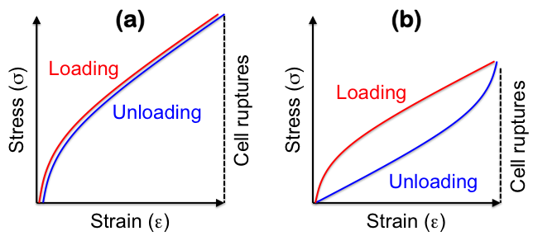

1. Write the formula for Stress (σ). Write the formula for Strain (ε). Define the terms.

2. Which cell is stiffer?
Cell (a) is stiffer than cell (b).
Cell (b) is stiffer than cell (a).
Cell (a) and cell (b) are equally stiff.
Impossible to tell from these graphs.
Explain your answer:

3. Which cell is more extensible?
Cell (a) is more extensible than cell (b).
Cell (b) is more extensible than cell (a).
Cell (a) and cell (b) are equally extensible.
Impossible to tell from these graphs.
Explain your answer:

4. Which cell is stronger?
Cell (a) is stronger than cell (b).
Cell (b) is stronger than cell (a).
Cell (a) and cell (b) are equally strong.
Impossible to tell from these graphs.
Explain your answer:

5. Which cell is more resilient?
Cell (a) is more resilient than cell (b).
Cell (b) is more resilient than cell (a).
Cell (a) and cell (b) are equally resilient.
Impossible to tell from these graphs.
Explain your answer:

EXERCISE 3 "BIOMECHANICS OF THE BACTERIAL CYTOSKELETON" :

The “Minicell” (Min) system functions to ensure that the “FtsZ ring” assembles at the middle of the cell (along the longitudinal axis) with the ring oriented along the cell’s short axis.

1. The Min system comprises three proteins: MinC, MinD, and MinE. Briefly describe the function of each of these proteins.

2. Explain how the components of the Min system work together to localize the FtsZ ring at midcell.

3. Imagine a bacterial cell treated with a drug that depletes the MinCDE proteins. What phenotype would you predict for the MinCDE-depleted cell?

4. Imagine a bacterial cell treated with a drug that depletes the FtsZ protein. What phenotype would you predict for the FtsZ-depleted cell?

5. The FtsZ protein forms dynamic filaments that “treadmill” around the short axis of the bacterial cell. Explain: what is “treadmilling” and how does it work?

EXERCISE 4 "BIOMECHANICS OF THE BACTERIAL CYTOSKELETON" :

1. In solid objects under stress, formation and propagation of cracks is the primary cause of material failure. Explain why.

2. Intermediate filament proteins form “coiled coils”. Explain: what is the overall structure of a “coiled coil”?

3. Intermediate filament proteins form “coiled coils”. Explain: what drives the formation of “coiled coils”?

4. “Coiled coils” of intermediate filament proteins are highly extensible. Explain how this works.

5. Intermediate filaments form mesh-like networks that are resistant to crack propagation. Explain how this works.

