EXERCISE 1 "Biomechanics of the bacterial cell ENVELOPE" :

Imagine two spherical cells, one large and one small.

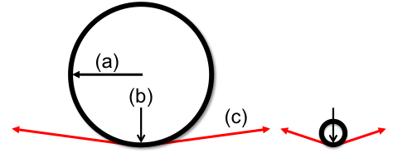

1. Write the equation for Laplace’s Law: __________________________ and define each term below, referring to the diagram above. Do not peek at the slides until you’ve made your best effort to write everything from memory!

(a) =
(b) =
(c) =

2. If the internal pressure is the same in both cells, then the cell wall tension:
A. Will be higher in the small cell.
B. Will be higher in the large cell.
C. Will be the same in both cells.
Explain your answer:

3. If the cell wall tension is the same in both cells, then the internal pressure:
A. Will be higher in the small cell.
B. Will be higher in the large cell.
C. Will be the same in both cells.
Explain your answer:

4. Starting from the same internal pressure, if the pressure is gradually increased then:
A. The small cell will rupture first.
B. The large cell will rupture first.
C. Both cells will rupture at the same time.
Explain your answer:

5. Imagine two cells with equal size (volume), a sphere-shaped cell and a cube-shaped cell. Starting from the same internal pressure, if the pressure is gradually increased then:
A. The sphere-shaped cell will rupture first.
B. The cube-shaped cell will rupture first.
C. Both cells will rupture at the same time.
Explain your answer:

EXERCISE 2 "BIOMECHANICS OF THE BACTERIAL CELL ENVELOPE" :

Here is a schematic diagram of a “generic” bacterial cell wall :
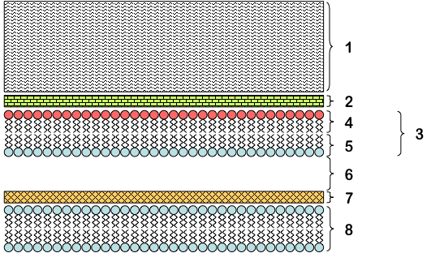

Identify each layer (1-8) and briefly state its biological function(s).

1. Name:
Function(s):

2. Name:
Function(s):

3. Name:
Function(s):

4. Name:
Function(s):

5. Name:
Function(s):

6. Name:
Function(s):

7. Name:
Function(s):

8. Name:
Function(s):

9. On the basis of the diagram, is this organism Gram-positive or Gram-negative?
Explain:

10. In class we discussed some mechanisms that layers #1 and #4 contribute to evasion of the host complement system.
Explain (layer #1):
Explain (layer #4):

EXERCISE 3 "Biomechanics of the bacterial cell ENVELOPE" :

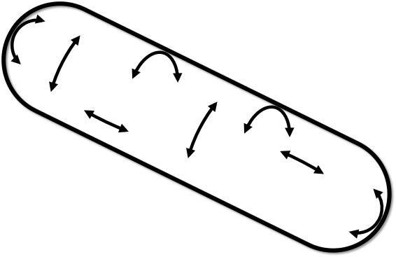
The schematic depicts the distribution of stresses in the bacterial cell wall under positive internal osmotic pressure:

1. Write the equations that describe cell wall stress in the same direction as the long axis of the cell: ___________ and in the same direction as the short axis of the cell: ___________ and define each term below. Do not peek at the slides until you’ve made your best effort to write everything from memory!

P =
r =
σ_{H} =
σ_{L} =
t =

2. Imagine a rod-shaped cell with no peptidoglycan in which internal pressure increases until the cell ruptures. The cell would rupture along:
A. Its short axis.
B. Its long axis.
C. Either axis with equal probability.
Explain:

3. In order to provide the best mechanical support against internal pressure, peptidoglycan cables should be oriented:
A. In the same direction as the short axis of the cell.
B. In the same direction as the long axis of the cell.
C. In the same direction as both axes of the cell (long and short).
D. Randomly.
Explain why:

4. If you increase the thickness of the cell wall while keeping the internal pressure the same, the tensile stress in the cell wall will:
A. Increase.
B. Decrease.
C. Stay the same.
Explain:

5. If the width (i.e., the length of the short axis) of a cell increases by 2-fold, the resistance of the cell to rupture caused by osmotic pressure will:
A. Increase by 2-fold.
B. Increase by 4-fold.
C. Decrease by 2-fold.
D. Decrease by 4-fold.
Explain:

