Question 1 "LIVING AT MICRO SCALE" :

Imagine two microorganisms with equal mass and volume but different shapes, (a) and (b):

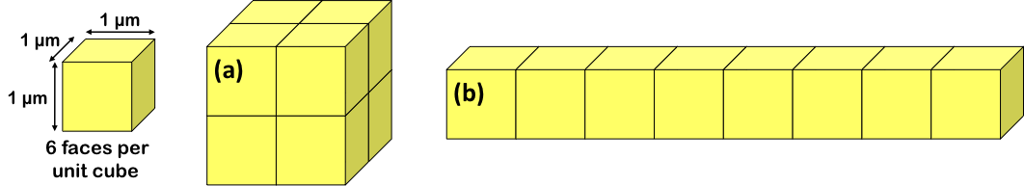

1. Which shape has the lower ratio of surface area to volume (S/V ratio)?
A. Shape (a).
B. Shape (b).
C. Shapes (a) and (b) have the same S/V ratio.
Explain your answer:

2. Which shape is better optimized to conserve internal heat (for example, heat generated by metabolic processes)?
A. Shape (a).
B. Shape (b).
C. Shapes (a) and (b) are equivalent with respect to conservation of internal heat.
Explain your answer:

3. Which shape is better optimized to promote rapid exchange of diffusible materials (for example, nutrients) between the outside and inside?
A. Shape (a).
B. Shape (b).
C. Shapes (a) and (b) are equivalent with respect to exchange of diffusible materials.
Explain your answer:

4. If cell (a) grows larger while keeping the same shape, how does the S/V ratio change?
A. As the cell grows larger the S/V ratio increases.
B. As the cell grows larger the S/V ratio decreases.
C. As the cell grows larger the S/V ratio stays the same.
Explain your answer:

5. If cell (b) “stretches” to get longer and thinner while keeping the same volume, how would the S/V ratio change?
A. As the cell stretches the S/V ratio increases.
B. As the cell stretches the S/V ratio decreases.
C. As the cell stretches the S/V ratio stays the same.
Explain your answer:

Question 2 "LIVING AT MICRO SCALE" :

1. Write the exponential growth rate equation: _____________ and define each term below. Do not peek at the slides until you’ve made your best effort to write everything from memory!

N =
N₀ =
e =
k =
t =
t_{d} =

2. Imagine a cell culture growing exponentially with a doubling time of 2.00 hours.
The culture’s growth rate constant is: _____
Show your work:

3. Imagine a cell culture growing exponentially with a growth rate constant of 1.40 per hour.
The culture’s doubling time is: _____
Show your work:

4. Imagine a cell culture growing exponentially with a doubling time of 2.00 hours.
Starting from one cell, how long would it take the culture to reach one million cells: _____
Show your work:

5. Imagine a cell culture growing exponentially with a growth rate constant of 1.40 per hour. Starting from one cell, how long would it take the culture to reach one million cells: _____
Show your work:

EXERCISE 3 "LIVING AT MICRO SCALE" :

Imagine a container filled with water and separated into two equal-volume compartments, (a) and (b), by a membrane that is permeable to water but impermeable to solutes.
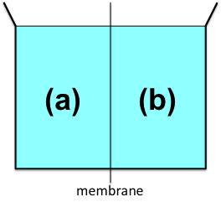

1. Write the equation for the van’t Hoff relation: ____________________ and define each term below. Do not peek at the slides until you’ve made your best effort to write everything from memory!

n =
P =
R =
T =
V =

2. If you add some solute to compartment (a), what happens?
A. The volume of water increases in compartment (a) and decreases in compartment (b).
B. The volume of water increases in compartment (b) and decreases in compartment (a).
C. The volume of water remains the same in both compartments.
Explain your answer:

3. If you add 0.2 moles (mol) of solute to compartment (a) with a volume (V) of one liter (0.001 m³) at 27°C (300°K), the resulting osmotic pressure (P) would be: __________
Show your work:

4. Imagine a bacterium surrounded by a rigid (non-elastic) cell wall that is water-permeable. If you put the bacterium in a container filled with pure distilled water:
A. The bacterium’s internal pressure increases.
B. The bacterium’s internal pressure decreases.
C. The bacterium’s internal pressure stays the same.
Explain your answer:

5. If you change the shape of a bacterium from sphere-shaped to cube-shaped while maintaining the same size (volume), what happens?
A. The bacterium’s internal pressure increases.
B. The bacterium’s internal pressure decreases.
C. The bacterium’s internal pressure stays the same.
Explain your answer:

