Spectrometer

1. Calibration
Show example pictures of your calibration for two different filters (e.g., 590 nm and 630 nm). Measure a wavelength calibration curve with a minimum of 4 points for the first and the second diffraction orders (for instance: 570 nm, 590 nm, 610 nm, 630 nm, 645 nm, wavelength versus position). Put it in the table below. Fit a second order polynomial and give the equation and plot the curves (two plots, calibration equations). Comment your results.

Picture1–
Filter: ….

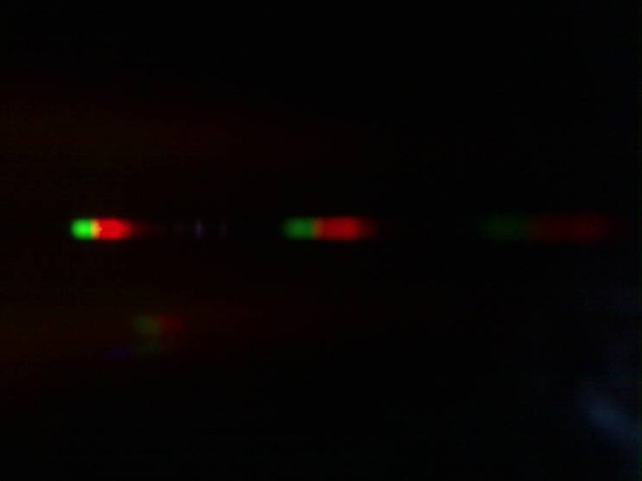
Picture 2
Filter: …

Measure a wavelength calibration curve with a minimum of 4 points for the first and the second diffraction order (for instance: 570 nm, 590 nm, 610 nm, 630 nm, 645 nm, wavelength versa position). Put it in a tabular form as shown (table).

Calibration wavelengths (nm) | First order edge position (pxl) | Second order edge position (pxl)
570
590
610
630
645
..

Give combined plot of your calibration

Graph 1–
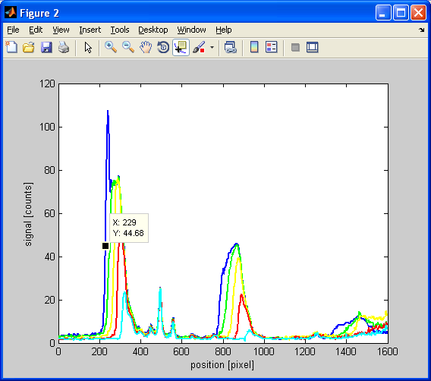

Fit a second order polynomial and give the equation and plot the curves (two plots, calibration equations).

Graph 2–
First order calibration plot

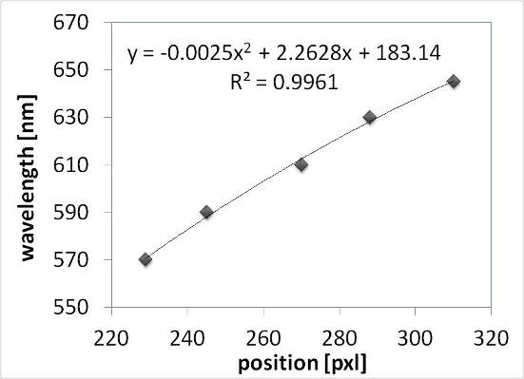
Graph 3–
Second order calibration plot

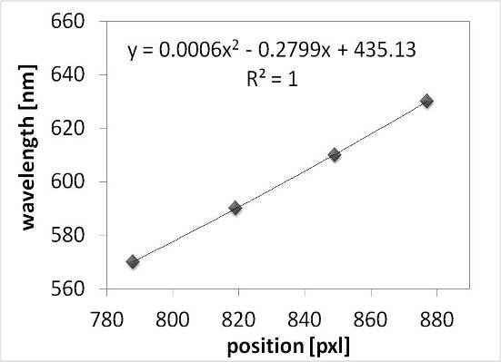

Calibration equation first order diffraction (y wavelength, x position in pxl)

y(wavelength) $= -0.0025 x^{2}+ 2.2628 x + 183.14$

Calibration equation second order diffraction (y wavelength, x position in pxl)

y(wavelength) = $0.0006 x^{2}+ 0.2799 x + 435.13$

Interpret your results and give the resolution (nm/pixel) of your spectrometer for the first and second diffraction orders.

2. Transmission of a band-pass filter
Show the spectra and the transmission measurement for the filter BG36 (two plots). Interpret the spectra with the help of the transmission line plot. Remember that transmission has values between one and zero. Compare the curve with the transmission of the filter as given by SCHOTT, comment and find similarities.

Graph 1–
Spectra (raw signal)

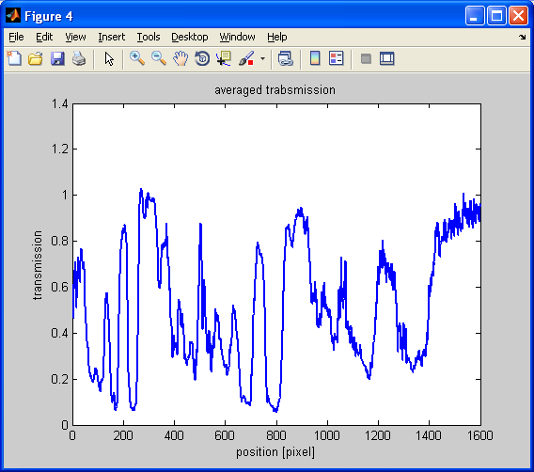
Graph 2–
Transmission

Graph 3– Transmission of BG36 for comparison
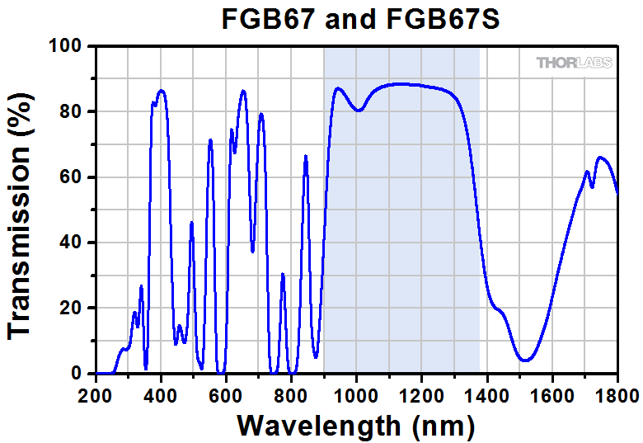

Discussion. Compare the curve with the transmission of the filter as given by SCHOTT (Graph as plotted above) and find similarities. Please note that the spectral range of our spectrometer is given by the NIR filter and limited between 400-700 nm!

3. Spectral measurement of an LED
Show images to document the evaluation (spectra, line plot and averaged line plot). Present a table that summarizes the spectral measurement for the first and second order: centre wavelength and spectral width (table).
Graph 1–
Spectra (raw signal)
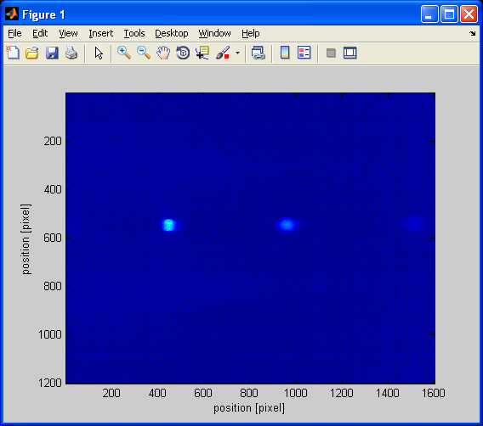
Graph 1–
Spectra (raw line plot)
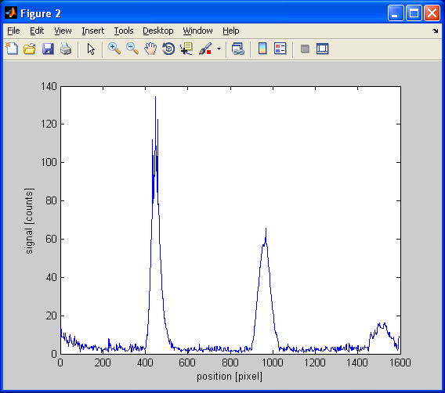
Graph 1–
Spectra (average line plot)
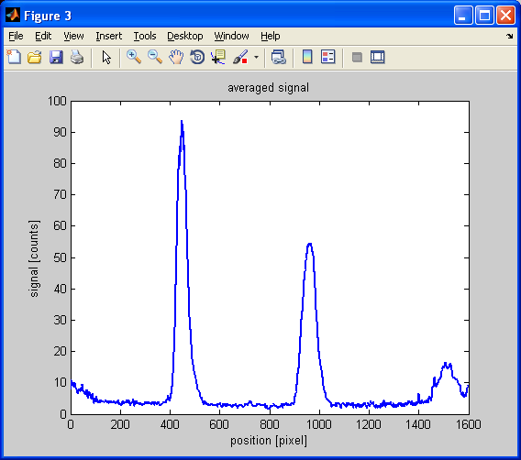

 | First order | FWHM | Second order | FWHM
peak position (pxl)
Wavelength (nm)

Compare with literature values and comment your results.

4. Example from the web
Search the web for a grating spectrometer, copy a photo of a sample spectrometer (not a spectra) in your report and note its spectral range and resolution (at this spectral range). Find out the operation principle (scanning or static) and write it down.

(Optional) Personal feedback:

Was the amount of work adequate?

What is difficult to understand?

What did you like about it?

How can we do better?

