Diffraction

1. Diffraction with a collimated beam setup and verification
Take pictures of the diffraction pattern for the 100 microns pinhole and 100 microns rectangle. Measure the distance from the diffracting object to the camera chip. Calculate the theoretical 2-dimensional diffraction pattern with Matlab and plot it next to the measured ones. Give your simulation parameters in the report.
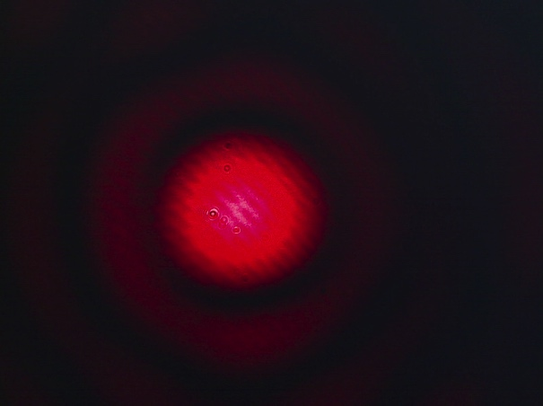

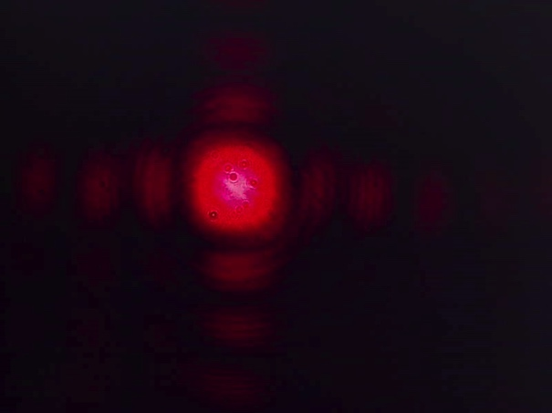

Simulation parameters

w (slit width) =

z (propagation distance)=

λ (wavelength)=

Comment about the quality of how measurements and simulations compare!

2. Fraunhofer diffraction and application of the Fourier transform
Take a picture of the diffraction pattern for the 100 microns slit, show an image of the pattern and center lines (raw and average data). Measure the distance of the slit to the camera chip. Simulate the diffraction pattern with Fraunhofer diffraction theory based on Fourier transforms using Matlab and plot the results next to the measured ones.


raw data single line averaged data
Calculate the Fresnel number for your experiment and write your simulation parameters in the report.
Fresnel number $N_{F}=\frac{w^{2}}{4λz}$

w =
z =

M (number of averages) =

NF =

With the help of the Fresnel number judge if the Fraunhofer approximation is valid in our case.

Is the Fraunhofer approximation valid? YES or NO

Present diffraction pattern line-plots and compare the position of minimum intensity for measurement and theory. Compare the first minimum of measured diffraction curve with theory.

For the slit we can use the analytical diffraction equation to verify our results. The zeros of intensity for the first order diffraction minima of a slit are given by the equation

$$\sin\left(θ\right)=\frac{λ}{W}$$

where θ is the diffraction angle, W is the slit width and λ is the wavelength.

In the experiment, the distance from the slit to the camera is z. On our camera image, the positions x of the minima are given by the relation $\tan{θ=\frac{x}{z}}$ and with the diffraction angle θ from above, we have
$$x=z\tan\left(θ\right)=z\tan\left(\arcsin\left(\frac{λ}{W}\right)\right)$$

Calculate the values for x and compare them with your measurement and simulation!

Comment about the quality how measurement and simulation compare!

3. Grating diffraction and Fourier transform
Present images of the measured diffracted intensity for each grating as shown below.

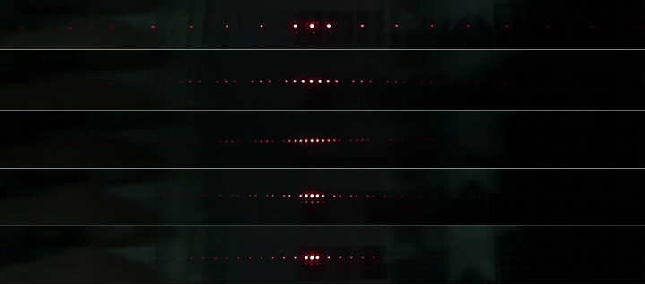

Simulate the diffraction patterns for the grating geometries and show your own simulation results similar to the one below for the following parameters:
(Λ=40μm, w=10 μm), (Λ=60μm, w=10 μm), (Λ=60μm, w=20 μm) and (Λ=60μm, w=30 μm)

(Λ=20μm, w=10 μm)

Explain what happens if you change the period of the grating at constant rectangle (slit) width. (one or two sentences)

Explain what happens if you change the rectangle (slit) width and keep the period of the grating constant. (one or two sentences)

Compare the measurements with simulations for two grating configurations and plot the figures.

Λ=40μm and w=10 μm

Λ=20μm and w=10 μm

Discuss briefly features like spacing and height of diffraction peaks.

(Optional) Personal feedback:

Was the amount of work adequate?

What is difficult to understand?

What did you like about it?

How can we do better?

