Detector Noise

1. Noise evaluation
Please provide a table with the different means and standard deviations including parameters for each image and each color, for blue, green and red. (4 dark noise, 2 nearly saturated).

 |  | RED |  | GREEN |  | BLUE
 |  | Mean | STD | Mean | STD | Mean | STD
Dark | Low Gain – Short exposure
Dark | High Gain – Short exposure
Dark | Low Gain – Long exposure
Dark | High Gain – Long exposure
Bright | Low Gain – adjusted exposure
Bright | High Gain – adjusted exposure

Give example line plots with a width of one line taken in the middle of the image for the measurement. (select one channel – red, green or blue, six plots (4 dark noise, 2 nearly saturated, select one channel – red, green or blue).

Specify the channel color you have selected : ….

Dark noise plots

Picture 1 - Low Gain – Short exposure
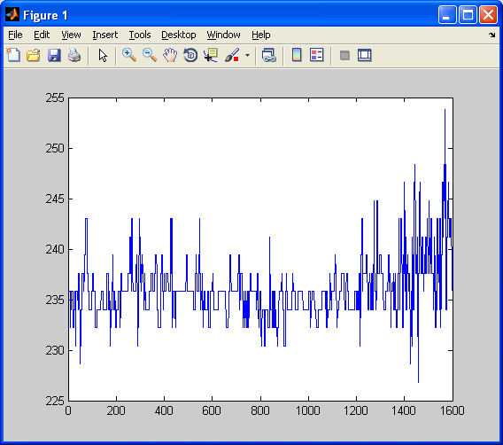
Picture 2 - High Gain – Short exposure

Picture 3 - Low Gain – Long exposure
Picture 4 - High Gain – Long exposure

Bright images

Picture 1 - Low Gain – adjusted exposure

Picture 1 - High Gain – adjusted exposure

Comments:

2. Noise reduction by averaging (45 min)
Show one set of example images like in Figure 14 for the high gain! (one channel – red, four plots). Make a table with the values for single line for low and high gain.

Picture 1 – Step image

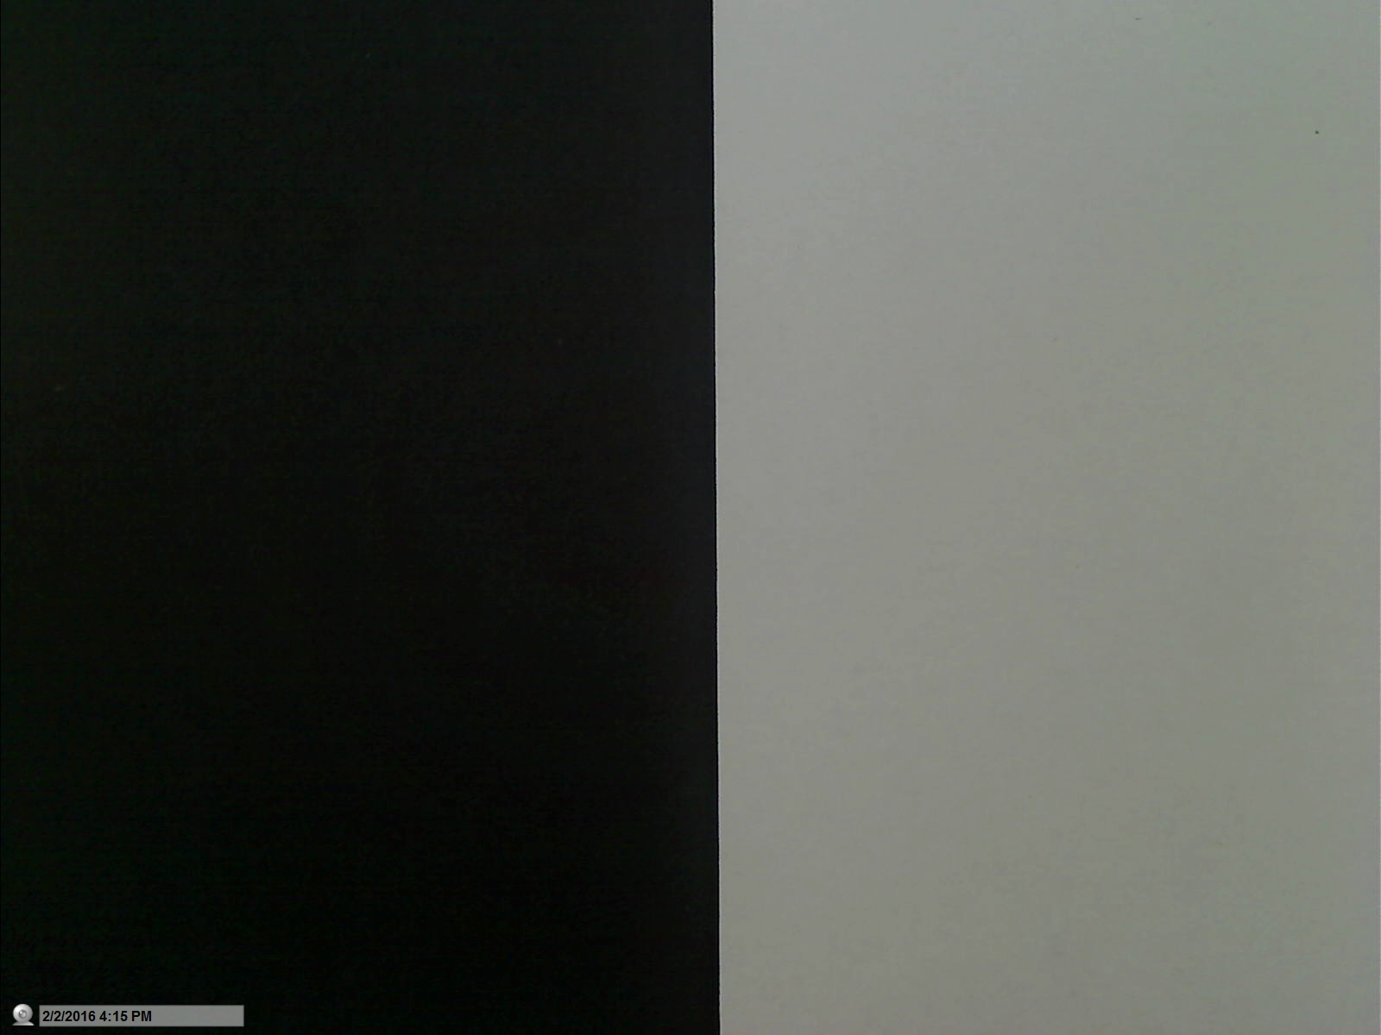
Picture 2 – Line plot

Picture 3 – cropped line plot low signal

Picture 5 – cropped line high signal

Find out how many lines (N = ?) from the high gain image have to be averaged to compensate the noise added by the gain!

 | Low gain N=1 | High gain N=1 | High Gain N = ???
MEAN_red_left
STD_red_left
MEAN_red_right
STD_red_right

Comments:

3. High dynamic range imaging (45 min)
Show the images with the ROI (two plots).

Picture 1 – High Gain exposure setting

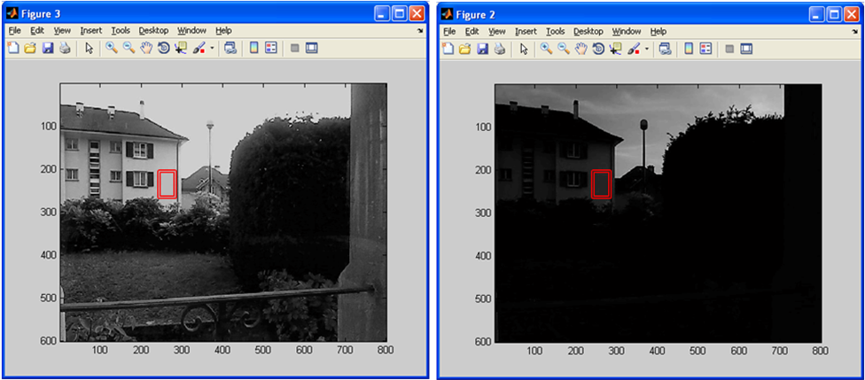
Picture 2 – Low Gain exposure setting

Indicate the measurement zone in the images!! Find the values as below

Image high gain: MEAN_ROI =

STD_ROI =

Image low gain: MEAN_ROI =

STD_ROI =

Evaluate the dynamic range increase obtained by the changing of the gain from low to high and calculate the dynamic range factor G with its error! (use the standard deviations as errors for the input values)

The dynamic range factor G is

$G_{0}=\frac{Mean signal value for high gain}{Mean signal value for low gain}=\frac{{MEAN_ROI}_{high gain}}{{MEAN_ROI}_{low gain}}$ =……….

Error calculation

$\frac{∆G}{G_{0}}=\sqrt{{\left|\frac{\left({STD_{ROI}}_{high gain}\right)}{{MEAN_{ROI}}_{high gain}}\right|}^{2}+{\left|\frac{\left({STD_{ROI}}_{low gain}\right)}{{MEAN_{ROI}}_{low gain}}\right|}^{2}}$= ………….+…………=

Give the final result

$$G=G_{0}± ∆G= ………… ± …….$$

Show an example of high dynamic range imaging and provide the three images as shown in the example. Indicate in the image in which area one can gather supplementary information.

Picture 1 - bright

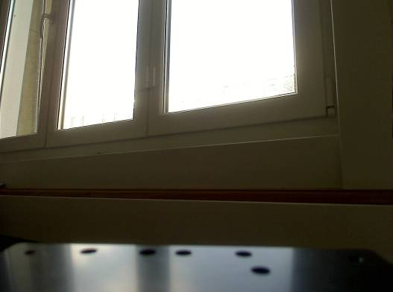
Picture 2 - dark

Picture 3 – HDR combined

Describe below what are your observations.
Comments:

4. Web example for HDR
Find a HDR example image on the web and cite correctly!

Picture 1 – example image

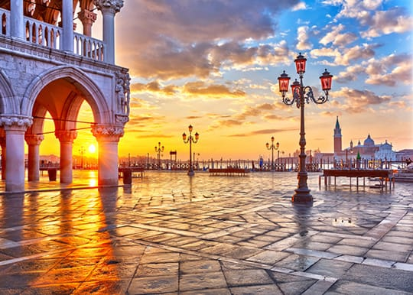

https://www.fotor.com/features/hdr.html, downloaded 20.2.2019

What is your opinion about such images?

Comments:

(Optional) Personal feedback:

Was the amount of work adequate?

What is difficult to understand?

What did you like about it?

How can we do better?

