Exercise 5 – Questions

Exercise 1 — Municipal solid waste separation
Municipal solid waste is separated by a mechanical sorting plant into a combustible fraction (30%) and another fraction (70%) that is digested by a subsequent biochemical process. Approximately half of the latter fraction is transformed to biogas during the anaerobic treatment.
- Draw the system as a quantitative flow chart.
- The concentrations of Hg are: Municipal solid waste input – 1.5 mg/kg, combustible fraction – 1 mg/kg, biogas – 0.005 mg/kg, digestion product – 3.4 mg/kg. Calculate all mass flows and transfer coefficients for Hg.

Exercise 2 — Regional MFA of construction material
Figure 1 depicts a quantitative MFA of construction materials in a fictional region.
- Which stock will be most important for sand and gravel after 100 years, assuming that the material management stays constant?
- Which conditions are required in order that recycling of construction materials can make a substantial contribution to the supply of construction materials (both buildings and underground)?
- Which differences in material quality do you expect in the four stocks? Which is the fourth stock?
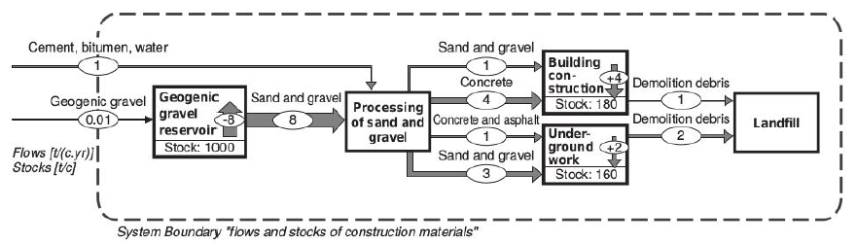
Figure 1: Diagram of the flows and stocks of construction materials in a fictional region (Brunner & Rechberger, 2005, pg. 257)

Exercise 3 — Copper recycling
Assume that the incineration of one ton of municipal solid waste (copper content ca. 0.1%) yields the following solid residues: 250 kg of bottom ash, 25 kg of fly ash, 3 kg of iron scrap, and 3 kg of neutralisation sludge from the treatment of scrubber water. About 90% of the copper (Cu) leaves incineration via bottom ash, and 10% via fly ash. The Cu flow via other residues such as off–gas, iron scrap, etc. is <1% and can be neglected. Investigations show that by mechanically processing the bottom ash, approximately 60% of the Cu can be separated in the small fraction of metals concentrate. The Cu content of this fraction (ca. 50%) can be recovered in a metal mill.
- Develop a diagram of the waste management process described above.
- What is the recovery efficiency for the combined process "municipal solid waste and mechanical processing of bottom ash"?

Exercise 4 — Photovoltaic cell production (solved in class)
The production of photovoltaic cells can be represented in a simplified manner depicting only the two main processes; silicon wafer production and photocell production. The flow data for each of the processes are as follows:
Wafer production (for 1kg silicon wafers)
Input
Silicon [kg] | 1
Energy [MJ] | 420
Output
Silicon wafers [kg] | 1

Photocell production (for 1m² photovoltaic cells)
Input
Energy [MJ] | 13.6
Glass [kg] | 10
Silicon wafers [kg] | 1.6
Output
Photovoltaic cells [m²] | 1

- Perform a system analysis: establish the system diagram and derive the balance equations.
- Develop the output equations considering each of the inputs, and calculate the amount of energy, silicon and glass needed to produce 1 m² of photovoltaic cells.

