World’s major cities hit by 25% leap in extremely hot days since the 1990s
https://www.theguardian.com/environment/2025/sep/30/worlds-major-cities-hit-by-25-leap-in-extremely-hot-days-since-the-1990s
Capitals from London to Tokyo need urgent action to protect people from deadly high temperatures, analysts say
Damian Carrington Environment editor
Tue 30 Sep 2025 02.01 CEST
The world’s biggest capital cities are now sweltering under 25% more extremely hot days each year than in the 1990s, an analysis has found. Without urgent action to protect millions of people from high temperatures, more and more will suffer in the dangerous conditions, analysts said.
From Washington DC and Madrid to Tokyo and Beijing, the analysis shows a marked rise in hot days as the climate crisis intensifies. Overall, the assessment by the International Institute for Environment and Development (IIED), found the number of days above 35C in 43 of the world’s most populous capital cities rose from an average of 1,062 a year from 1994-2003 to 1,335 from 2015-2024.
The rise was seen across the world, with the average number of days above 35C doubling in Rome and Beijing, and tripling in Manila. In Madrid, there are now an average of 47 days a year over 35C, compared with 25 before. In London, which has a relatively cool climate, the number of days above 30C doubled.
Global heating caused by fossil fuel burning is making every heatwave more intense and more likely. Extreme heat is likely to have caused the early death of millions of people over the past three decades, with elderly and poor people in fast-growing cities most deeply affected.
“Global temperatures are rising faster than governments probably expected and definitely faster than they seem to be reacting,” said Anna Walnycki, an IIED researcher. “Failing to adapt will condemn millions of city dwellers to increasingly uncomfortable and even dangerous conditions because of the urban heat island effect.”
“The poorest people will likely suffer the most whether they’re in London, Luanda or Lima, but the impacts will be significantly worse in low-income or unplanned communities in the global south thanks to lower-quality housing,” she said, noting that a third of the world’s city dwellers live in slums or informal settlements. “Climate change is the new reality. Governments can’t keep their heads buried in the sand any more.”
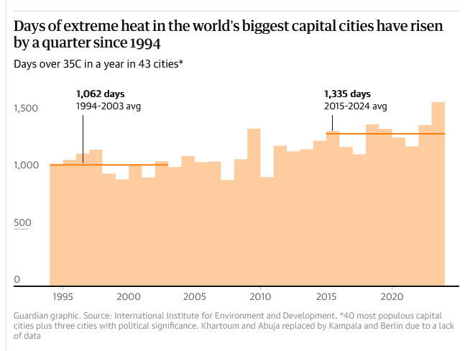
The fossil fuel emissions causing the climate crisis are still rising, despite needing to fall by 45% by 2030 to have a chance of keeping global temperature below the Paris agreement target of 1.5C above preindustrial levels. As a result, scorching temperatures were recorded around the world in 2024, from the US and Canada to Egypt, China and Japan. The latter hit its all-time record temperature of 41.2C in July, with more than 10,000 people taken to hospital. In Europe, at least 16,500 heat deaths were the result of the climate crisis between June and August.
Many major cities, from Dallas to Shanghai, are also dealing with “climate whiplash”, bringing deadly swings between extreme wet and dry weather, the Guardian reported in March.
The new analysis compiled temperature data for the 40 most populous capital cities and three further cities with high political significance this year. The UN’s climate summit, Cop30, will be held in Brazil in November and its capital, Brasília had only three days over 35C in total between 1994 and 2003, compared with 40 between 2015 and 2024. In South Africa, which holds the current G20 presidency, residents of Pretoria now have 11 days a year over 35C on average, up from only three a year in the 1990s.
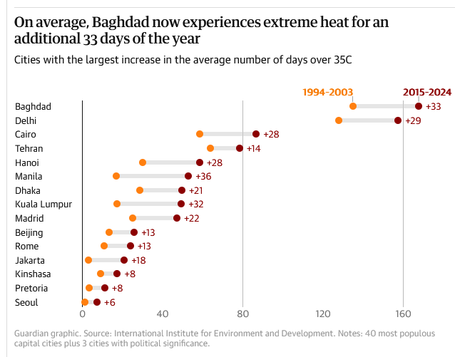
The Global Center on Adaptation (GCA) launched a campaign on Thursday, called The Heat is On, to accelerate the scale-up of solutions that save lives and protect livelihoods, from cooling centres and shaded rest areas to climate-smart work schedules and early-warning systems.
Macky Sall, GCA chair and a former president of Senegal, said: “Extreme heat is not a distant risk – it is here now, threatening our people, our economies and our future. By investing in practical, proven solutions, we can protect our citizens.” In the UK, the government’s preparations to protect people from the escalating impacts of the climate crisis were condemned as “inadequate, piecemeal and disjointed” by official advisers in April.
Walnycki said: “Many of us know what it’s like to lie awake at night dripping sweat during a heatwave. This isn’t a problem we can simply air-condition our way out of. Cities need an immediate funding boost to improve insulation and ventilation of buildings, develop heat plans and create shade cover where possible.”

