Simulation Session 2 : MICROSTRIP PATCH ANTENNAS
Course EE-446: Antennas

Patch antennas
Patch antennas are fabricated using the same process as Printed Circuit Boards (PCBs), which makes them cheap, light and versatile. They consist of a ground plane and a patch on either side of the substrate. The characteristics of these antennas depend on the substrate material, and its electrical properties (relative permittivity and losses) have a direct impact on the antenna size, bandwidth and efficiency.
In this Session, the students will work with two aspects of these antennas: their matching (directly related to their input impedance), and their radiation characteristics (pattern, directivity and radiation efficiency).

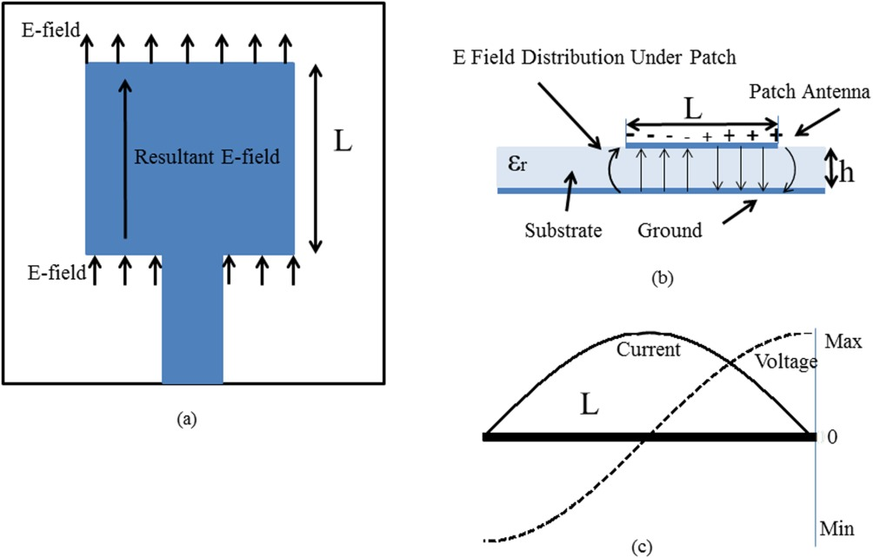
Figure 1. Field distribution of a patch antenna [1].

Matching to the desired frequency: input impedance and bandwidth

The resonant frequency of patches is set by adjusting their length (L in Figure 1) to λ/2, and depends also on the permittivity of the substrate, which modifies the electrical size of the antenna.
There are several methods to feed patch antennas, which are summarized in Figure 2. In this session we use a probe-fed feeding (coaxial probe), as it is simple and allows to visualize the input impedance and matching at specific points of the patch.
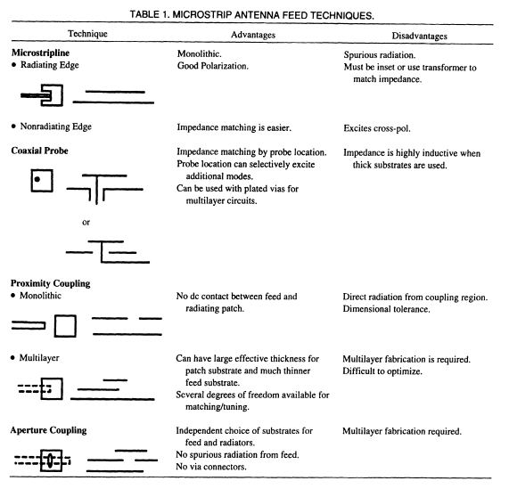
Figure 2. Different techniques to feed patch antennas [2].

To start, first, open the file 2023_AntennaCourse_Session3_PatchAntenna_StudentVersion.aedt, and then the design 1.PatchAntenna. The design parameters are gathered in the following Table.

Variable name | Nominal value | Variable Description
sub_x | 120mm | Size of the substrate and ground along the X axis.
sub_y | 120mm | Size of the substrate and ground along the Y axis.
sub_h | 1.27mm | Thickness of the substrate
lambda0 | 122mm | Wavelength in free space at 2.45GHz
patch_x | 38mm | Size of the patch along the X axis. Controls the resonant frequency, as the feed is defined along the X axis too.
patch_y | 38mm | Size of the patch along the Y axis. Wider patches can increase the bandwidth. We keep the same value as for the X axis for simplicity.
feed_w | 1mm | Width of the feeding port.
feed_pos | 7mm | Position of the feeding port. At 0mm it is at the very centre of the patch.

- To start, adjust the length of the antenna needs to be tuned to λ/2 to make it resonant at 2.45 GHz. The wavelength in this case is modified by the substrate, made of Rogers RT5880, with a relative permittivity ($ε_{r}$) of 2.2. The antenna size will be smaller in this case, and the position of the resonance can be adjusted by modifying the variable patch_x, until the imaginary part of the input impedance of the antenna, is zero at the target frequency. Note: the input impedance and reflection coefficient plots have already been generated for you, and you can find them under Results in the Project Tree (left part of the screen).

- Once the imaginary part of the input impedance is zero at 2.45 GHz, one can adjust the real part (resistance) by modifying the position of the feeding along a line through the design variable feed_pos. The student should see how the impedance changes with this parameter and find a spot where the real part of the impedance is close to 50Ω at 2.45GHz and therefore the antenna matching is improved. Note: remember that to consider that an antenna is matched, if not specified otherwise, we consider that the reflection coefficient in dB should be below -10dB.

  - What is the trend of the impedance as one gets closer to the edge of the patch? Hint: Use the scheme in Figure 1.

  - What happens to the input impedance in the Smith Chart as you move the feeding point along the patch? You can copy the Smith Chart in the Table below.

Centre | Mid-point (between edge and centre) | Patch edge

Radiation characteristics (pattern and gain)
The particularity of a patch antenna, compared to the dipoles and monopoles that we have seen already in the simulation sessions, is that they have a directive pattern [3]. The student will visualize the 3D polar plot, and the main cuts in ANSYS Electronics Desktop to respond to the following questions. You can use the Tables below to write down the values and/or copy the results/screenshots.
- How does the directivity and pattern shape of these antennas compare to the dipoles and monopoles?

- Why is the gain lower than the directivity for these antennas? Did you see that difference for the dipoles and monopoles?

- Visualize the pattern and check what is the Half Power Beamwidth (HPBW) of the patch, for its two main pattern cuts. Note: From the peak point, the HPBW is defined at half power, that is, -3dB in dB.

- Comparing the patch with the λ/2 dipole: the dipole has an omnidirectional pattern, which means that it has a HPBW of 360º, and around 2.2dBi of peak directivity. The patch has higher directivity and lower HPBW. Can you extrapolate a conclusion on the relation between beamwidth and directivity from these two cases?

 | Radiation characteristics
 | Cut (φ=0º) | Cut (φ=90º)
HPBW (º)
Directivity (dBi)
Gain (dBi)

Pattern cuts
Cut (φ=0º) | Cut (φ=90º)

References

[1] M. S. Rabbani and H. Ghafouri-Shiraz, ‘Size improvement of rectangular microstrip patch antenna at MM-wave and terahertz frequencies’, Microw. Opt. Technol. Lett., vol. 57, no. 11, pp. 2585–2589, 2015, doi: 10.1002/mop.29400.
[2] C. A. Balanis, Antenna Theory: Analysis and Design, 3rd Edition. Hoboken, NJ: Wiley-Blackwell, 2005.
[3] A. K. Skrivervik, ‘Rayonnement et antennes: notes du cours’, EPFL.

