ChimeraX Course Commands #1 Live Demo
BIO643 2025

We will go over the layout of the program. There is a Menu bar at the top (Mac), Movable Panels (ie. Log, Models) and ribbon panels.

If you are missing the command line interface or log interface to go (Menu Bar) Tools > General > Log/Command Line Interface

The log shows all the commands executed, clicking on the blue hyperlinks brings you to the definition of the command and its use.

__________________________

Here is to follow along what we will be doing

First open the command line

(Menu bar) Tools>Command Line

To open

open 4GJS
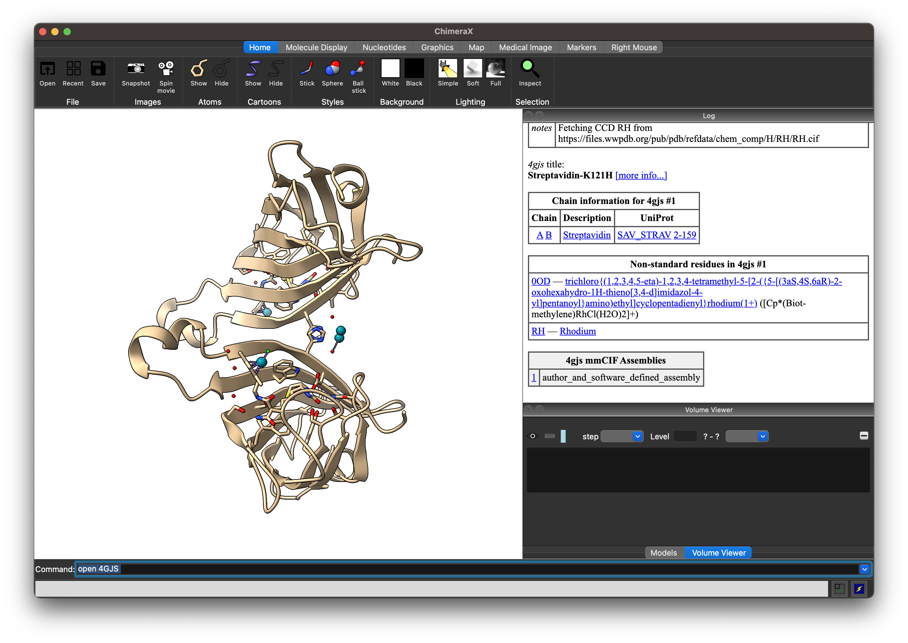
The top panel and menu bar gives access to common visualization effects

Lets try changing the feel of the screen

(Top Ribbon, Graphics) Change lighting to simple, soft, silhouettes

I will hide all molecules I don’t want to see ie. Ligands, H2O and metal

(Menu Bar) Select > Residues > All non standard
Then click (Top Ribbon, Home) ‘Atoms: Hide’

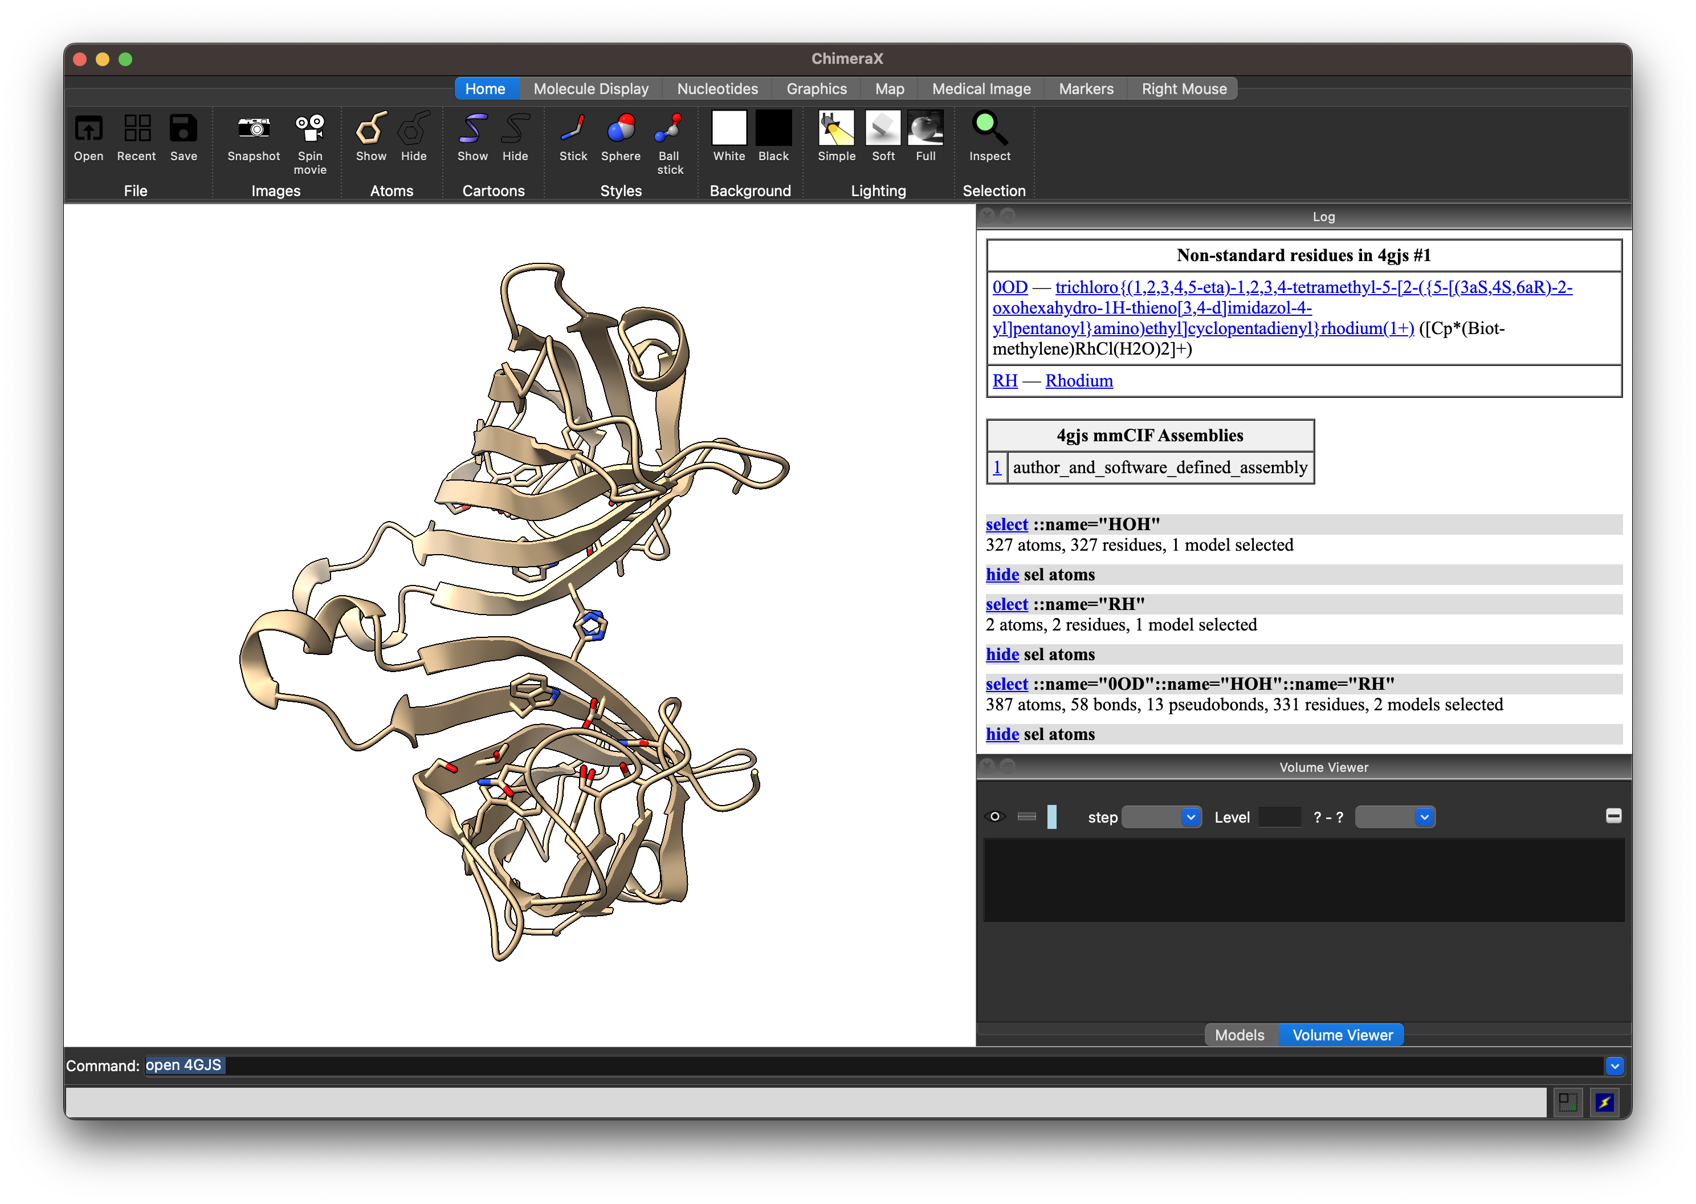We will now rotate and play with the views

With your mouse

Left click hold – rotate
Right click hold – translate
Middle scroll – zoom

What do you see? Why is Strepavidin here represented as a dimer ie. Two chains? What should it be?

Lets generate more copies of the dimer based on the crystal.

(Menu Bar) Tools > Higher order structure > Crystal contacts
Enter a radius of 3 Å
Click ‘Show Contacts’
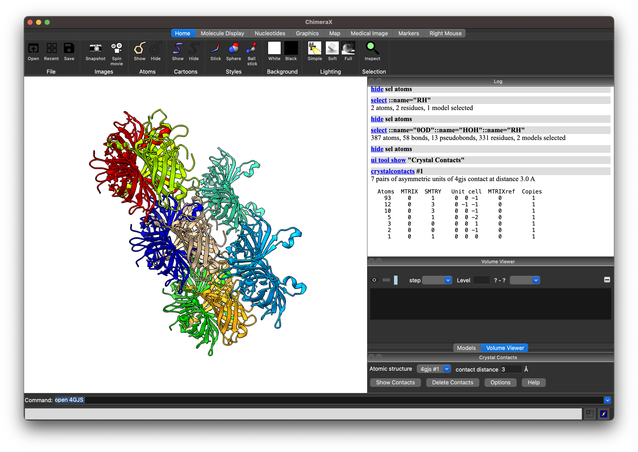
What do you see? Note the coloured molecules (not coloured default brown) are the newly generated symmetry related dimers.

We know that Strepavidin is a tetramer.

Let’s only see a tetramer defined by the initial brown dimer

Let’s remove the symmetry related dimers we think are not necessary.

First, ‘Deselect’ everything by Ctrl + Left click on white space. The command line log should show ‘select clear’

To close a model:

close #2.2

(Hint: Close #2.2 to 2.7)

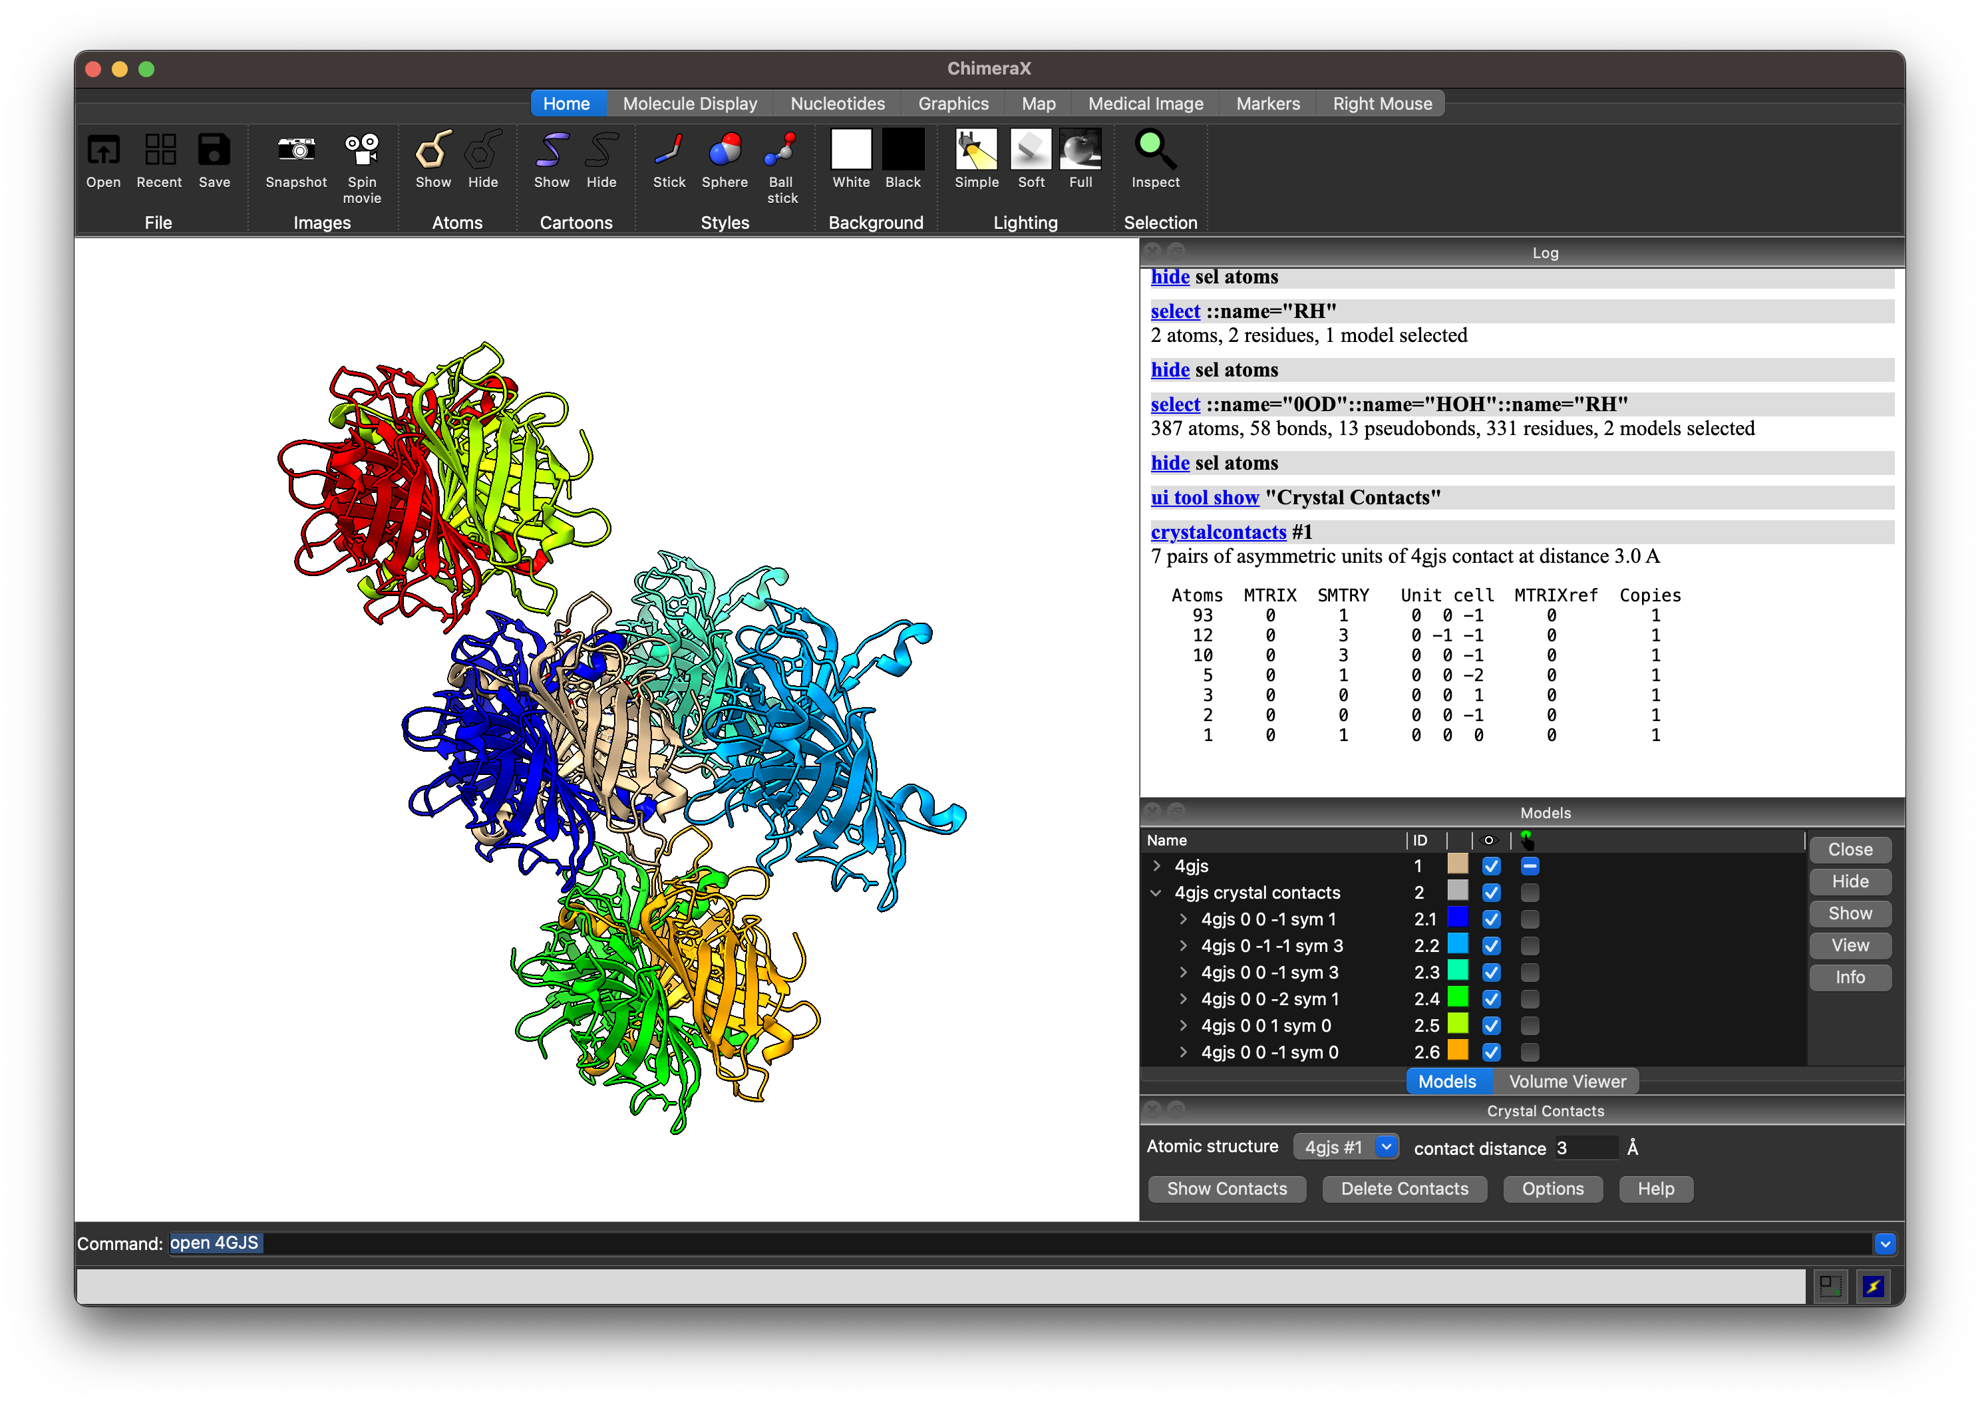

Let’s change the coloring

Let’s try (Top Ribbon:Molecule Display) ‘chain coloring’

We only see two colours as each Model (#1 and 2.1) each contain two chains, that are named the same letter (/A or /B). ie. In ChimeraX syntax: we have #1/A and #2.1/A and #1/B and #2.1/B

Let’s select parts of the Strepavidin.

Hover on the molecule and see what chain it belongs to.
Find Model 1, Chain A, ie. ‘4gjs #1/A’

After you have two choices :

1)
Ctrl + Left Click on white space (Deselect)
Ctrl + Left Click on chain #1/A
On keyboard, tap ‘up arrow’ twice (one entire domain should be highlighted in green)

(Hint: ChimeraX first selects the local secondary structure, then the full chain, then the full model, then everything)

OR

2)
sel #1/A (one entire domain should be highlighted in green)

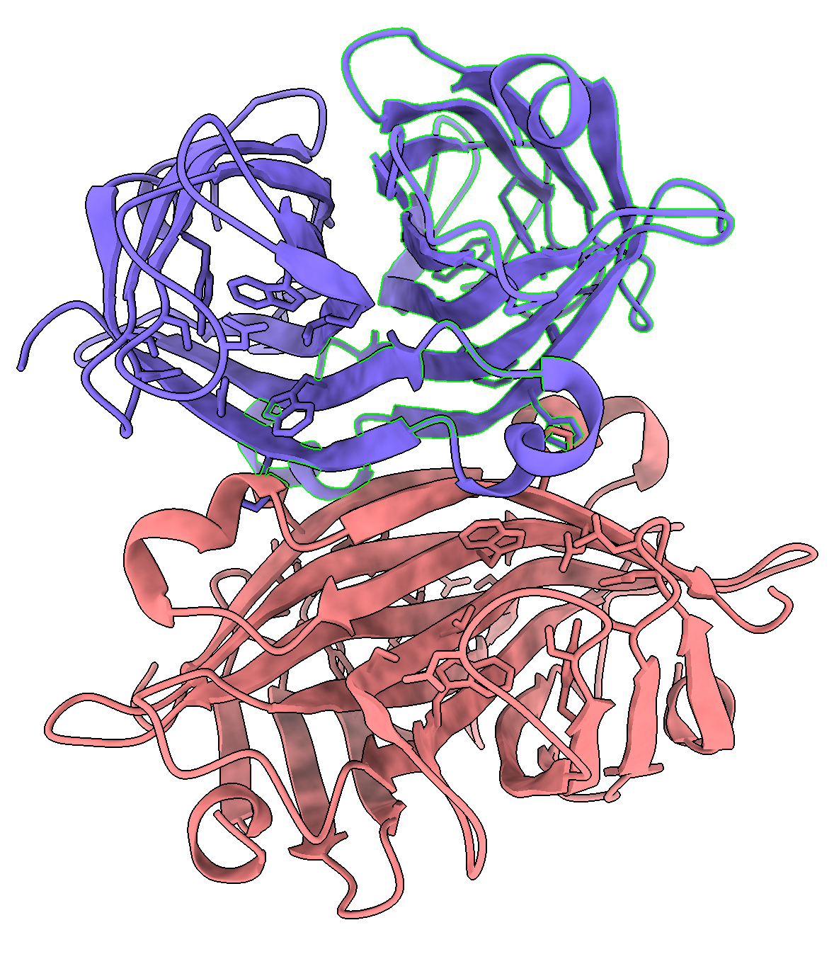

Let’s show the surface of Model #1 chain A

You have two choices :

(Top Ribbon:Molecule Display) ‘Surfaces:Show’
OR

2)

surf sel

(Hint: if you can select and do surface at the same time by using ‘surf #1/A’)

Let’s make the surface transparent

sel #1/A, then (Menu Bar) Actions>Surface>Transparency>50%

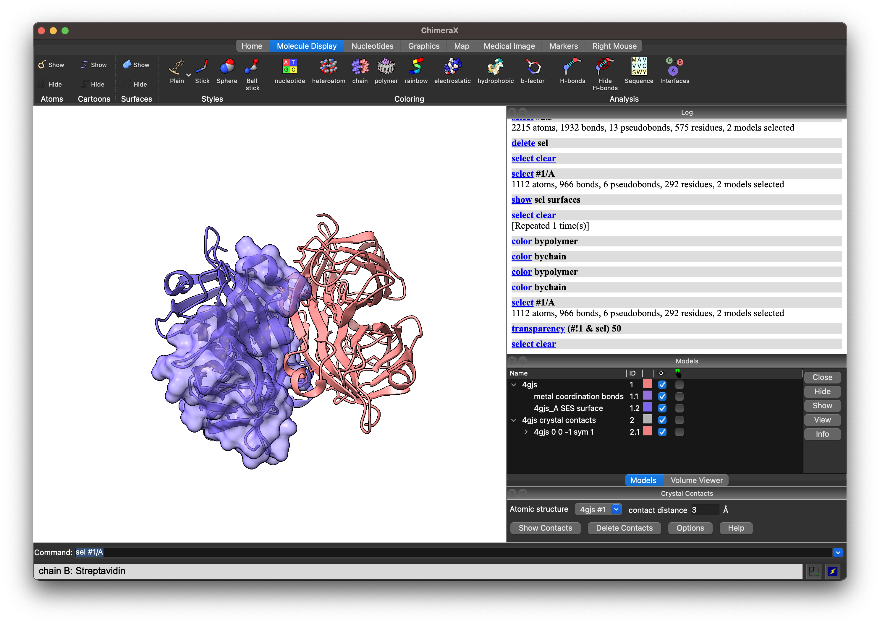

Let’s now selectively colour only the atoms that are visible by ‘hetero atom coloring’

color sel byhet

(This works because we never deselected the model and chain we selected previously, if you did….)

color #1/A byhet

You will see this:

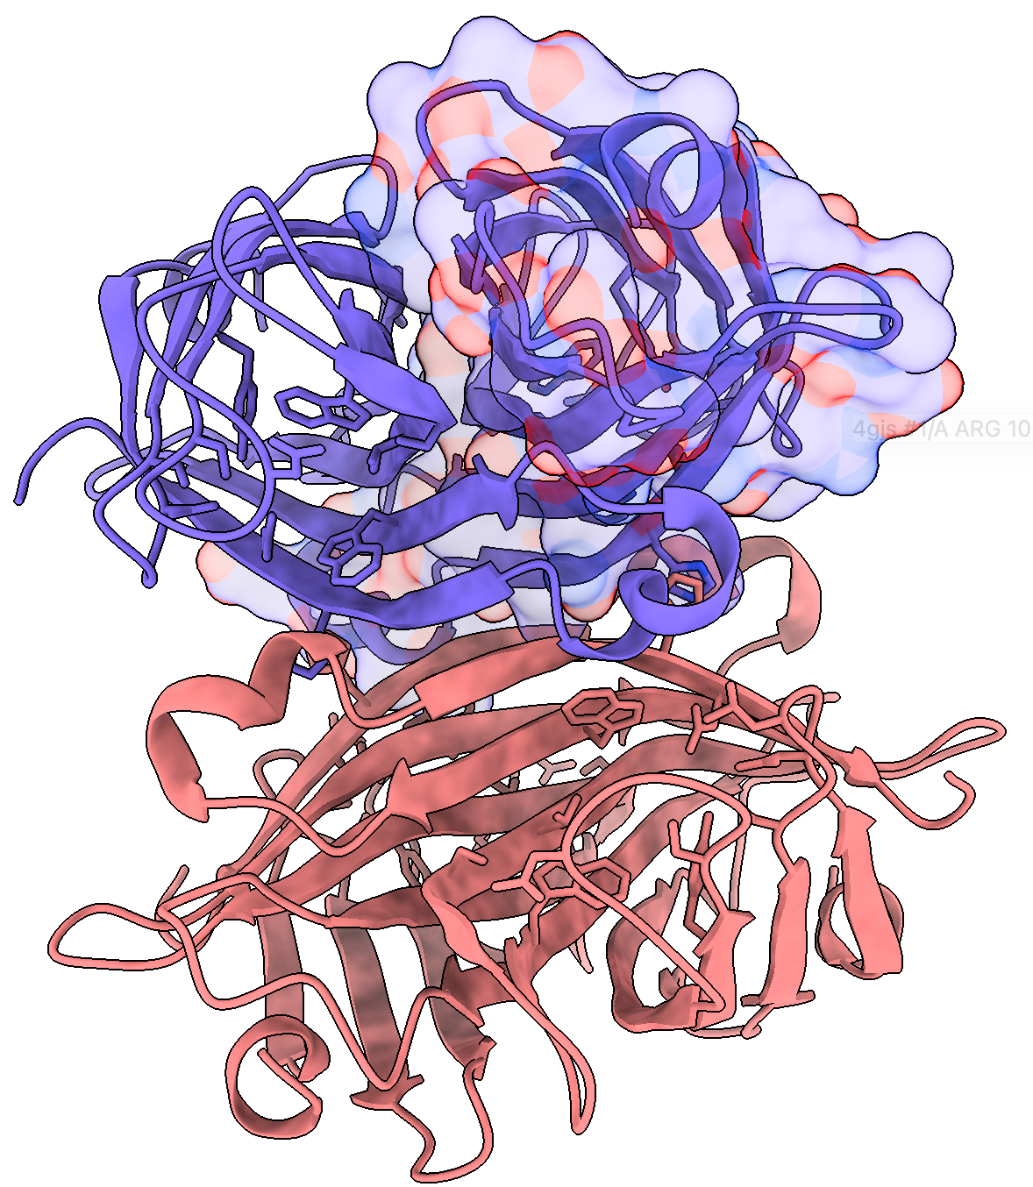

What happened? This is not what we want.

The commands we used changes even the surface.

For clarity we only want to do this for the atoms, not the surface

Let us go back a step

undo (doesn’t work for all commands)

To be more specific now you can

- color #1/A byhet atoms

or

- (Menu Bar) Actions>Color>All options. Here you can then select under “coloring applies to” : Atoms and then clicking on “By Heteroatom”

You can see now that only the atom colors are changed that represent the standard coloring of carbon (model color) , oxygen (red) and nitrogens (blue).
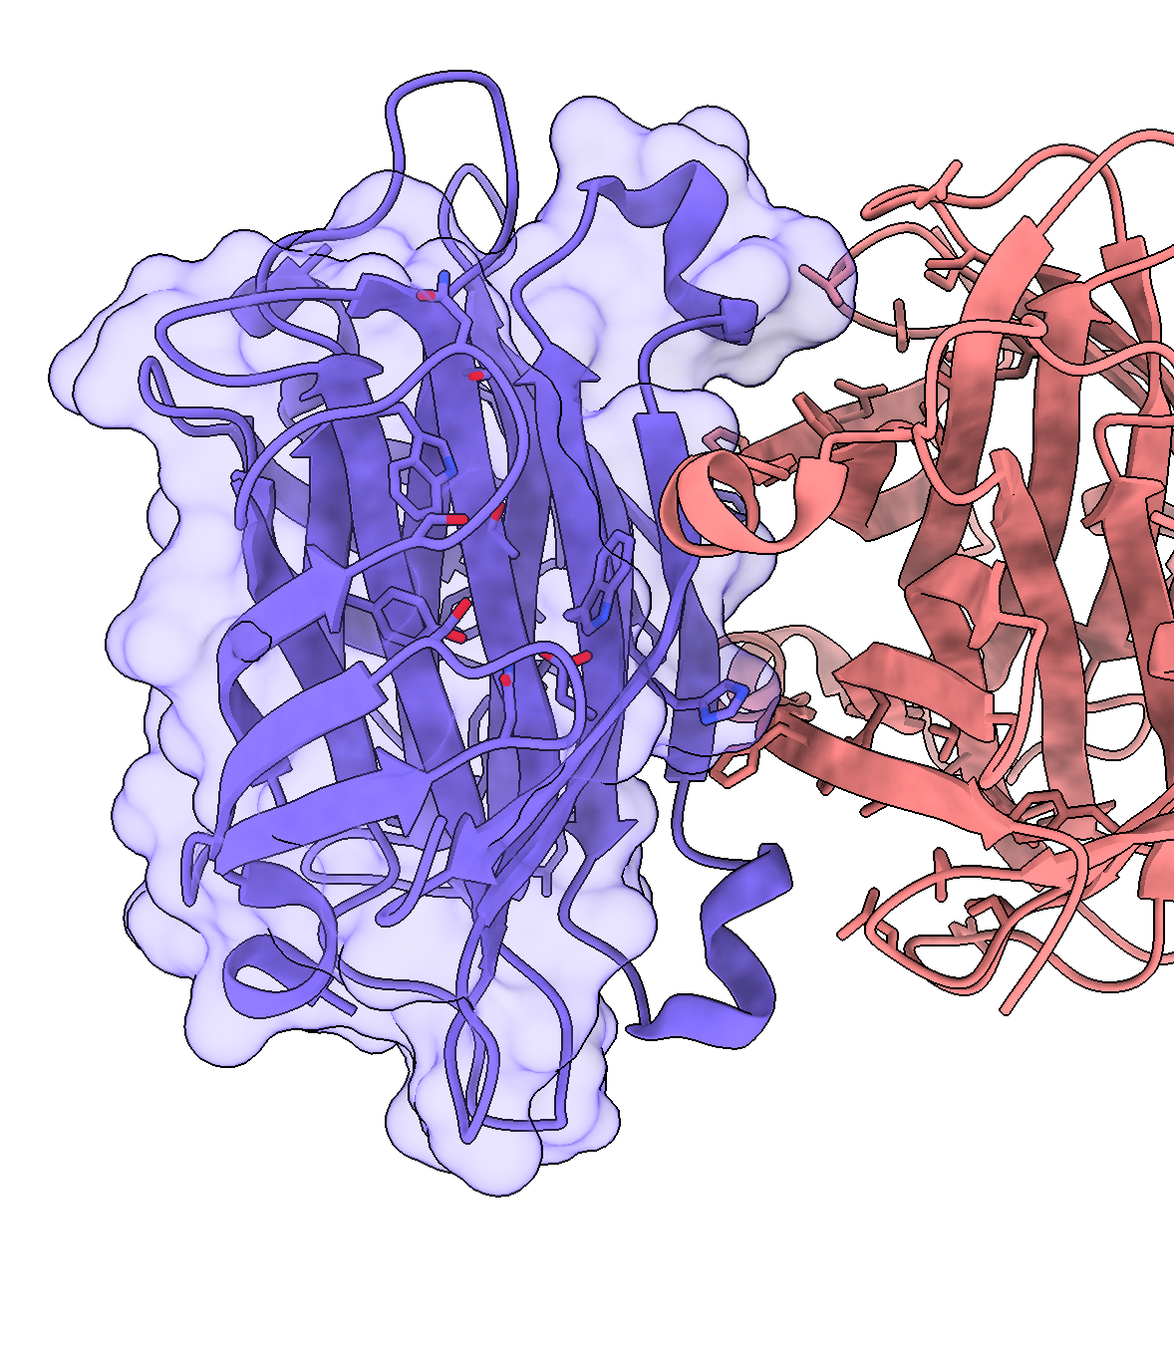

Let’s select the ligand that should bind to the chain A of this Model 1

sel #1/A:0OD
show sel

Now color the atoms of the selected ligand by heteroatom coloring

color sel byhet

Lets change the lighting

light gentle

Deselect everything

Ctrl + Left click

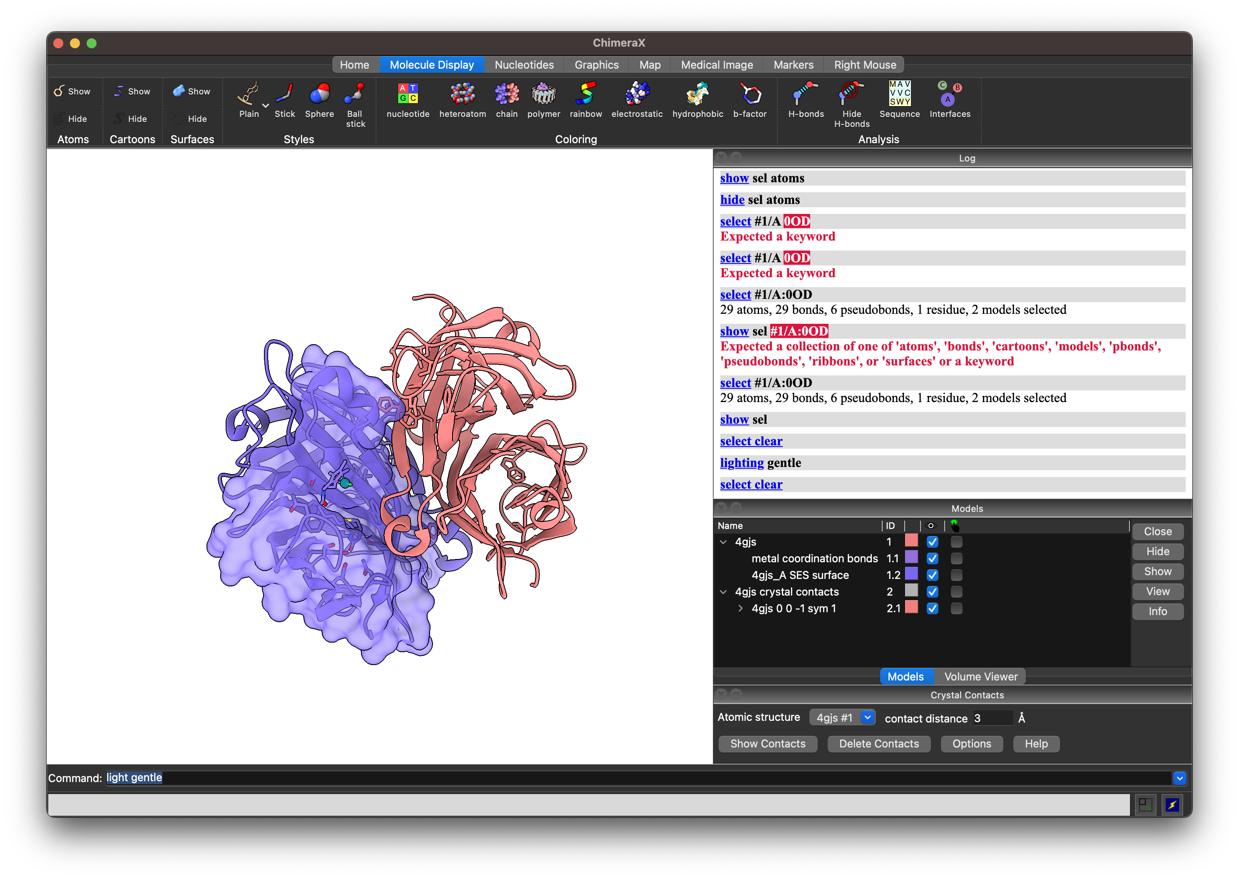
Its hard to see the colour of the ligand here, lets make it more visible

sel #1/A
color sel cornflower blue
transparency (#1/A & sel) 50
color sel byhet atoms
sel #1/A:0OD
color sel orange
color sel byhet

Deselect everything

Ctrl + Left click

We like this now, lets make a Figure

(Top Ribbon:Home> Snapshot)

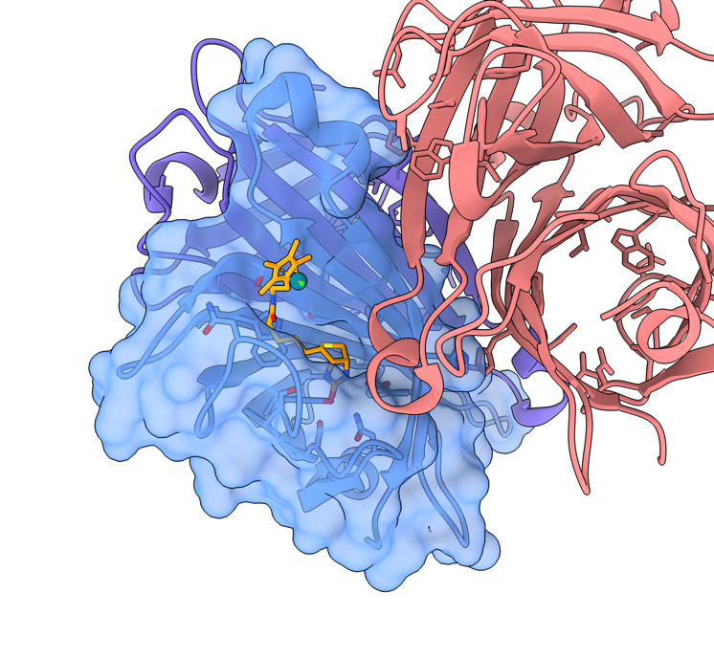

Let analyze a bit of the structure. What could be the residues that are binding to the ligand.

First lets hide ONLY amino acids

(Menu Bar) Select > Residues > Standard amino acids

hide sel

Lets see what is 3Å distance from the ligand.

sel zone #1/A:0OD 3 residues true
(selects all residues with in 3A of #1/B and selects their originating residues)
info sel
(outputs in the log the selected residues, you can copy and paste this text elsewhere if you need it for the future. Fun tip: You can train ChatGPT to extract the residue numbers as this list shows every atom of a residue)
show sel
color sel forest green atoms
color sel byhet atoms
style sel ball
(Make them balls and sticks)

Now let’s analyze hydrogen bonds.

(Menu Bar) Tools > Structure Analysis > H-Bonds

A new pop-up window appears.
We only want to visualize the hydrogen bonds related to our ligand.

sel #1/A:0OD

Tick the box Limit by selection (with at least one end selected), tick Write information to log, then click apply.

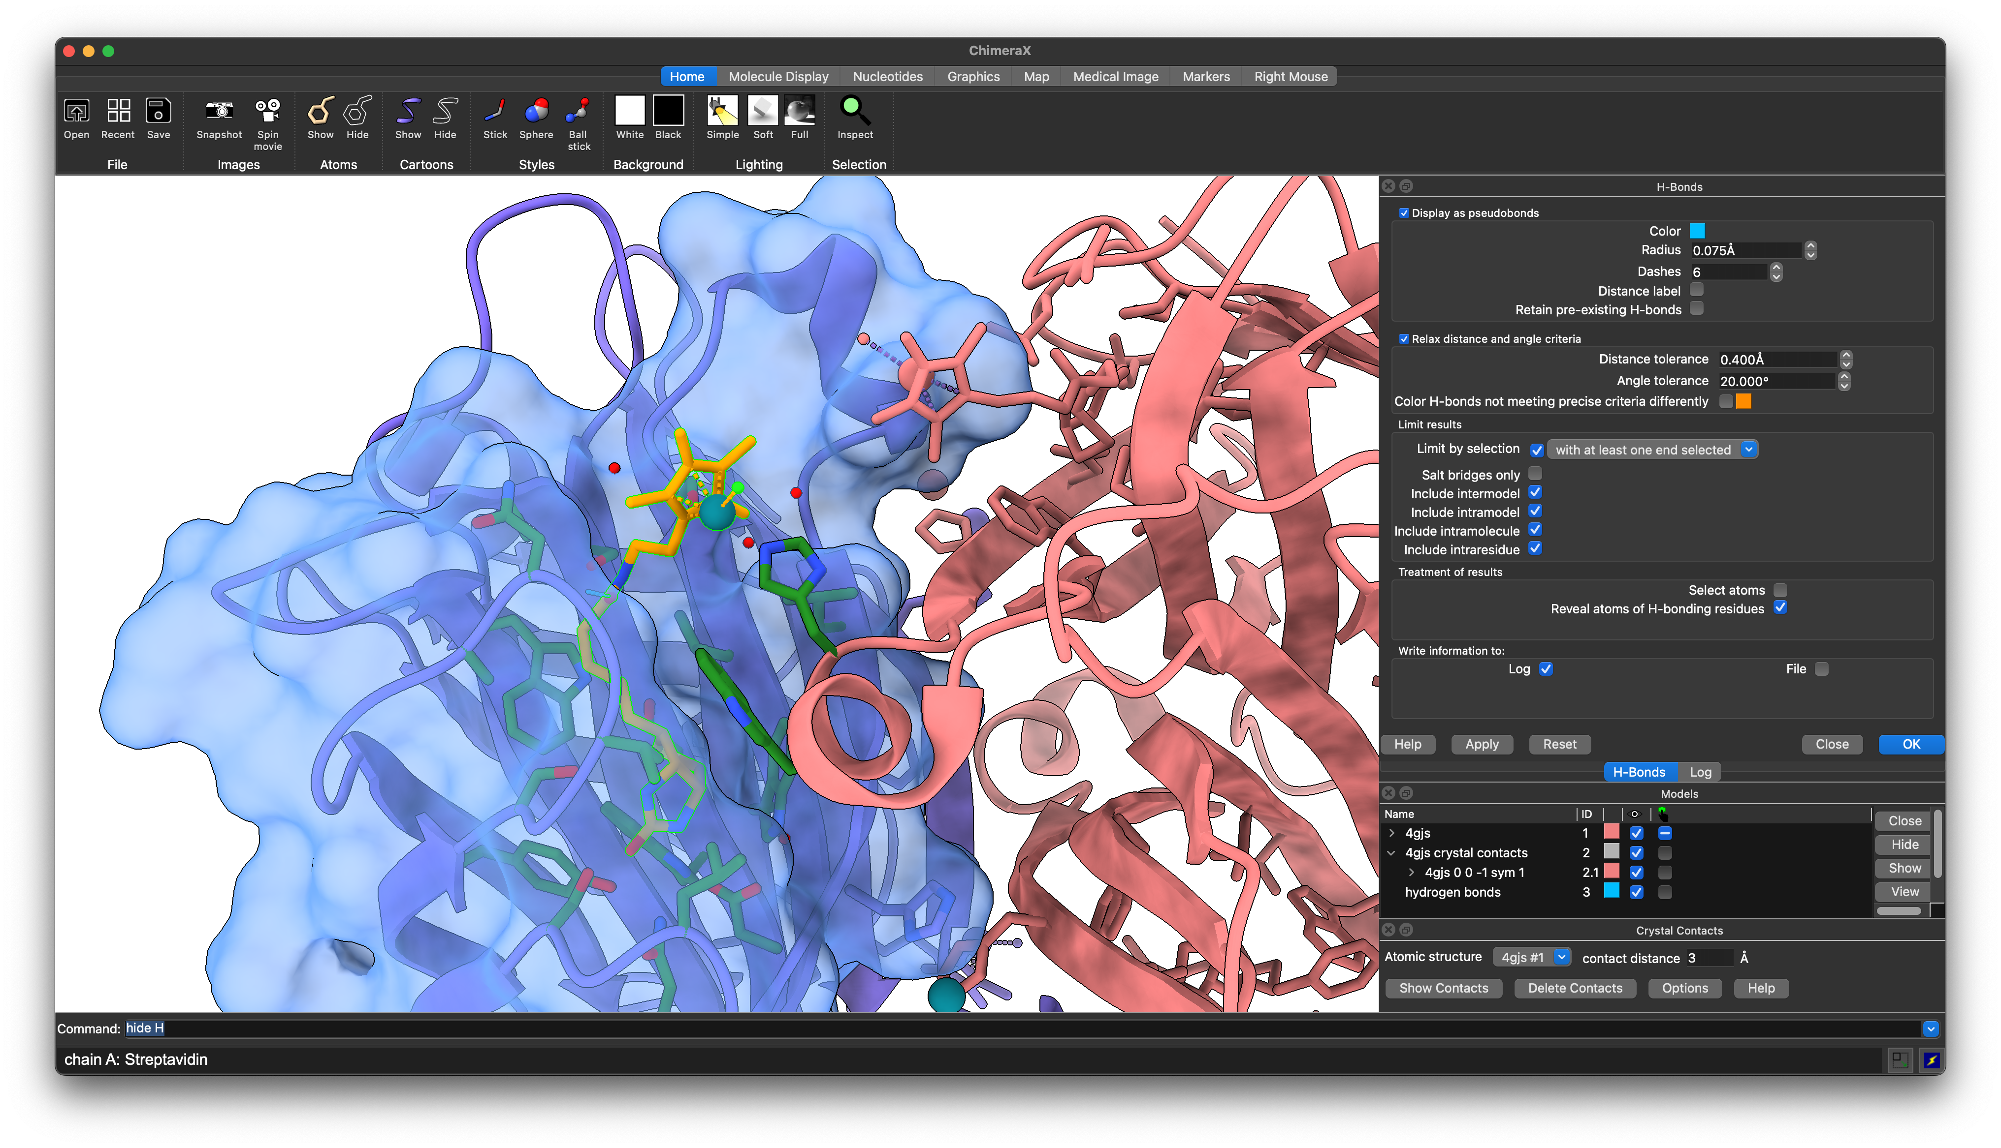

The log lists the identified hydrogen bonds (7 in this case). We see that there is an additional interaction with Ser45 that we didn’t highlight previously, as the h-bond is slightly over 3 Å. So let’s repeat the above selection steps to highlight the closest amino acids, but this time a distance threshold of 3.2 Å instead.

Now let’s find a good view of the ligand. To come back to the same scene all the time you can save the view:

view name zoom1

If you now zoom out and move around, you can restore this exact view with:

view zoom1

Now let’s make the cartoons more transparent, so the image becomes less busy. First, select everything but the first chain #1/A. There are multiple options to do so:
select #1/B
select add #2
Alternative 1:
select #1/B | #2
Alternative 2:
select #1/B#2
Or, you select chain #1/A and then invert the selection using the dropdown menu.

Menu bar > Select > Chains > Streptavidin > [4gjs #1] chain A
Menu bar > Select > Invert > All Models

To modify the transparency of the cartoon, but not of the atom representation of the histidine, you can type the following (target c stands for cartoon):

transparency sel 50 target c

In order to save this image, you can either use
Top Ribbon > Home > Images > Snapshot

This will save the current image to your desktop.
Alternatively you can use the command line to specify height and width of your image.

save bioeng643.tiff format tiff width 4096 supersample 3 transparentBackground true

Great. Finally, let’s save this as a session.

(Menu Bar) File > Save > Files of type: ChimeraX session (*.cxs)

Like this, you can revisit this session later if you need to re-export an image of your structure because your supervisor would like to have a slightly different shade of blue.
Alternatively, you can copy all the commands that you used into a ChimeraX command script (*.cxc). For tasks that were executed through a button in the gui, the corresponding command is printed in the log (.e.g the above H-Bond tool executed the command hbonds sel reveal true log true).

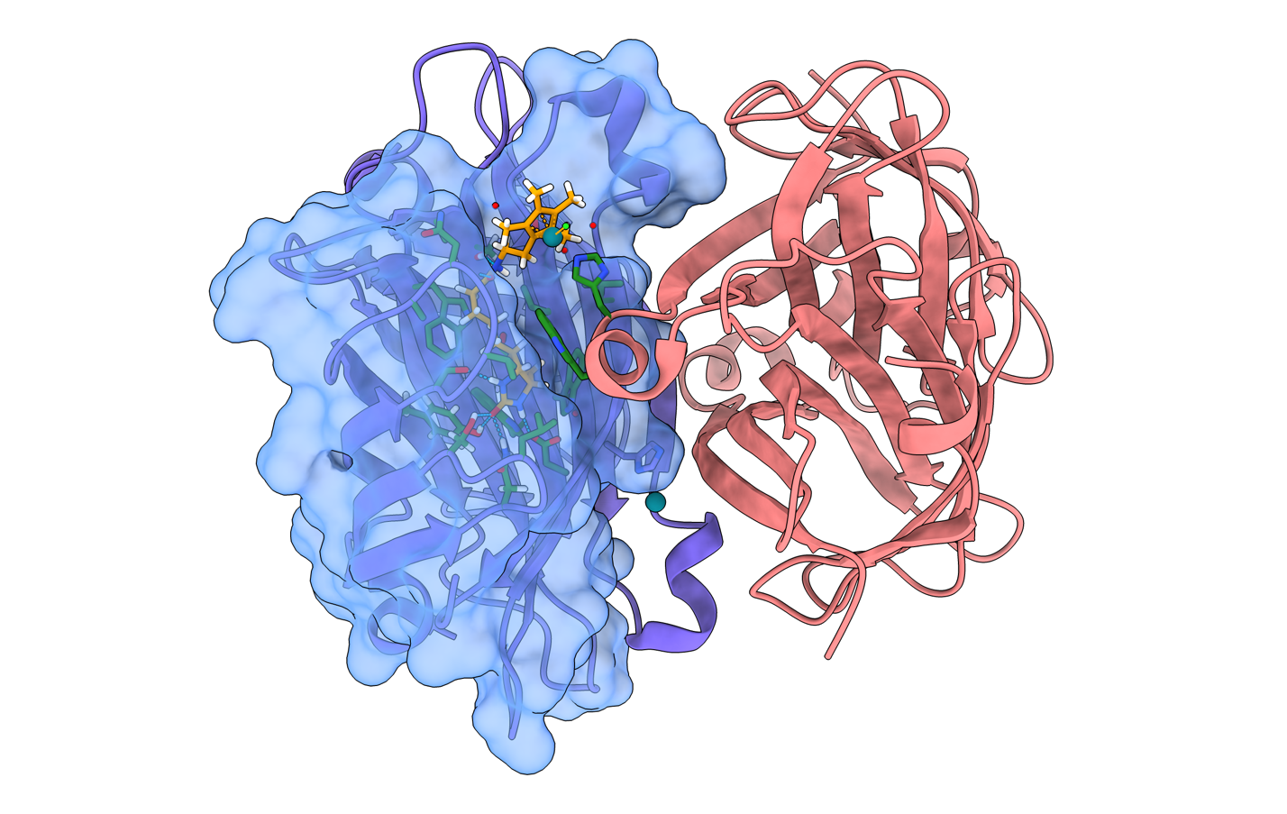

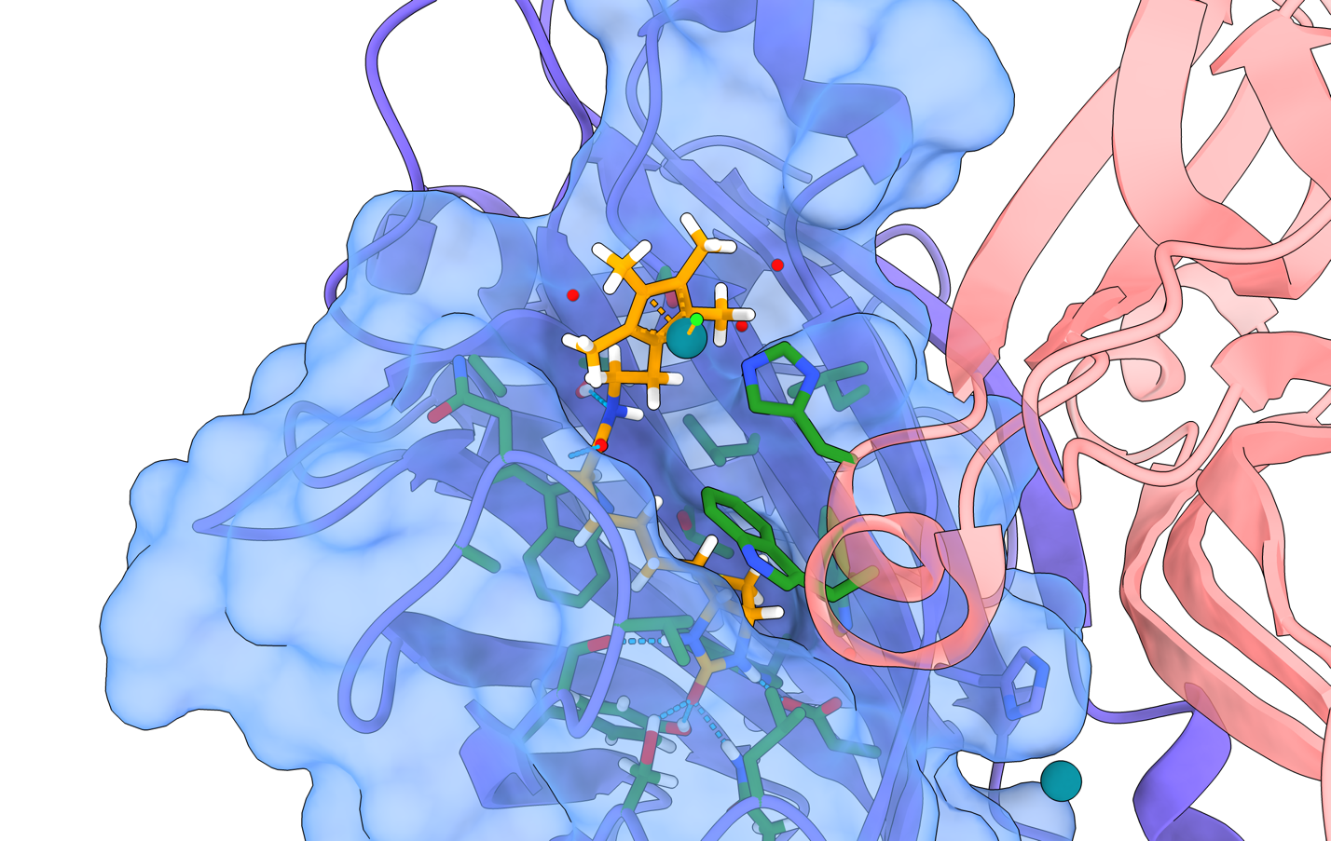

When speaking about a structural figure one needs to be explicitly clear and we cannot physically point things out if we are not there. By colouring things differently (many online colour palettes to choose from), with different representations one can easily write or say the following here:

“Two chains of a Strepavidin dimer are shown. One chain is coloured blue with a transparent surface and another chain is coloured pink. The ligand in sticks representation is in orange is bound inside a cleft of the blue chain. The ligand is coordinated by two metals (turquoise and fluorescent green balls). All amino acids within 3.2 Å of the ligand are shown in forest green in ball-and-stick representation with formed hydrogen bonds indicated. One can note that one histidine residue that makes contacts with the ligand is located on the second chain”

Bonus: Movie rendering

ChimeraX is very good for movie making as well. It works best by providing a set of commands that define the order in which the structure should rotate, move, zoom, disappear etc. The following movie script is just an illustration of how movies can be generated, highlighting the most important commands.

Find a good starting position that gives an overview of the protein packing. Save this view as above (view name OV).
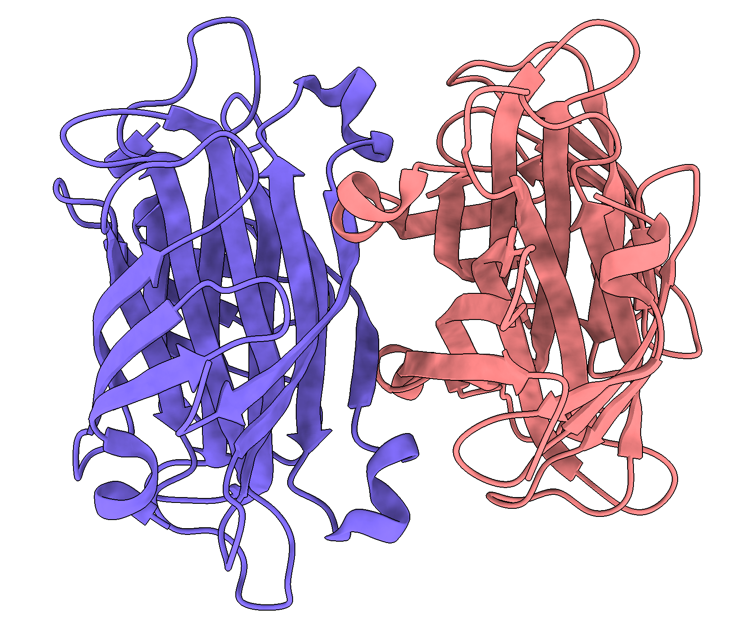

Reset the view:
transparency 0 target sc
hide surface
hide atoms
view OV

Then copy and paste the lines below in the command line all at once and press enter. Alternatively, you can copy them into a new file with the extension .cxs and open it in ChimeraX. The software will execute the commands and generate a movie.

##########################
# this tells the software to save the individual frames
movie record supersample 3
# rock is a simple command that shakes the current structure back and forth. It rotates ±60° around the y axis for 120 frames which corresponds to one cycle.
rock y 60 frames 120 cycle 120; wait 121
# Next, we turn by 3° 30 times, giving us a full 90° rotation
turn x 3 30; wait 31
# The crossfade command is very useful for movie making. Whatever command is executed with it is stretched over 30 frames (default). Here, we slowly make the other chains transparent and show the surface of chain A, followed by the ligand
crossfade; surface #1/A; transparency ~#1/A 50 target c; wait 31
crossfade; show #1/A:0OD; wait 31
# We saved the view of the ligand earlier. This can be called again with the view command. By adding a number of frames (here 30), the camera will fly to that position instead. You might need to adjust the name according to how you called it.
view zoom1 30; wait 31
# Now we render the surface transparent, show the interacting atoms, as well as the hydrogen bonds.
crossfade; transparency #1/A 50 target s; sel zone #1/A:0OD 3.2 residues true; show sel atoms; sel cl; hbonds #1/A:0OD reveal true; wait 31;
# Finally, we rock the scene again back and forth, but this time centered around the ligand
rock y 60 frames 120 cycle 120 center #1/A:0OD; wait 121
# Now we just need to encode the recorded frames
movie encode ~/Desktop/myfirstchimeraxmovie.mp4 format h264
#####################

