Exercises Biol-480 “Neuroscience” – Epigenetics 2

Solutions (28/11/2025)

Exercise 1 : Gräff et al., 2012 (Nature)
- What molecular signals lead to HDAC2 upregulation in Alzheimer’s disease?
  - Oxidative stress (e.g., H₂O₂)
  - Amyloid-β toxicity
  - Activation of the glucocorticoid receptor (GR1): GR1 binds the HDAC2 promoter, increasing HDAC2 transcription.
- What is CK-p25? What does this figure indicate about the relationship between HDAC2 levels and neurodegeneration? What about HDAC1 and HDAC3?
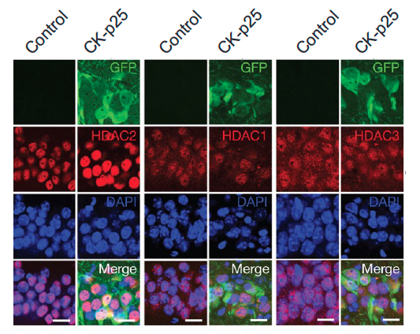
CK-p25 is a mouse model of AD. Increased HDAC2 staining indicates abnormally elevated HDAC2 expression in AD models. This supports the idea that HDAC2 contributes to epigenetic repression of genes required for synaptic plasticity. HDAC1 and HDAC3 do not increase, showing specificity of HDAC2 in cognitive impairment.
- Which technique was used to measure HDAC2 binding and histone acetylation at gene promoters? Briefly describe how the technique works.
Chromatin immuno-precipitation. Cells are crosslinked to fix proteins (e.g., HDAC2 or acetylated histones) to DNA. DNA is fragmented, and antibodies pull down protein-DNA complexes. qPCR is used to identify which gene promoter regions were bound. This allows measurement of HDAC2 binding and histone acetylation at memory-related gene promoters.
- Reducing HDAC2 expression improves memory performance in behavioral tests. How did the researchers reduced HDAC2 expression? Explain the technique. What do these results tell you about the role of epigenetic modulation in cognition?
They used RNAi expression (shHDAC2) to cleave HDAC2 mRNA and reduce its expression. Improvement in fear conditioning and water maze shows that epigenetic repression underlies memory deficits. Cognitive dysfunction in early AD may be reversible through epigenetic modulation.

Exercise 2
HDAC inhibitors can “prime” neuronal chromatin, making plasticity-related genes easier to activate during learning. Recent research shows that combining HDAC inhibition with training enhances learning, fear extinction, and long-term memory consolidation.
Such epigenetic priming is even being tested in humans.

- What does “epigenetic priming” mean in the context of learning and memory?
Creating a chromatin state that is more permissive to transcription. Memory-related genes can be activated faster and more strongly during learning.
- What HDACi supports exposure therapy for arachnophobia?
Valproic acid

