Exercises Biol-480 “Neuroscience” – Epigenetics 2

Solutions (28/11/2025)

Exercise 1 : Gräff et al., 2012 (Nature)
- What molecular signals lead to HDAC2 upregulation in Alzheimer’s disease?
- What is CK-p25? What does this figure indicate about the relationship between HDAC2 levels and neurodegeneration? What about HDAC1 and HDAC3?
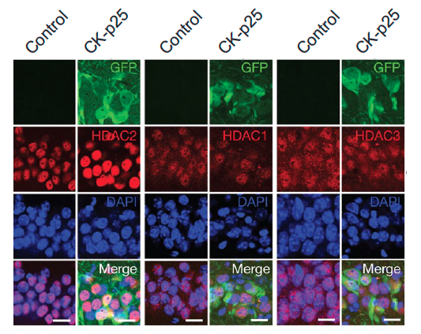
- Which technique was used to measure HDAC2 binding and histone acetylation at gene promoters? Briefly describe how the technique works.
- Reducing HDAC2 expression improves memory performance in behavioral tests. How did the researchers reduce HDAC2 expression? Explain the technique. What do these results tell you about the role of epigenetic modulation in cognition?

Exercise 2
HDAC inhibitors can “prime” neuronal chromatin, making plasticity-related genes easier to activate during learning. Recent research shows that combining HDAC inhibition with training enhances learning, fear extinction, and long-term memory consolidation.
Such epigenetic priming is even being tested in humans.

- What does “epigenetic priming” mean in the context of learning and memory?
- What HDACi supports exposure therapy for arachnophobia?

