BIO-411 Mock open questions 11 DEC 25

A) In a quest for novel therapies for dementia, you discover a family where some members never develop dementia despite living until old age. You examine the inheritance of this resistance; find it is recessive and maps to a single locus. However, when you genome sequence this region in family members, you find no changes of any protein encoding genes compared to controls. However, using transcriptomics and proteomics you did find that several mRNAs (and the proteins they encode) expressed from genes located in many different regions of the genome have increased levels in individuals that are homozygous.

Can you speculate on the type of gene that could be altered in these families? How would test this hypothesis by examining the mRNAs (or proteins) that you have identified to have increased expression?

You eventually identify the candidate gene that could be linked to resistance to dementia. What tissues do you predict it might be expressed in? Using modern technologies, how would you confirm this, what is a limitation of the approach you propose, and how could it be overcome?

You identify a gene in mice similar to the dementia resistance gene in humans. How would you manipulate this gene to examine if it also protects against dementia in old mice? What is an important thing to consider that could limit the usefulness of mice to model the function of this gene?

B) The image below shows a two-dimensional hierarchical clustering of interactions determined by synthetic genetic array (SGA) analysis in S. cerevisiae. Red boxes denote lethality, black boxes viability.
synthetic lethal interaction

a) Explain how SGA analysis is performed (2 points).
b) Ciliobrevin is a small compound that inhibits dynein function. What consequence do you expect Ciliobrevin to have on wild-type S. cerevisiae? What about on cells lacking KAR9?
c) How would you test whether the human homologues of RAD9 and DCC1 exhibit the same type of interaction as in S. cerevisiae?

C) The graph below is the outcome of a simple production-decay process simulated as an ordinary differential equation (only synthesis and degradation).
x is the number of mRNAs, s the synthesis rate, and k the degradation rates in function of time.

1. Complete the bottom plot for the degradation rate k(t).
Hint: k stays constant within each of the three intervals, but it may change from one interval to the next.

2. Draw on the top plot what you would have obtained if you had simulated the system with the Gillespie algorithm. What would be the value of the signal-to-noise ratio (mean over standard deviation) in the interval [8,10]?

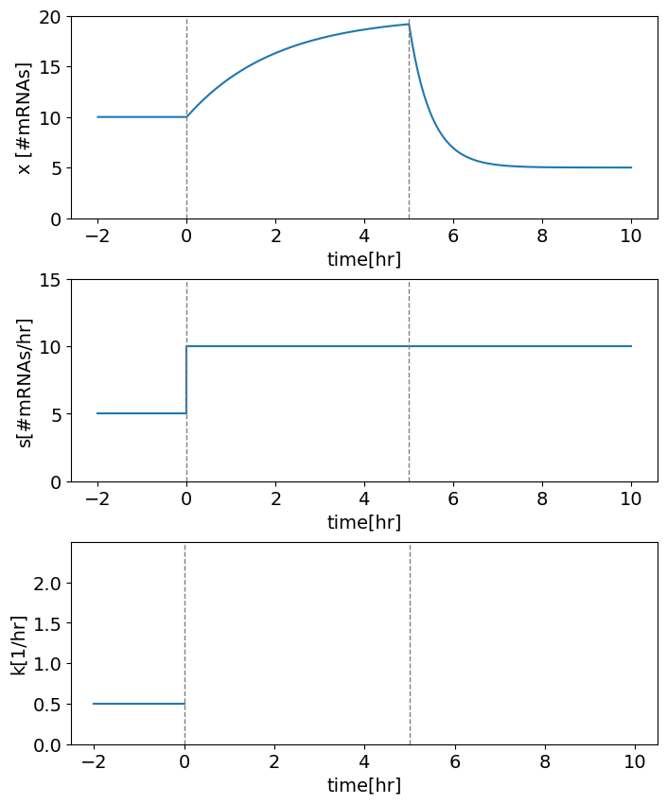

This graph shows the pre-mRNA and mRNAs levels of two transcripts in the muscle (left: dashed thin line is at y=1). One peaks in the morning and the other in the evening.

Explain the difference between the two genes in terms of their transcription rate and/or mRNA half-life. Link this with the observed delays of pre-mRNA to mRNA, mean levels, and max to min ratios for the two mRNAs (orange).

Hint: You can assume in both cases that the half-live does not change with time. Also, the splicing rate of both genes is the same.

