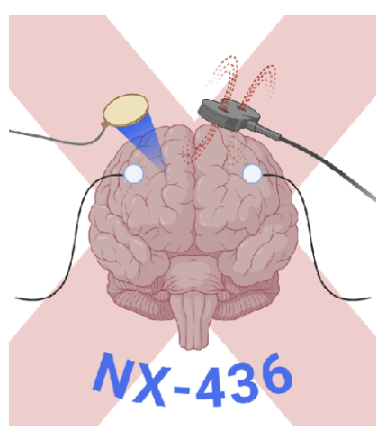

Semester exercise 2024/2025 - Vignette- Groups PSL

Advancing Closed-Loop Epidural Electrical Stimulation (EES) of the Spinal Cord for Gait Deficits in Parkinson’s Disease

Problem: Parkinson's disease (PD) is the second most common neurodegenerative disorder after Alzheimer's disease, affecting approximately 10 million people worldwide -a number expected to double by 2050. Well-known symptoms of PD include tremor, rigidity, and bradykinesia, but severe locomotor deficits often emerge in the later stages of the disease. These gait deficits can lead to reduced mobility and independence, increasing risks of falls and injuries, which in turn raises mortality and severely impacts quality of life. Dopaminergic
replacement therapy and deep brain stimulation (DBS) have become standard treatments for alleviating some motor symptoms, but they are typically insufficient for addressing gait-related deficits [1,2].

Current solution: Emerging research suggests that Epidural Electrical Stimulation (EES) of the spinal cord, specifically targeting the lumbar region, can activate spinal circuits and improve gait in PD patients [3, 4]. However, current solutions to deliver EES operate on open-loop models, delivering continuous stimulation that does not adapt to the dynamic and fluctuating nature of PD symptoms [5, 6]. These fluctuations can be influenced by various factors, including medication cycles, disease progression, and patient fatigue, leading to inconsistent therapeutic outcomes.

Next step: To improve therapeutic efficacy, there is a need to develop a closed-loop EES system that dynamically adjusts stimulation parameters in response to real-time brain activity. This approach would ensure that EES is modulated according to the patient’s current state, optimizing therapeutic outcomes and minimizing side effects.

Assignment: In this project, you will design a closed-loop EES system aimed at alleviating motor symptoms in PD, with a focus on gait improvement. Your main challenges include:
- Decoding Neural Activity: Utilize the implanted DBS leads to decode brain activity that correlates with the patient’s state. This includes algorithms capable of real-time analysis of this data to detect motor states, freezing events, and/or fluctuations.
- Adaptive EES Modulation: Develop a system to adjust EES parameters (e.g., frequency, amplitude) in real-time based on decoded neural signals.
- Data Integration and Remote Monitoring: Implement a data management system that collects and integrates neural signals and EES parameters, providing comprehensive health reports. This system should support remote patient monitoring, enabling healthcare providers to adjust treatment protocols as needed.
- [Extra] Rehabilitation Integration: Incorporate a rehabilitation program that works in tandem with the closed-loop EES system to further enhance motor recovery. Investigate how physical therapy and other rehabilitation strategies can synergize with EES to maximize patient outcomes.

Translation to Clinical Application: To facilitate the translation of this approach from research to clinical practice, outline the steps necessary for testing this closed-loop EES system in non-human primates, followed by clinical trials in human patients. Consider ethical implications, potential challenges in scaling the technology, and strategies for regulatory approval.

References

Bloem, B. R., Hausdorff, J. M., Visser, J. E., & Giladi, N. (2004). Falls and freezing of gait in Parkinson's disease: a review of two interconnected, episodic phenomena. Movement disorders: official journal of the Movement Disorder Society, 19(8), 871-884.

Schaafsma, J. D., Giladi, N., Balash, Y., Bartels, A. L., Gurevich, T., & Hausdorff, J. M. (2003). Gait dynamics in Parkinson's disease: relationship to Parkinsonian features, falls and response to levodopa. Journal of the neurological sciences, 212(1-2), 47-53.

Moraud, E. M., Capogrosso, M., Formento, E., Wenger, N., DiGiovanna, J., Courtine, G., & Micera, S. (2016). Mechanisms underlying the neuromodulation of spinal circuits for correcting gait and balance deficits after spinal cord injury. Neuron, 89(4), 814-828.

Milekovic, T., Moraud, E. M., Macellari, N., Moerman, C., Raschellà, F., Sun, S., ... & Courtine, G. (2023). A spinal cord neuroprosthesis for locomotor deficits due to Parkinson’s disease. Nature Medicine, 29(11), 2854-2865.
[
Schrag, A., & Quinn, N. (2000). Dyskinesias and motor fluctuations in Parkinson's disease: A community-based study. Brain, 123(11), 2297-2305.

Denny, A. P., & Behari, M. (1999). Motor fluctuations in Parkinson’s disease. Journal of the neurological sciences, 165(1), 18-23.

