https://www.theguardian.com/environment/2024/nov/04/two-sides-of-the-same-coin-governments-stress-links-between-climate-and-nature-collapse?CMP=Share_AndroidApp_Other

‘Two sides of the same coin’: governments stress links between climate and nature collapse
Representatives at the Cop16 summit in Colombia negotiated against a backdrop of extreme weather and ecosystem collapse
The age of extinction is supported by

About this content
Patrick Greenfield and Phoebe Weston in Cali
Mon 4 Nov 2024 07.00 CET
As world leaders gathered in Colombia this week, they also watched for news from home, where many of the headlines carried the catastrophic consequences of ecological breakdown. Across the Amazon rainforest and Brazil’s enormous wetlands, relentless fires had burned more than 22m hectares (55m acres). In Spain, the death toll in communities devastated by flooding passed 200. In the boreal forests that span Siberia, Scandinavia, Alaska and Canada, countries were recording alarming signs that their carbon sinks were collapsing under a combined weight of drought, tree death and logging. As Canada’s wildfire season crept to a close, scientists calculated it was the second worst in two decades – behind only last year’s burn, which released more carbon than some of the world’s largest emitting countries.
In global negotiations, climate and nature move along two independent tracks, and for years were broadly treated as distinct challenges. But as negotiations closed at the Cop16 biodiversity summit in Cali on Saturday, ministers from around the world underscored the crucial importance of nature to limiting damage from global heating, and vice versa – emphasising that climate and biodiversity could no longer be treated as independent issues if either crisis was to be resolved. Countries agreed a text on links between the climate and nature, but failed to include language on a phase out of fossil fuels.
The UK environment secretary, Steve Reed, said that attending the summit in Colombia had brought home the links between climate and biodiversity. “One of the other things that’s really struck me coming here and speaking to the Colombians in particular is how for them the nature crisis and the climate crisis are exactly the same thing. In the UK, perhaps more widely in the global north, we tend to talk a lot about climate and particularly net zero, and much less about nature – perhaps because we’re already more nature-depleted. But those two things connect entirely,” he said.
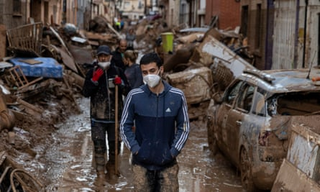
People walk along streets full of mud and waste in Valencia, Spain, after recent flooding, during which more than 200 people died. Photograph: Pablo Blázquez Domínguez/Getty Images
The Cop16 president, Susana Muhamad, Colombia’s environment minister, has sought to put nature on a level with global efforts to decarbonise the world economy during the summit, warning that slashes to greenhouse gas emissions must be accompanied by the protection and restoration of the natural world if they are to be effective. Her presidency has repeatedly described nature and climate as “two sides of the same coin”.
“There is a double movement humanity must make. The first one is to decarbonise and have a just energy transition. The other side of the coin is to restore nature and allow nature to take again its power over planet Earth so that we can really stabilise the climate,” she has said throughout Cop16 and during the buildup.
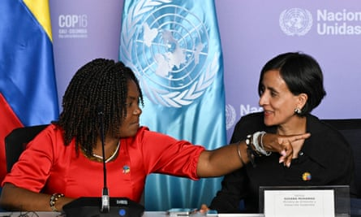
The Colombian vice president, Francia Marquez, left, and environment minister Susana Muhamad, who has sought to put nature on a level with global efforts to decarbonise the world economy. Photograph: Joaquín Sarmiento/AFP/Getty Images
The shift toward a more intertwined view of climate and biodiversity was also reflected in the negotiations at last year’s Cop28 climate summit in Dubai. Countries agreed to update their next generation round of climate plans in line with their commitments on nature. It comes amid growing scientific concerns about how forests, oceans and other natural carbon sinks are responding to global heating, with new research indicating a collapse in the amount of carbon absorbed by land – as a net category – in 2023, the hottest year on record.
The planet’s oceans, forests, soils and other natural carbon sinks absorb about half of all human emissions, shielding humanity from the full effects of fossil fuel pollution. Without this, warming would rapidly accelerate.
Brazil and the Democratic Republic of Congo, home to enormous areas of the Amazon and Congo basin rainforests respectively, pushed for greater recognition of the climate-stabilising effects of the ecosystems they house, both of which are threatened with destruction.
Ève Bazaiba, DRC’s environment minister, said that her country’s forests helped sustain rainfall as far away as Egypt and were critical to the health of the planet, calling for better international recognition of its importance. Marina Silva, Brazil’s environment minister, who has once again overseen a sharp drop in deforestation under the presidency of Luiz Inácio Lula da Silva, said that more money for forested countries was required.
“Brazil has a commitment to zero deforestation by 2030. We know that the reasons why biodiversity is destroyed have to do with several factors, one of which is certainly overwhelmingly the issue of deforestation. Another that is closely associated with the serious problem of climate change that is destructive to our biodiversity.
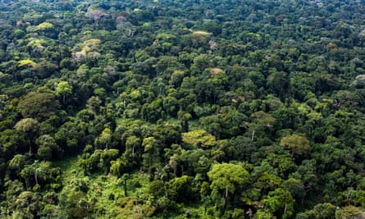
Peatland forest Équateur province, DRC. Photograph: Daniel Beltrá/Greenpeace
Smaller forested countries were also keen to underscore the importance of natural ecosystems to mitigating climate breakdown. Jiwoh Abdulai, the environment and climate change minister of Sierra Leone, said he was concerned that land sinks had absorbed less carbon in 2023. “That’s why we’re here. We have these assets which are essentially globally critical infrastructure,” he said.
The degradation of forests is already affecting rural communities that depend on rain-based agriculture as weather patterns are no longer predictable, resulting in lower yields, a drop in income and more food insecurity. As land becomes less fertile, people are increasingly encroaching into the forest.
Abdulai added: “Our countries host these forests. Our local communities are the custodians, but the benefits of having these forests are shared globally.”
Others were concerned that the loss of their forests could undermine climate progress. In Nigeria there has been a 13% decrease in forest cover since 2000. “The rate of forest loss in Nigeria is one of the highest in the world,” said the country’s environment minister, Iziaq Kunle Salako.
He added: “The role that forests need to play in net zero targets is particularly significant. If you look at the UN convention on climate change, on biodiversity, and on desertification, the forest is central. So this is an area that is very, very concerning in Nigeria.
“If the forest is not sequestering [carbon], it’s not playing the primary role it has to play, and it will be challenging for the world to reach the target of zero emissions.”

https://www.theguardian.com/environment/2024/oct/14/nature-carbon-sink-collapse-global-heating-models-emissions-targets-evidence-aoe?CMP=Share_AndroidApp_Other

Trees and land absorbed almost no CO2 last year. Is nature’s carbon sink failing?
The sudden collapse of carbon sinks was not factored into climate models – and could rapidly accelerate global heating
Read more: What happens to the world if forests stop absorbing carbon? Ask Finland
The age of extinction is supported by
About this content

Patrick Greenfield
Mon 14 Oct 2024 09.00 CEST
It begins each day at nightfall. As the light disappears, billions of zooplankton, crustaceans and other marine organisms rise to the ocean surface to feed on microscopic algae, returning to the depths at sunrise. The waste from this frenzy – Earth’s largest migration of creatures – sinks to the ocean floor, removing millions of tonnes of carbon from the atmosphere each year.
This activity is one of thousands of natural processes that regulate the Earth’s climate. Together, the planet’s oceans, forests, soils and other natural carbon sinks absorb about half of all human emissions.
But as the Earth heats up, scientists are increasingly concerned that those crucial processes are breaking down.
In 2023, the hottest year ever recorded, preliminary findings by an international team of researchers show the amount of carbon absorbed by land has temporarily collapsed. The final result was that forest, plants and soil – as a net category – absorbed almost no carbon.
There are warning signs at sea, too. Greenland’s glaciers and Arctic ice sheets are melting faster than expected, which is disrupting the Gulf Stream ocean current and slows the rate at which oceans absorb carbon. For the algae-eating zooplankton, melting sea ice is exposing them to more sunlight – a shift scientists say could keep them in the depths for longer, disrupting the vertical migration that stores carbon on the ocean floor.
None of these models have factored in losses such as the wildfires in Canada last year that amounted to six months of US fossil emissions
“We’re seeing cracks in the resilience of the Earth’s systems. We’re seeing massive cracks on land – terrestrial ecosystems are losing their carbon store and carbon uptake capacity, but the oceans are also showing signs of instability,” Johan Rockström, director of the Potsdam Institute for Climate Impact Research, told an event at New York Climate Week in September.
“Nature has so far balanced our abuse. This is coming to an end,” he said.
The 2023 breakdown of the land carbon sink could be temporary: without the pressures of drought or wildfires, land would return to absorbing carbon again. But it demonstrates the fragility of these ecosystems, with massive implications for the climate crisis.
Reaching net zero is impossible without nature. In the absence of technology that can remove atmospheric carbon on a large scale, the Earth’s vast forests, grasslands, peat bogs and oceans are the only option for absorbing human carbon pollution, which reached a record 37.4bn tonnes in 2023.
At least 118 countries are relying on the land to meet national climate targets. But rising temperatures, increased extreme weather and droughts are pushing the ecosystems into uncharted territory.
The kind of rapid land sink collapse seen in 2023 has not been factored into most climate models. If it continues, it raises the prospect of rapid global heating beyond what those models have predicted.

‘We have been lulled – we cannot see the crisis’
For the past 12,000 years, the Earth’s climate has existed in a fragile equilibrium. Its stable weather patterns allowed the development of modern agriculture, which now supports a population of more than 8 billion people.
As human emissions rose, the amount absorbed by nature increased too: higher carbon dioxide can mean plants grow faster, storing more carbon. But this balance is beginning to shift, driven by rising heat.
“This stressed planet has been silently helping us and allowing us to shove our debt under the carpet thanks to biodiversity,” says Rockström. “We are lulled into a comfort zone – we cannot really see the crisis.”
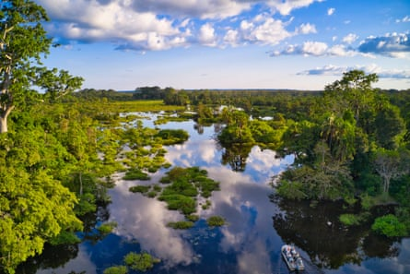
A tourist boat in the Republic of Congo’s Odzala-Kokoua national park. The Congo basin is the only tropical rainforest that consistently removes more CO2 than it releases.
Photograph: G Guni/Getty
Only one major tropical rainforest – the Congo basin – remains a strong carbon sink that removes more than it releases into the atmosphere. Exacerbated by El Niño weather patterns, deforestation and global heating, the Amazon basin is experiencing a record-breaking drought, with rivers at an all-time low. Expansion of agriculture has turned tropical rainforests in south-east Asia into a net source of emissions in recent years.
Emissions from soil – which is the second-largest active carbon store after the oceans – are expected to increase by as much as 40% by the end of the century if they continue at the current rate, as soils become drier and microbes break them down faster.
Tim Lenton, professor of climate change and Earth system science at Exeter University, says: “We are seeing in the biosphere some surprising responses that are not what got predicted, just as we are in the climate.
“You have to question: to what degree can we rely on them as carbon sinks or carbon stores?” he says.
A paper published in July found that while the total amount of carbon absorbed by forests between 1990 and 2019 was steady, it varied substantially by region. The boreal forests – home to about a third of all carbon found on land, which stretch across Russia, Scandinavia, Canada and Alaska – have seen a sharp fall in the amount of carbon they absorb, down more than a third due to climate crisis-related beetle outbreaks, fire and clearing for timber.
Combined with the declining resilience of the Amazon and drought conditions in parts of the tropics, the hot conditions in the northern forests helped drive the collapse of the land sink in 2023 – causing a spike in the rate of atmospheric carbon.
“In 2023 the accumulation of CO₂ in the atmosphere is very high and this translates into a very, very low absorption by the terrestrial biosphere,” says Philippe Ciais, a researcher at the French Laboratory of Climate and Environmental Sciences, who was an author of the most recent paper.
“In the northern hemisphere, where you have more than half of CO₂ uptake, we have seen a decline trend in absorption for eight years,” he says. “There is no good reason to believe it will bounce back.”
The oceans – nature’s largest absorber of CO₂ – have soaked up 90% of the warming from fossil fuels in recent decades, driving a rise in sea temperatures. Studies have also found signs that this is weakening the ocean carbon sink.

‘None of the models have factored this in’
The flow of carbon through the land and ocean remains one of the least understood parts of climate science, say researchers. While human emissions are increasingly simple to measure, the sheer number and complexity of processes in the natural world mean there are important gaps in our understanding.
Satellite technology has improved monitoring of forests, peatlands, permafrost and ocean cycles, but assessments and forecasts in international reports often have large error margins. That makes it difficult to predict how the world’s natural carbon sinks will behave in future – and means many models do not factor in a sudden breakdown of multiple ecosystems.
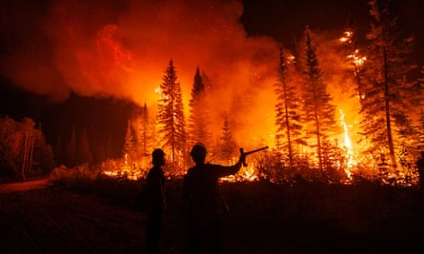
Firefighters battling the Tsah Creek wildfire in British Columbia. Last year’s wildfires in Canada released as much carbon as six months of US fossil-fuel emissions. Photograph: J Winter/Guardian
“Overall, models agreed that both the land sink and the ocean sink are going to decrease in the future as a result of climate change. But there’s a question of how quickly that will happen. The models tend to show this happening rather slowly over the next 100 years or so,” says Prof Andrew Watson, head of Exeter University’s marine and atmospheric science group.
“This might happen a lot quicker,” he says. “Climate scientists [are] worried about climate change not because of the things that are in the models but the knowledge that the models are missing certain things.”
Many of the latest Earth systems models used by scientists include some of the effects of global heating on nature, factoring in impacts such as the dieback of the Amazon or slowing ocean currents. But events that have become major sources of emissions in recent years have not been incorporated, say scientists.
“None of these models have factored in losses like extreme factors which have been observed, such as the wildfires in Canada last year that amounted to six months of US fossil emissions. Two years before, we wrote a paper that found that Siberia also lost the same amount of carbon,” says Ciais.
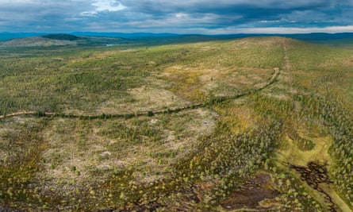
A logged area near Inari. The disappearance of Finland’s land sink in recent years has cancelled out the gains from reducing industrial emissions by 43%. Photograph: J Hevonkoski/Guardian
“Another process which is absent from the climate models is the basic fact that trees die from drought. This is observed and none of the models have drought-induced mortality in their representation of the land sink,” he says. “The fact that the models are lacking these factors probably makes them too optimistic.”

‘What happens if the natural sinks stop working?’
The consequences for climate targets are stark. Even a modest weakening of nature’s ability to absorb carbon would mean the world would have to make much deeper cuts to greenhouse gas emissions to achieve net zero. The weakening of land sinks – which has so far been regional – also has the effect of cancelling out nations’ progress on decarbonisation and progress towards climate goals, something that is proving a struggle for many countries.
In Australia, huge soil carbon losses from extreme heat and drought in the vast interior – known as rangelands – are likely to push its climate target out of reach if emissions continue to rise, a study this year found. In Europe, France, Germany, the Czech Republic and Sweden have all experienced significant declines in the amount of carbon absorbed by land, driven by climate-related bark beetle outbreaks, drought and increased tree mortality.
Finland, which has the most ambitious carbon neutrality target in the developed world, has seen its once huge land sink vanish in recent years – meaning that despite reducing its emissions across all industries by 43%, the country’s total emissions have stayed unchanged.
So far, these changes are regional. Some countries, such as China and the US, are not yet experiencing such declines.
“The issue of natural sinks has never really been thought about properly in political and government fields. It’s been assumed that natural sinks are always going to be with us. The truth is, we don’t really understand them and we don’t think they’re always going to be with us. What happens if the natural sinks, which they’ve previously relied on, stop working because the climate is changing?” says Watson.
In recent years, several estimates have been published on how the world could increase the amount of carbon that its forests and natural ecosystems absorb. But many researchers say the real challenge is protecting the carbon sinks and stores we already have by halting deforestation, cutting emissions and ensuring they are as healthy as possible.
“We shouldn’t rely on natural forests to do the job. We really, really have to tackle the big issue: fossil fuel emissions across all sectors,” says Prof Pierre Friedlingstein of Exeter University, who oversees the annual Global Carbon Budget calculations.
“We can’t just assume that we have forests and the forest will remove some CO₂, because it’s not going to work in the long term.”

